

Looking After Your Bladder, Bowel and Pelvic Floor When You Have A Baby

Physiotherapy Department

Your pelvic floor muscles are important for bladder and bowel control, and for satisfaction during sex. Weak pelvic floor muscles may not support the pelvic organs and this can contribute to prolapse (dropping of the uterus, bladder or bowel).

In pregnancy

- Drink at least 1.5-2 litres of fluid a day, (6-8 drinks). Include water and try to avoid drinks containing caffeine, such as coffee and cola.

- See your doctor or midwife if you think you have a urine infection.

- Avoid constipation - it puts pressure on your pelvic floor muscles. Ask your midwife, doctor or specialist physiotherapist for advice.

- Do your pelvic floor muscle exercises regularly (see page 2). Research shows that if you do pelvic floor muscle exercises in pregnancy you are less likely to suffer from incontinence after having your baby.

- When you are in labour it is important to empty your bladder regularly.

The first 24 hours after the birth

- Empty your bladder at least every 4 hours. The feeling of wanting to urinate may not return straight away. You must tell your midwife if you are unable to empty your bladder.

- Do short pelvic floor muscle squeezes at first (see page 2). This may help to reduce swelling. Lying on your side is a comfortable position to start exercising.

- Speak to your midwife if you feel you need medication to manage any pain. Being comfortable will assist with your mobility, which in turn helps the healing process. Ice packs can also help reduce swelling and discomfort. Make a simple ice pack at home by dampening a clean sanitary towel with water, placing it in a polythene bag and freezing it. To use, wrap in a clean wet flannel and place on your perineum for 5 minutes. Caution: ice can burn so do not use it for more than 5 minutes. Do not sit on top of an ice pack.

- When you empty your bowels it may help to support your perineum (between the vagina and anus) with a clean sanitary towel.

Getting back to normal

- Practice your pelvic floor muscle exercises regularly. Some women find it helpful to do them when feeding their baby or after using the toilet.

- Tighten your pelvic floor muscles when you cough or sneeze. The reflex that makes you do this naturally can be reduced after having a baby. Regular practice protects your pelvic floor muscles and helps to train them to work automatically again.

- Avoid heavy lifting. If you need to lift - tighten your pelvic floor muscles before you lift and keep squeezing during the lift.

- Avoid sit ups and high impact exercise for at least 3 months after the birth.

- Do not try to exercise your pelvic floor muscles by stopping your flow of urine when you are emptying your bladder. Doing this frequently can contribute to bladder infection in some women.

Find and exercise your pelvic floor muscles

Your pelvic floor muscles are like a trampoline stretched across the base of your pelvis. There are three openings in the muscle – the urethra (bladder outlet), vagina (birth canal) and the anus (back passage).
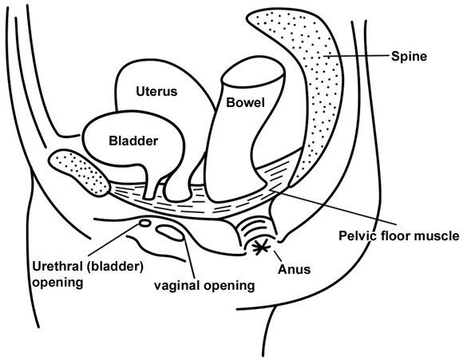
- Tighten gently around your back passage, squeeze the sides of the vagina together and bring the squeeze forward to close the urethra (bladder outlet). Relax for 1-2 seconds.

- Repeat this short squeeze up to 10 times. It is important not to squeeze any other muscles (e.g. tummy or legs) when you practice your pelvic floor muscle exercises.

- Now try to gently hold the squeeze for 4 seconds, breathing gently. Repeat 3-5 squeezes, 3-5 times a day.

- As you improve try to hold for longer - up to 10 seconds. Make sure that you are squeezing correctly to achieve this. Repeat up to 10 times, or more if you can do this well. Remember to continue practising your short squeezes as well.

With practice, you should be able to exercise in any position. You should continue to practice your pelvic floor muscle exercises forever, as they will help to look after you throughout your life.

Are you at risk of developing pelvic floor problems?

- Did you have incontinence in your pregnancy?

- Does your mother have incontinence or prolapse problems?

- Did you have a large baby or forceps delivery?

- Did you have a very slow or very fast second stage of labour?

- Do you suffer from constipation?

- Do you find pelvic floor muscle exercises difficult?

If you answered ‘yes’ to any of these questions you may be more likely to develop pelvic floor problems. If you would like help you can contact your physiotherapist, GP or midwife.

For further information, please contact;

Pelvic and Maternal Health Physiotherapy
Telephone 01603 287130 (24 hour answer phone)

