**Physiotherapy Advice after Vaginal Prolapse Repair Surgery**

**Physiotherapy Department**

**CIRCULATION AND BREATHING EXERCISES**

You should start the following exercises as soon as you can after your operation to help your circulation and breathing. You should do these exercises ***every hour you are awake***. You can stop them when you are able to get out of bed and walk around normally.

#### Circulation Exercises

#### Bend and straighten your knee - stretch your leg away from you and then bend your knee up as far you can - three times on each leg.

#### Ankle movements - with your legs straight, move your feet up and down five times. Then circle five times.

**Breathing Exercises**

You can start these exercises as soon as you wake up after your operation.

* Take a slow deep breath in (through your nose if possible) filling the base of your lungs.
* Hold this breath for three seconds then relax and breathe out gently through your mouth. Repeat three more times and then rest (more than this may make you feel dizzy or light-headed).

**Clearing Your Chest**

If you have secretions on your chest (need to cough up phlegm);

1. Sit upright. Do three deep breaths as above. Rest.

2. Bend your knees and support your stitches with your hand or a pillow.

3. Breathe in and give a strong huff (as though you are ‘fogging up’ a mirror). Repeat three times.

4. Alternate huffs and deep breaths as follows;

* + Breathe in and out deeply 3 times.
  + Breathe in and out gently 3 times
  + Breathe in and huff 3 times. Repeat until you can cough up sputum easily.

The best activity for your lungs is to get back up on your feet as soon as possible. Sitting out in the chair and mobilising help prevent complications that can occur following surgery and can therefore minimise the length of time you need to stay in hospital, getting you home quicker.

**HOW TO GET OUT OF BED**

Getting out of bed as soon as you are able is very important for your recovery; patients who are out of bed and moving sooner are likely to have a shorter hospital stay.

1. Roll onto your side
2. Let your feet come over edge of the bed
3. Push yourself up with your elbows and hands

Use a towel or pillow to support your tummy if you need.

**GOING TO THE TOILET**

**Passing urine**

Once you have had your catheter removed, you will be able to empty your bladder as usual. Avoid hovering over the seat as this can make it more difficult to empty your bladder fully.

Aim to drink 1.5-2 litres of water each day. Try to limit yourself to 2-3 caffeinated drinks a day. Try not to go to the toilet ‘just in case’.

**Opening your bowels**

Sometimes it takes a little while to open your bowels following surgery; try to relax fully to make this easier. You may like to support your stitches with your hand or a small clean towel. You may be prescribed laxatives to avoid constipation and straining.

It may help to;

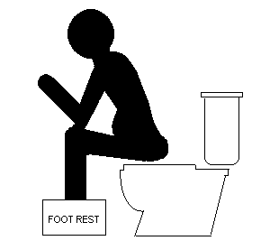

* Drink plenty of fluid and eat a well-balanced diet
* Go to the toilet when you feel the urge to go. Try not to hold on for too long
* Raise your knees slightly when sitting on the toilet, use a small footstool (see diagram)
* Relax and allow your bowel to empty naturally whenever possible. Avoid straining.

##### PELVIC FLOOR MUSCLE EXERCISES

Your pelvic floor muscles are important for bladder and bowel control and support

of your pelvic organs. Those who are sexually active may find that exercising the muscles improves satisfaction for both partners. You can start these exercises once you have had your catheter removed and you are passing urine normally.

Squeeze the muscles around your back passage, vagina and bladder as if you are stopping yourself from passing wind and stopping yourself from passing urine. Feel your pelvic floor muscles lift up. Release.

You should exercise your muscles in two different ways:

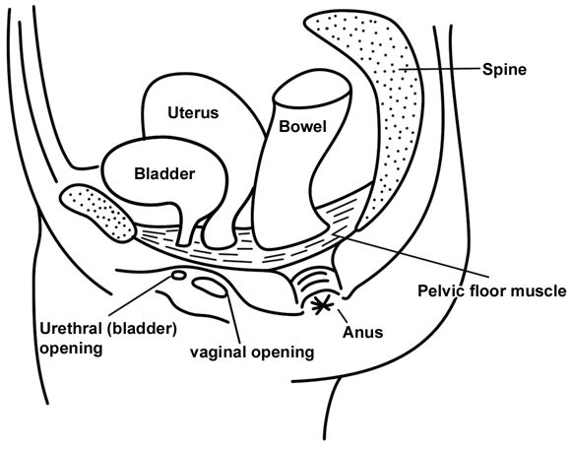

1. Squeeze your muscles as strongly as you can and release. Repeat 10 times or until your muscles start to get tired. Try to do this 4-5 times daily.
2. Squeeze your muscles more gently and hold for 5 seconds. Release. Gradually increase the length of time that you hold for, up to 10 seconds as your muscles become stronger. Try to do 4-5 times daily.

It may be easier to start these exercises lying down. Progress to sitting and standing up to make the exercises more difficult.

##### Tips for Your Pelvic Floor Muscles

##### Squeeze your pelvic floor before you cough, sneeze or lift

#### Try to get in the habit of exercising regularly, for example when you wash your hands, boil the kettle or after using the toilet.

#### Once you have recovered from your surgery it is important to keep doing these exercises once or twice a day forever. If you have problems with bladder control after your surgery, tell your doctor or call the number at the end of this leaflet.

##### You might find downloading the NHS endorsed pelvic floor training app ‘Squeezy’ is useful in helping you to remember to do your exercises. You can find it on your phone’s app store for a small charge.

**RETURNING TO NORMAL ACTIVITIES**

**0-6 weeks**

You should avoid lifting anything heavier than a kettle for 6 weeks. Remember to bear this in mind when thinking about laundry, cooking, cleaning and grocery shopping – you may need to have assistance or to modify these tasks.

Most women do not drive for the first 2-4 weeks after surgery. You are advised to check with your insurance company. Be sure that you are comfortable and safe to do an emergency stop, reverse the car, and concentrate to drive.

Use walking to maintain good mobility, strength and stamina whilst you are recovering.

**6-12 weeks**

Gradually reintroduce your normal activities within your comfort limits. You might want to start doing more exercise such as pilates, yoga, cycling, swimming (if your bleeding has settled).

**After 12 weeks**

You should be able to return to all normal activities after 12 weeks. Please build up to your normal exercise level gradually to avoid injury.

If you have any questions, please contact the Pelvic and Maternal Health Physiotherapy Team on 01603 286994 (24-hour answer phone – replies within 48 hours Mon-Fri 8.30-4.30).

