Wrist and Hand Pain During and After Pregnancy

Physiotherapy Department

Symptoms

Many women experience tingling, burning, numbness or pain in their fingers (especially thumb, index and middle fingers) during pregnancy. This may be just one hand, or both hands. The feeling may be worse during the night or first thing in the morning. Your hands may feel clumsy or weak.

What causes these symptoms?

Carpal Tunnel Syndrome - the extra fluid in your body due to pregnancy may cause swelling in your wrists and hands. This can put pressure on the nerves which pass through your wrist into your fingers. This leads to a tingling or burning feeling, numbness or pain in your fingers. Usually this occurs in the later stages of pregnancy.

Thumb Tendonitis (De Quervain’s Tenosynovitis) - some women develop an inflammation of one of the tendons at the base of the thumb instead. This causes pain in your thumb and the side of your wrist. This seems to be more common than usual during pregnancy.

Other causes include pain which is referred from your neck, and tennis elbow (lateral epicondylitis).

What can I do to ease my symptoms?

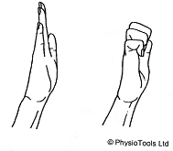
The exercises below may help to ease your symptoms. Do these exercises 3 – 4 times a day. Stop any exercise if it causes pain (a gentle stretching feeling is normal).

1. Reach both hands above your head - slowly make a fist and then open your fingers 5- 10 times. You can also do this exercise squeezing a sponge ball to help decrease the amount of fluid in your hands.

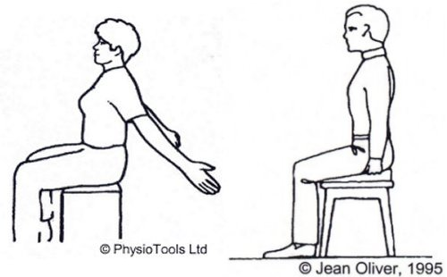

2. Sitting with good posture, open your shoulders and arms out a few times every hour. This will help your circulation.

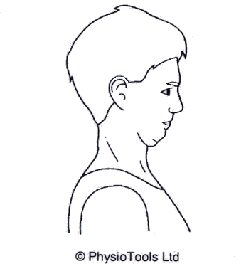

3. Sitting up straight and keeping your head level,
gently pull your chin straight in. This may give you a
stretch at the back of your neck. Hold for a few
seconds, repeat 5 times.

Contrast bathing

Fill one container with cold water from the tap and add a handful of ice cubes. Fill another container with warm water. Place your hands in the cold water for 30 seconds. Place your hands in the warm water for 30 seconds. Repeat 5 times. This can be soothing and help to reduce any extra fluid in your hands.

General Advice
- Try to avoid repetitive movements with your wrist held in a bent position e.g. writing, repetitive lifting.
- Make sure you wear a well-fitting and supportive bra.
- Make sure your pillows support your neck well in bed.
- Try to avoid sitting for a long time in a slumped posture.

If your symptoms continue or worsen after trying the exercises and following the advice in this leaflet, you should contact your midwife or physiotherapist. You may be given splints to support your wrists or hands.

Will the wrist pain go after delivery?

After delivery, as the swelling in your hands decreases, your wrist and hand pain should also resolve. This may take a few weeks. You should continue to follow the advice and exercises as described in this leaflet. Make sure that you sit with good posture and keep your wrists straight when you are feeding your baby.

If your symptoms persist, or affect your daily life, you should contact your midwife, GP or physiotherapist.

If you have any questions about the information in this leaflet, please contact Pelvic and Maternal Health Physiotherapy.

Telephone 01603 287130

(24hr answer phone)



