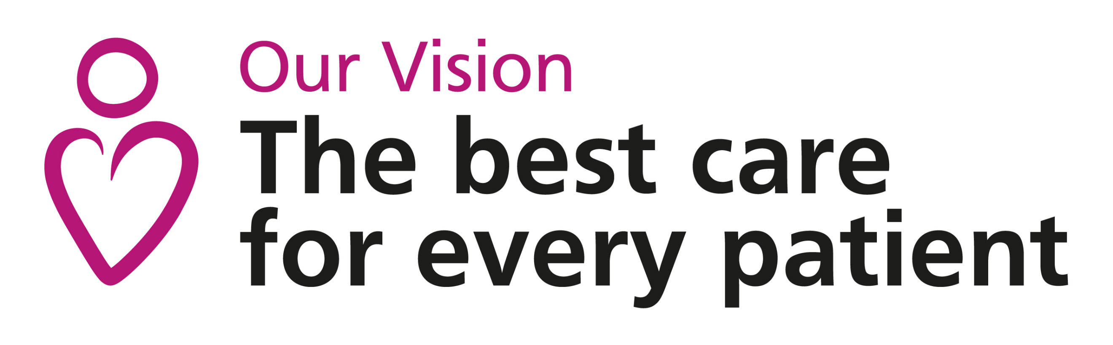

Diabetes - Diet and Diabetes – the first steps

This dietary advice sheet gives some general information to help you start to make changes in your diet following your diagnosis of diabetes.

These are only the first steps! As part of your on-going care, you should also be invited to an appointment with a Specialist Dietitian with the Diabetes team to give you more detailed and personalised help.

- Eat regular meals. Avoid skipping meals and space them out through the day e.g. breakfast, lunch and evening meal. This will help control your appetite and blood glucose levels.

- Include a starchy carbohydrate food (such as bread, potatoes, rice, pasta or breakfast cereal) at each meal. See overleaf for more details.

- Cut back on foods and drinks with added sugar. You should
choose sugar-free drinks but you can include small amounts of sugar in
foods as part of a healthy, balanced diet, provided you don’t over-do it.

4. Cut down on fatty foods. Fat is the greatest source of calories and eating
less will help with weight loss if necessary.

5. Eat plenty of vegetables and moderate amount of fruits. Aim for at least
5 portions per day of a mixture of fruits and vegetables to provide you with
vitamins, minerals and fibre in your diet.

A portion is:
1 medium sized fruit like a small banana or apple
10-12 grapes or berries
2 plums, satsumas or kiwis
3 heaped tablespoons of cooked vegetables or salad
Fruit contains natural sugars so spread your intake out over the day and
avoid drinking fruit juices and smoothies.

6. Do not use ‘diabetic foods’. These add no benefit to your diabetes control
and contain fat and calories similar to the regular versions. They are also
expensive and may have a laxative effect.

This dietary advice sheet gives some general information to help you make the recommended changes to your diet. If you need more detailed advice, or if you are following a special diet that makes it difficult to make these changes, please ask your doctor to refer you to a registered dietitian.

Carbohydrate and blood glucose control

Almost all of the glucose in your blood comes from the carbohydrate that you eat and drink.

There are 2 main forms of carbohydrates in our diet: sugars and starches.

Sugars
- Sugars added to foods and drinks– these should be kept to a minimum.
- Sugars found naturally in milk and fruits – these should still be included as part of a healthy diet but in moderate amounts.

Starchy foods
- Examples include bread, potatoes, pasta, flour, oats, rice and other grains

Carbohydrate is an important source of energy in the diet but the
type and especially the amount directly affect your blood glucose
levels.

A meal containing a large portion of carbohydrates (or a combination of various types of carbohydrates) will increase your blood glucose much more than a meal containing a small amount.

Be aware of your portion sizes; 1 portion is:

Bread 1 medium slice
Breakfast cereals 2-3 tbsp
Muesli 2 tbsp
Porridge 3 tbsp (cooked)
Scone 1 small
Crackers/crispbread 3
New potatoes 2 egg sized
Mashed potato 2 tbsp
Pasta/rice/couscous 2-3 tbsp (cooked)

Remember to include a starchy food at each meal and spread evenly throughout the day. Aim for 5-8 portions a day e.g.
Breakfast: 2 portions
Lunch: 2 portions
Evening meal: 2 portions

The type of carbohydrate is also important. Choose slowly absorbed carbohydrate foods e.g. granary bread, porridge oats, waxy potatoes (especially new potatoes and sweet potatoes) and basmati or wild rice.

Include plenty of vegetables, especially pulses (peas, beans, lentils)
which will also help to slow down the absorption of the carbohydrates in
the same meal. Having lean protein in your meals is also part of a healthy diet.


