**Department of Radiology**

**Percutaneous Cholecystostomy**

**(Gallbladder Drain Insertion)**

**What is cholecystostomy?**

Cholecystostomy is a procedure to place a drain (thin tube) in the gallbladder. It is done to drain infected and blocked gallbladder fluid. It allows the acute inflammation and infection to settle down until it resolves or a further treatment is carried out.

This procedure has been recommended by your doctor. It is a safe procedure that is minimally invasive and carried out under image guidance.

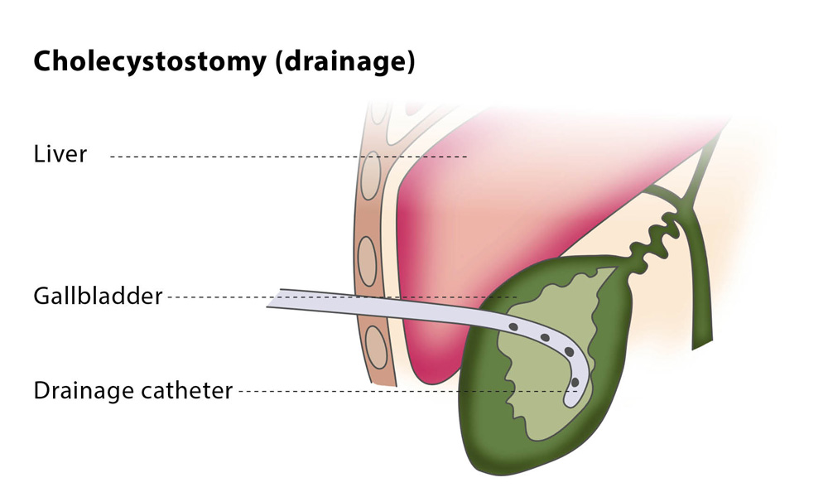

**How is it done?**

* Cholecystostomy is performed by a specially trained team led by a radiologist.
* The procedure is done under sterile conditions and with ultrasound or x-ray guidance.
* Initially the skin is cleaned, and then local anaesthesia is given to numb the area, which can sting as it is injected. This will help with pain control.
* Under ultrasound guidance, a drain is then placed in the gallbladder. You should not feel any sharp pain after the anaesthetic but may experience a pushing sensation.

**Where is it done?**

The procedure is normally done in the Main Ultrasound Department on Level 2 in the East Block of the Norfolk and Norwich University Hospital. Occasionally you may go to the Interventional Radiology Unit (IRU) on Level 3 instead.

**How long does it take?**

Although the actual drain insertion takes around 10 minutes, patients usually spend about 30 minutes in the ultrasound room. Preparation for the procedure and filling a consent form takes most of the time. You can ask any questions you have before it starts.

**What are the risks?**

* If the gallbladder is infected, antibiotics will usually have been given already. There is small risk that infection might be released into your bloodstream, making you unwell for a short period of time.
* There is a small risk of bleeding. Your blood will be checked to ensure that you are not at increased risk of this. If you take blood thinning tablets, such as Warfarin, you must let your doctors know and these medicines need to be stopped 5 days prior the procedure.
* Rarely, if bleeding continues and is severe, then a blood transfusion or further radiological procedure may be required. In extremely rare circumstances, an operation may be necessary.
* The risk of injury to the bowel or internal organs is small as it is image guided.

**What happens after the procedure?**

* The drain is self-locking and secured in place with an adhesive dressing.

* A small drainage bag is attached.
* The drain may require 5-10 ml of normal saline flush up to 3 times a day to prevent it from blocking with thick body secretions. Staff will undertake this.
* If it gets blocked or falls out accidentally, the referring doctor will request further imaging and procedure can be done again if necessary.
* If you go home with the drain still in place you will be provided instructions by the nursing team as how to care for the drain and bags and whom to contact should it come out.

**How long is the drain required?**

The drain is required for a short period until the infection and inflammation settle down. This may be days to weeks but is difficult to predict. If you go home with the drain in place the medical team will explain to you what they expect to happen with it and make arrangements for follow up. If it is to remain permanently (this is rare) it may need to be changed every 6 months. The decision to remove the drain is made by your doctor.

**How is the drain removed?**

When it is decided by medical staff that the drain is no longer required, the drain is unlocked, often by cutting the end off, and simply pulled out by ward staff. This is decided by the consultant in charge of your care, or one of his team members. This should not be painful, but a pulling sensation may be experienced. There is occasionally some bile leakage from the drain site which will settle down and just needs a dressing placed over it.

**Who should I contact in case of a problem?**

Patients are encouraged to contact the medical or surgical team looking after them. These details should be available from the ward staff, or if you are an outpatient then via the relevant consultant’s secretary. Please contact the medical or surgical team out of hours and over the weekend. Hospital switchboard telephone number is 01603 286286.

