Having a Blood Test
 | You need to come to the hospital for a blood test
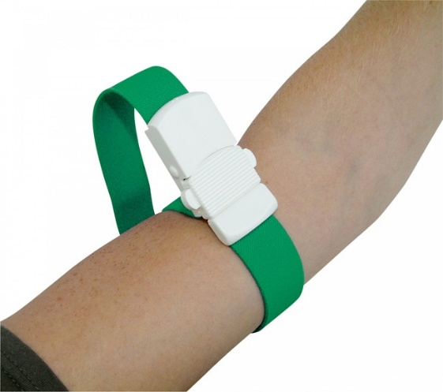 | The nurse will put a band on your arm, which squeezes
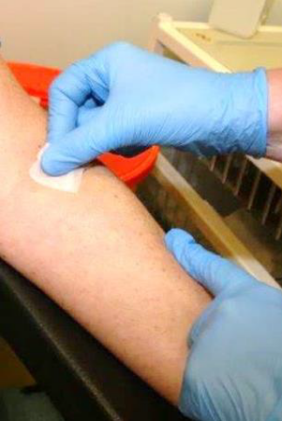 | A special wipe will be used to make your arm clean
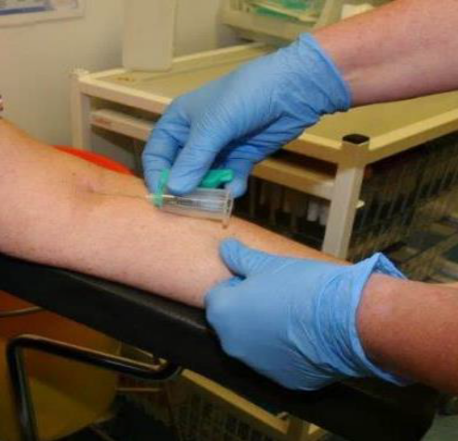 | The nurse will put the needle in and take the blood.
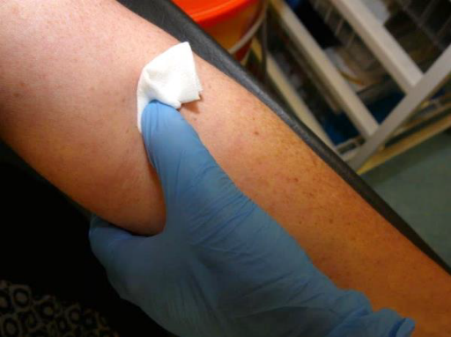 | Then the nurse will remove the needle and wipe your arm
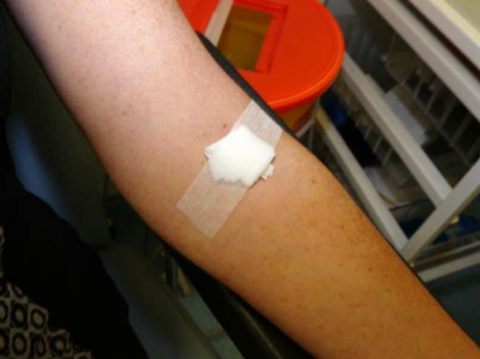 | The plaster will be put on, then you are finished and can go.

