NORFOLK & WAVENEY
Cellular Pathology User Survey April 2024 – March 2025

Introduction
In September to November 2025 the Norfolk and Waveney Cellular Pathology Network undertook a User Satisfaction Survey, as part of its commitment to Quality Improvement and compliance to ISO 15189.
The standard ISO 15189:2022 8.6.2 stipulates,
“The laboratory shall seek feedback from its patients, users and personnel. The feedback shall be analysed and used to improve the management system, laboratory activities and service to users. Records of feedback shall be maintained including the actions taken. Communication shall be provided to personnel on actions taken arising from their feedback”.

Method
The survey was conducted by using Microsoft forms, where the link was then communicated to all service users within NNUH via a communications email and the Beat (Trust Intranet page) – as below. The closing date was originally 30th September, but due to no responses having been gained, this was kept open until mid-November 2025.
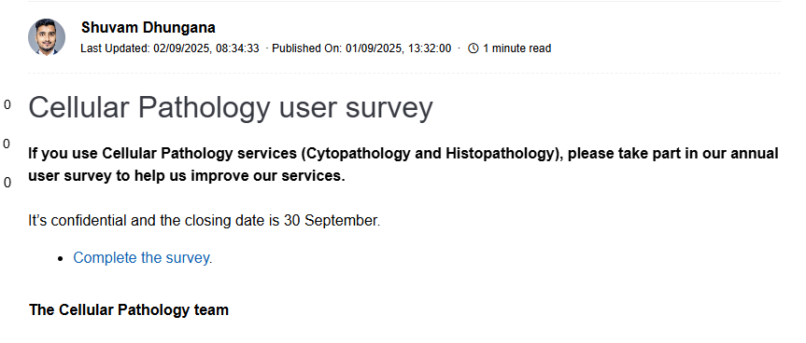
It was also emailed to the Divisional Operations Manager for Medicine, Diagnostics and Clinical Support at JPUH to share via email to the service users at that Trust.
In addition, a QR barcode was generated and added to all service user tins, in case the email communications and the Beat post was missed. This was also shared with JPUH Divisional Operations Manager for Medicine, Diagnostics and Clinical Support for dissemination.
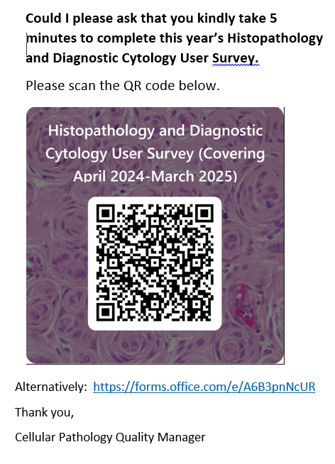
The questionnaire asked 22 questions covering the following topics; Support Services, User Information/guides, Repertoire, Electronic Requesting, Advice, Turnaround Times, Clarity of Reports, Response to Change, Overall Performance of Service, and changes to the department/service improvements. One survey was used to cover both diagnostic Cytology (excluding Cervical Cytology) and Histopathology services though some specific questions were asked about each aspect.
The questions consisted of a statement about the aspects of the service, where users were asked to score. The choices have been expanded from previous years, with the choices being Poor (1), Fair (previously acceptable) (2), Good (3), Very Good (previously excellent) (4) and Exceptional (new) (5) as appropriate. After each statement/question a space for comments was provided. An option for N/A was offered but no score will be given, as there is an understanding that not all
Each response was allocated a score of 1 to 5 (poor-exceptional) in order to quantify and rank.
Responses
A total of 1 response were returned, the previous User Survey 2023-2024 saw 10 responses, which is 9 less from previous responses.

Results
Overall, 22 questions were answered by the service user, with 11 responses gained. 8 of these questions are not scored as they are response driven, which were not answered within this optional section. 2 questions were deemed to be not applicable due to the service user not using that aspect of the service or not being able to comment, surrounding Cytology TATs and the clarity/relevance of the report.
The overall responses were as follows (*percentages not calculated):
 | 2019 Survey | 2020 | 2021 | 2022 | 2023 | 2024 | 2025 *
Poor | 3 (3.8%) | 5 (4%) | 3 (0.6%) | 3 (2.7%) | 16 (6.3%) | 4 (2.9%) | 3
Fair (Acceptable) | 6 (7.5%) | 15 (12.3%) | 27 (5.6%) | 9 (8%) | 33 (13%) | 10 (7.1%) | 6
Good | 31 (38.8%) | 56 (45.9% | 287 (59.7%) | 30 (26.8%) | 63 (25%) | 58 (41.4%) | 2
Very Good (Excellent) | 40 (50%) | 46 (37.7%) | 145 (30.1%) | 48 (42.8%) | 75 (29.6%) | 23 (16.4%) | 0
Exceptional |  |  |  |  |  | 5 (3.6%) | 0

There were 0, not applicable responses to specific questions relating to a specialised service (i.e. Cytopathology/ transport/ supplies).

Ranking of responses

Ranking of results has not been undertaken due to only receiving one response.

Individual trended question results 3.4

Unable to undertake due to having only received one response.

Overall comments

Unfortunately due to the lack of engagement from service users, it is incredibly difficult to provide comment based on an individual response. The response gained, has provided poor or fair comments surrounding the questions posed. It is clear that service users are not happy with the service being provided, particularly by Histopathology. Actions are in place to try and address the issues that are being faced.

Compiled Table of Comments and Actions
All comments received on any of the questions have been recorded below; the responses were numbered/ recorded by the date/ time order of receipt. No comments were made.

- The ease of ordering Histopathology and Cytopathology Supplies | Comment back to the responder/Action points | Responsibility/ Timescale
No comments made | No action points generated.
- Specimen Collection and Transport
No comments made | No action points generated.
- The delivery of supplies (sample containers etc)
No comments made | No action points generated.
- The usefulness of the User Guide
No comments made to both Histopathology and Cytology | No action points generated.
- Range of Investigations
No comments made | No action points generated.
- The ease of use of the ICE electronic requesting system, (if you have access to it)
No comments made | No action points generated.
- The availability of advice, either by telephone or email
No comments made | No action points generated.
- Turnaround Time Cytopathology
No comments made | No action points generated.
- Turnaround Time Histopathology
No comments made | No action points generated.
- Clarity and Relevance of Cytopathology Report
No comments made | No action points generated.
- Clarity and Relevance of Histopathology Report
No comments made | No action points generated.
- Comments on Ability to respond to Change in Clinical Practice
No comments made | No action points generated.
Final Comments on Overall Performance
No comments made. | No action points generated.
Service Improvements
No comments made. | No action points generated.

