What adjustments (help) can I ask for? |   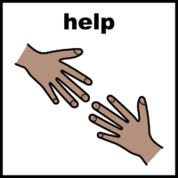
If you need to have numbing cream, you need to get this from your pharmacy and put it on before you come. | 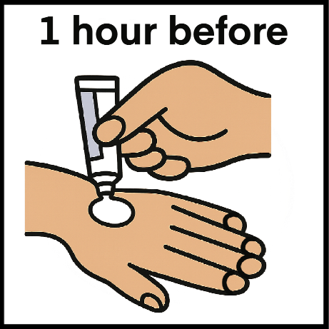
You can ask not to wait in the waiting room, if it is too busy or noisy. | 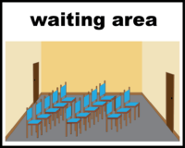  
You can ask to be seen in a room on your own. | 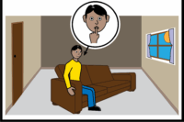
You can ask to have the lights dimmed or other changes to the environment, if this will help with your sensory needs. | 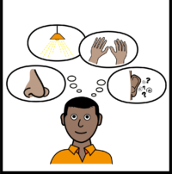  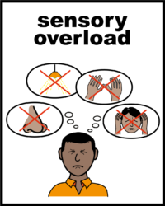
You can ask to have a longer appointment. | 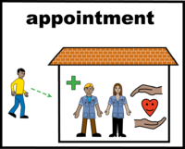  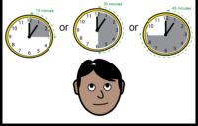
You can ask to have somebody you know stay with you during the blood test. | 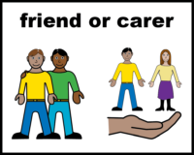
You can ask to have access to sensory items to help distract you during your blood test.  You can bring your own items to distract you too! |   
If you need more help or you still think you won’t be able to have your test, you can ask to speak to the Learning Disability and Autism Specialist Nurses. | 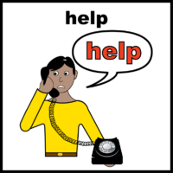  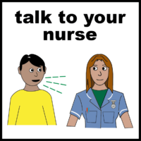  Learning disability / autism nurse
They can help you write a plan for the appointment and to share it. |   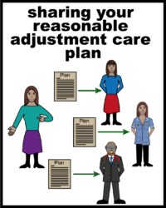
How do I do this?  You can send an email to:  Phlebotomy.Services@nnuh.nhs.uk  Or you can call 01603 286921 and leave a message.  Someone will call you back to discuss your special requirements and book your appointment. |   