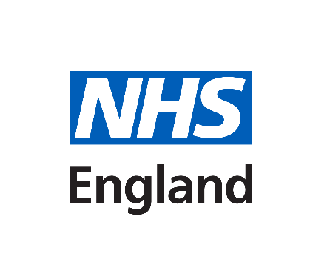

Non-Invasive Prenatal Testing (NIPT) R445:

Offer for women with a previous pregnancy with Down’s syndrome, Edwards’ syndrome or Patau’s syndrome (T21, T18 and T13)

Information for parents
[Full version]

Developed by:

NHS England R445 Working Group

Full Version
What are my testing options if I have previously had a pregnancy or child with Down’s syndrome, Edwards’ or Patau’s syndrome?
We understand that you might need different information for your current pregnancy when you have previously had a baby with Down’s syndrome (also known as Trisomy 21 or T21), Edwards’ syndrome (Trisomy 18 or T18) or Patau’s syndrome (Trisomy 13 or T13). This leaflet will outline the screening and diagnostic testing options available to you.

The word ‘baby’ is used in this leaflet as feedback from parents tells us that this is the most acceptable word. We are aware that some people won’t find this appropriate and are sorry if it causes you any distress.

Down’s syndrome, Edwards’ syndrome and Patau’s syndrome
We appreciate that you may have had information about these conditions in previous pregnancies, have lost a baby with or have a child or family member living with either Down’s syndrome, Edwards’ syndrome or Patau’s syndrome. It is important that you have accurate information about all three syndromes when making choices about screening or diagnostic tests in a pregnancy. We have created a summary of information and links to organisations that will be able to provide you with further information and support.

Down’s syndrome (Trisomy 21)
Down’s syndrome is caused by an extra copy of chromosome 21 in all or some cells of the body. A person with Down’s syndrome will have some level of learning disability. Some health problems are more common in people with Down’s syndrome. These include heart conditions and problems with hearing and vision.

People with Down’s syndrome can have a good quality of life, and most say they enjoy their lives. With support, many people with Down’s syndrome can go to mainstream schools, get jobs, have relationships, and live semi-independently in adulthood.

For more information about Down’s syndrome please go to:
https://www.nhs.uk/conditions/downs-syndrome/

Edwards’ syndrome (Trisomy 18) and Patau’s syndrome (Trisomy 13)
Babies with Edwards’ syndrome have an extra copy of chromosome 18 in all or some cells. Babies with Patau’s syndrome have an extra copy of chromosome 13 in all or some cells. All babies born with Edwards’ syndrome and Patau’s syndrome will have a learning disability and a wide range of physical challenges, which can be extremely serious and present at birth.

Sadly, the survival rates are low and of those babies born alive only around 13% with Edwards’ syndrome and 11% with Patau’s syndrome will live past their first birthday. Some babies may survive to adulthood, but this is rare. Despite their difficulties, children can slowly make progress in their development.

For more information about Edwards’ syndrome please go to:
https://www.nhs.uk/conditions/edwards-syndrome/

For more information about Patau’s syndrome please go to:
https://www.nhs.uk/conditions/pataus-syndrome/

Screening tests for Down’s syndrome, Edwards’ syndrome and Patau’s syndrome

All eligible women are offered the choice of screening tests to work out the chance of their baby having one of these conditions. These tests are known as either the Combined test or Quadruple test depending on how many weeks pregnant you are. They involve a sample of blood from the arm to check specific hormone levels and an ultrasound scan to get measurements from the baby.

Further information about the screening tests, Down’s syndrome, Edwards’ syndrome and Patau’s syndrome can be found in Screening Tests for you and your baby leaflet provided by your healthcare professional and available online.

You are offered a different pathway to the combined test or quadruple test as you have had a previous baby with one of these conditions. The options available to you are explained in more detail in the next section.

Your testing options
There are three options available to you.
- No testing
Continue with routine antenatal care.
- Non-Invasive Prenatal Testing (NIPT)
A blood test which can tell you whether or not your baby is more likely to have the condition.
- An invasive diagnostic test (chorionic villus sampling (CVS) or amniocentesis) Provides a ‘yes’ or ‘no’ answer if the baby has the condition.
Which, if any, testing to have in your pregnancy is a personal decision. Your health care team will support you whatever you decide.
1. No Testing
If you decide to have no testing, you will still be offered all other parts of your routine antenatal care. Your midwife will explain what this means for you.
If you have any questions/concerns, please contact your healthcare provider. For example, Obstetrician (doctor for pregnancy) or Midwife.

2. Non-Invasive Prenatal Testing
Non-invasive prenatal testing (NIPT) is a screening test which is more accurate than the Combined or Quadruple test. This test involves measuring the DNA (genetic material) in your blood by taking a blood sample from your arm. It is completely safe and will not harm the baby.
NIPT blood samples may be kept by the NIPT laboratory for quality purposes for up to 5 years. Please tell your midwife if you do not wish your NIPT blood sample to be kept in this way.
How NIPT works
Your baby is joined to the placenta in your womb by the umbilical cord. During your pregnancy the placenta releases some DNA into the cord and from there into your bloodstream. As a result, your blood contains a mixture of DNA from you and from the baby’s placenta.
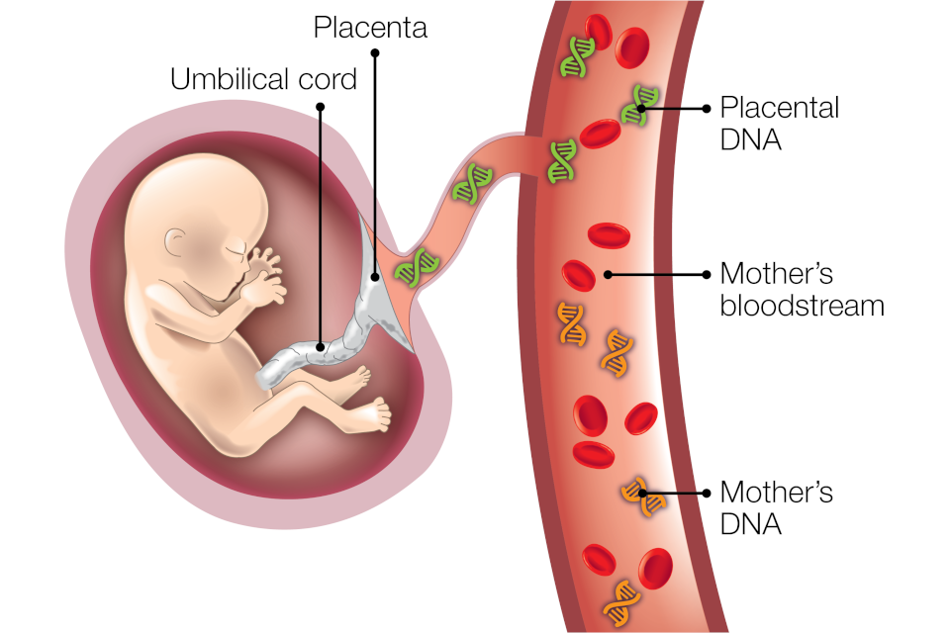
If NIPT finds more DNA than expected for chromosomes 21, 18 or 13 in your blood it could mean that the baby has either Down’s syndrome, Edwards’ syndrome or Patau’s syndrome.
Figure one: Image shows the mother’s and placental DNA in the mother’s bloodstream. This image is from: Your choices after a higher-chance screening result - GOV.UK (www.gov.uk)
Like any screening test, NIPT does not give a definite answer and it cannot tell you for certain if the baby has Down’s syndrome, Edwards’ syndrome or Patau’s syndrome. In most cases, the placental DNA will be the same as the baby’s DNA. One of the reasons why NIPT is not 100% accurate is because in rare cases the DNA from the placenta is not the same as the baby’s DNA. This is called confined placental mosaicism. Your healthcare provider will talk to you about this in more detail if you decide on this option.
This screening test is a more accurate test than the combined or quadruple test, as NIPT is looking at DNA within the bloodstream, however it will not be able to give you any information about the chance of any other conditions or tell you whether the baby is a boy or a girl.
Who can have NIPT?

NIPT can be offered to women who are at least 10 weeks pregnant, confirmed by an ultrasound scan. NIPT can be performed in singleton (carrying one baby) and twin pregnancies up to and including 21 weeks and 6 days (21⁺⁶).

The test cannot be offered if:

- You are pregnant with more than two babies.
- You have a twin pregnancy and one of the babies has miscarried.
- You currently have cancer (unless you are in remission)
- You have a known chromosomal or genetic condition, including Down's syndrome (please check suitability with your care provider)
- You have had a blood transfusion in the last four months.
- You have ever received a bone marrow or organ surgery.
- You have had immunotherapy (excluding IVIg treatment), or stem cell therapy
- Your current pregnancy was conceived using a donor egg.

NIPT results
If you decide to have NIPT, you can have it for:
- All three conditions
- Down’s syndrome only
- Edwards’ syndrome and Patau’s syndrome only
You will only receive a result for the conditions you have chosen to be tested for.
You can usually choose whether to receive NIPT results by phone or face-to-face. Discuss your preference with your healthcare professional. Most women will get their result within two weeks of having NIPT, however you should be contacted if there are any delays. It is important to remember that NIPT is still a screening test. The result will be reported as either ‘higher-chance’ or ‘lower-chance’ for the conditions screened for. In a small number of cases, it won’t be possible to give a result.
NIPT is a highly sensitive screening test and will identify the presence or absence of the three conditions for most women. However, there can also be false positive and false negative results, therefore it is not a diagnostic test.
- A false positive result means getting a higher-chance result when the baby does not have the condition.
- A false negative result means getting a lower-chance result when the baby does have the condition.
Lower-chance result
Receiving a lower chance NIPT result means it is very unlikely that your baby has either Down’s syndrome, Edwards’ syndrome or Patau’s syndrome, depending on the screening choice you have made. Having a lower-chance NIPT result means that you will not routinely be offered a diagnostic test and you will continue to receive usual antenatal care.
Higher-chance result
Having a higher-chance NIPT result does not mean that the baby definitely has the condition, but it is very likely. At least 90% (9 out of 10) of women who receive a higher-chance NIPT result for Down’s syndrome will have a baby with the condition.
Evidence suggests NIPT is less accurate for Edwards’ syndrome and Patau’s syndrome than it is for Down’s syndrome, the reasons are currently not fully understood. NIPT might also be less accurate in twin pregnancies.
After a higher-chance NIPT result, you will be offered diagnostic testing. But you may prefer to have no further tests.
No result
In a small number of cases, NIPT will not give a result. Not getting a result could be because of a technical issue relating to the test. It could also happen if there is not enough DNA present in the blood sample, for example because you have a body mass index (BMI) over 30 or you are having twins.
If you do not get a result, you can then choose between one further NIPT, a diagnostic test (see the next section) or having no further testing. We always advise that you discuss your individual NIPT result with your healthcare professional.
3.Diagnostic Testing

Invasive diagnostic testing involves taking a sample from the placenta (chorionic villus sample - CVS) or amniotic fluid (amniocentesis).

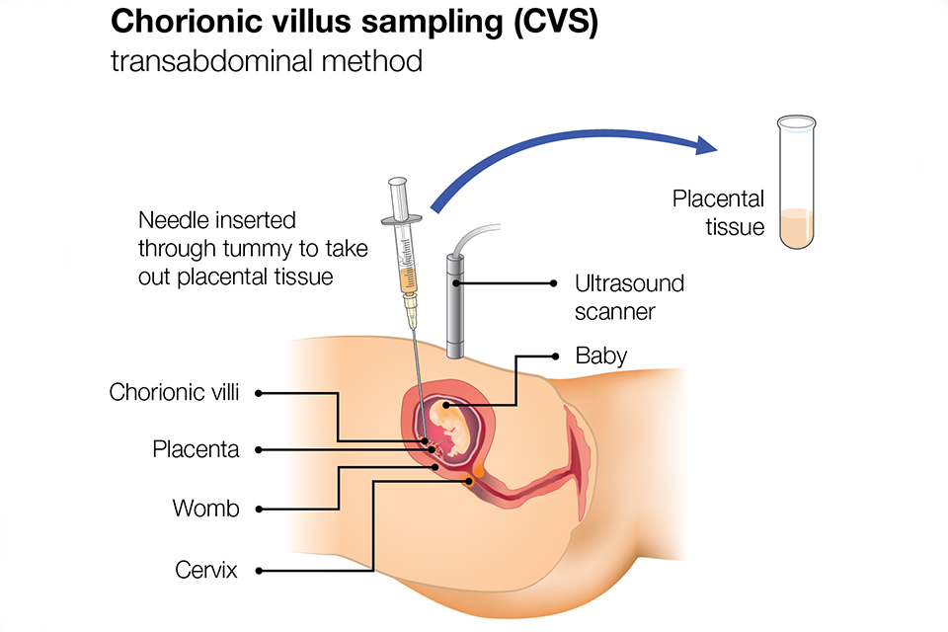
The sample is taken using ultrasound to guide a needle either into the placenta or into the amniotic fluid. It is performed by specialists trained in fetal medicine.
Figure Two: Chorionic villus sampling (CVS).
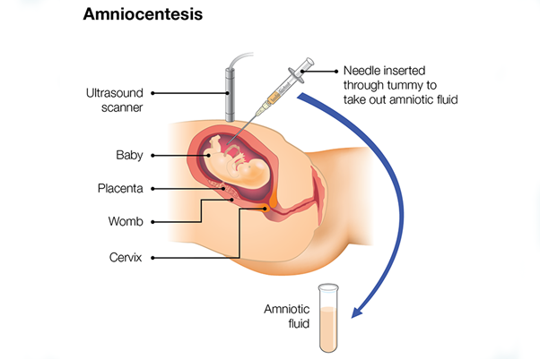
This image shows one of the techniques (transabdominal) of taking a sample from the placenta.
Figure Three: Amniocentesis
Image two (chorionic villus sampling (CVS) and image three (Amniocentesis) are taken from: Screening in pregnancy: CVS and amniocentesis information for parents - GOV.UK (www.gov.uk)

The type of test (either CVS or amniocentesis) depends on how many weeks pregnant you are, any other ultrasound findings and where the placenta is in relation to your womb.

A CVS can usually be performed from around 11 weeks of pregnancy and amniocentesis from around 15 weeks of pregnancy. Your fetal medicine specialist will be able to advise further during your consultation. A sample of your blood is often needed to help provide a result for the pregnancy.

The chance of miscarriage from either of these tests is around 0.5% (1 in 200). and there is a risk of less than 1 in 1,000 that CVS or amniocentesis will cause a serious infection.

It usually takes 2-3 days to get a result that can tell you if your baby does or does not have Down’s syndrome, Edwards’ syndrome or Patau’s syndrome. It may also tell you the sex of your baby. It will not test for any other conditions. Some results can be delayed due to issues with testing the sample. Rarely, we are unable to provide a result at all from that sample and your options would be discussed.

Your results will either be telephoned or given to you face-to-face, depending on what you have arranged with the team caring for you.

Storage of any DNA sample will be discussed with you at the time of the procedure.

Which, if any, testing to have in your pregnancy is a personal decision. Your health care team will support you whatever you decide.
Please be aware that this is general information and options outlined may not be suitable for all women with a previous child with Down’s syndrome, Edwards’ syndrome or Patau’s syndrome.
Always discuss your options with an appropriate healthcare provider
Support Organisations and Links below:

https://www.downs-syndrome.org.uk/
https://www.soft.org.uk/
https://www.arc-uk.org/

Named Midwife/Team | Antenatal Screening Team
Contact Tel: | 01603 287949
Contact Email: | Antenatal.newbornscreening@nnuh.nhs.uk

Please write further questions or information here:

References:
Screening tests for you and your baby (STFYAYB) - GOV.UK (www.gov.uk)
Your choices after a higher-chance screening result - GOV.UK (www.gov.uk)
Screening in pregnancy: CVS and amniocentesis information for parents - GOV.UK (www.gov.uk)

