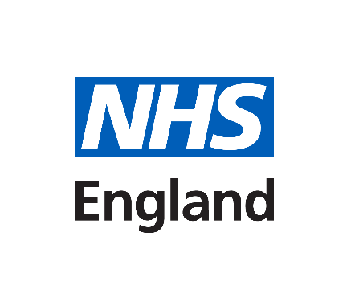

Non-Invasive Prenatal Testing (NIPT):

Information for parents

What is Down’s syndrome, Edwards’ syndrome and Patau’s syndrome

Down’s syndrome (Trisomy 21)
Down’s syndrome is caused by an extra copy of chromosome 21 in all or some cells of the body. A person with Down’s syndrome will have some level of learning disability. Some health problems are more common in people with Down’s syndrome. These include heart conditions and problems with hearing and vision.

People with Down’s syndrome can have a good quality of life, and most say they enjoy their lives. With support, many people with Down’s syndrome can go to mainstream schools, get jobs, have relationships, and live semi-independently in adulthood.

For more information about Down’s syndrome please go to:
https://www.nhs.uk/conditions/downs-syndrome/

Edwards’ syndrome (Trisomy 18) and Patau’s syndrome (Trisomy 13)
Babies with Edwards’ syndrome have an extra copy of chromosome 18 in all or some cells. Babies with Patau’s syndrome have an extra copy of chromosome 13 in all or some cells. All babies born with Edwards’ syndrome and Patau’s syndrome will have a learning disability and a wide range of physical challenges, which can be extremely serious and present at birth.

Sadly, the survival rates are low and of those babies born alive only around 13% with Edwards’ syndrome and 11% with Patau’s syndrome will live past their first birthday. Some babies may survive to adulthood, but this is rare. Despite their difficulties, children can slowly make progress in their development.

For more information about Edwards’ syndrome please go to:
https://www.nhs.uk/conditions/edwards-syndrome/

For more information about Patau’s syndrome please go to:
https://www.nhs.uk/conditions/pataus-syndrome/

Further information about the screening tests, Down’s syndrome, Edwards’ syndrome and Patau’s syndrome can be found in Screening Tests for you and your baby leaflet provided by your healthcare professional and available online.

Your testing options
This information is for pregnant women with singleton (having only one baby) and twin pregnancies who have received a higher chance result from the combined or quadruple screening test. These tests are for Down’s syndrome (also known as Trisomy 21 or T21), Edwards’ syndrome (Trisomy 18 or T18) and Patau’s syndrome (Trisomy 13 or T13).
There are three options available to you.
- No testing
Continue with routine antenatal care.
- Non-Invasive Prenatal Testing (NIPT)
A blood test which can tell you whether or not your baby is more likely to have the condition.
- An invasive diagnostic test (chorionic villus sampling (CVS) or amniocentesis) Provides a ‘yes’ or ‘no’ answer if the baby has the condition.
Which, if any, testing to have in your pregnancy is a personal decision. Your health care team will support you whatever you decide.
1. No Testing
If you decide to have no testing, you will still be offered all other parts of your routine antenatal care. Your midwife will explain what this means for you.
If you have any questions/concerns, please contact your healthcare provider.
Non-invasive prenatal testing
2. Non-invasive prenatal testing (NIPT)
Non-invasive prenatal testing (NIPT) is a more accurate screening test than the first screening test (the combined or quadruple test). It involves taking some blood from your arm. It is completely safe and will not harm the baby.
NIPT does not tell you for certain if the baby has Down’s syndrome, Edwards’ syndrome or Patau’s syndrome. Like any screening test, NIPT does not give a definite answer. It will not be used to find other conditions or tell you whether the baby is a boy or a girl. NIPT is offered up to 21⁺⁶ weeks of pregnancy as part of NHS screening.
How NIPT works
NIPT involves measuring the DNA (genetic material) in your blood. Your baby is joined to the placenta in your womb via the umbilical cord. During your pregnancy the placenta releases some DNA into your bloodstream. As a result, your blood contains a mixture of DNA from you and from the baby’s placenta.
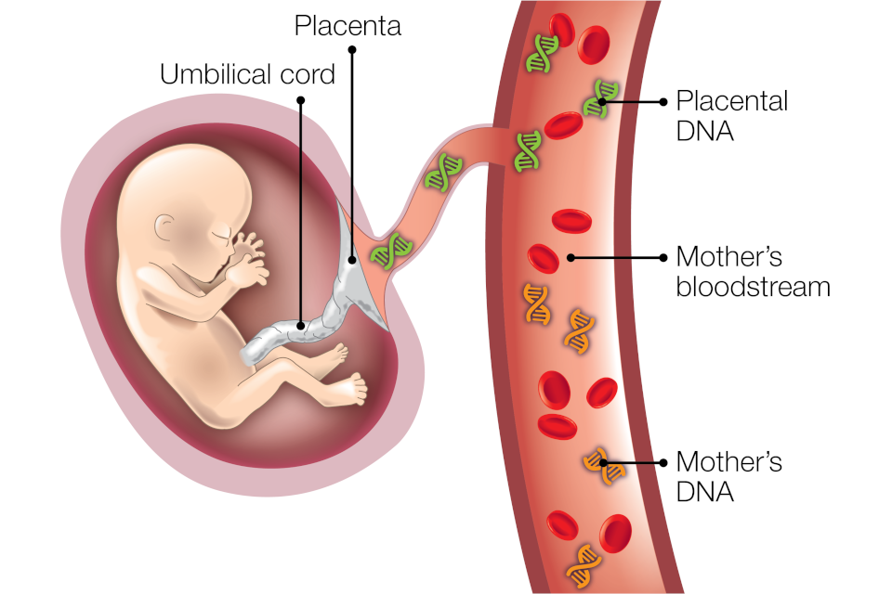
If NIPT finds more DNA than expected for chromosomes 21, 18 or 13 in your blood it could mean that the baby has one of the conditions.
In most cases, the placental DNA will be the same as the baby’s DNA. One of the reasons why NIPT is not 100% accurate is because it tests DNA from the placenta and in rare cases this is not identical to the baby’s DNA. This is called confined placental mosaicism.
The laboratory may keep your NIPT screening sample for up to 5 years for quality and testing purposes. If you do not wish your sample to be kept, let your healthcare professional know.
NIPT choices
NIPT may not be suitable for everyone. You should discuss with your healthcare professional to check it’s suitable for you.
If you decide to have NIPT, you can have it for:
- All 3 conditions
- Down’s syndrome only
- Edwards’ syndrome and Patau’s syndrome only
Most women with higher chance results will have a baby without any of the conditions. Some women will have a higher chance result for one of the conditions and the baby will have a different condition. For example, if you have a higher chance result for Down’s syndrome, there is a chance that the baby has Patau’s syndrome. Overall, around 3% of screening test results are higher chance.
If you receive a very high chance result (such a between ‘1 in 2’ and ‘1 in 10’) from your first screening test, you should have an in-depth discussion with a healthcare professional about your options. This is because NIPT is less accurate when you receive a very high chance result for Edwards’ syndrome or Patau’s syndrome.
NIPT results
You can usually choose whether to receive NIPT results by phone or face-to-face. Discuss your preference with your midwife. Most women will get their result within 2 weeks of having NIPT.
Depending on your NIPT screening choice, you will have up to 3 results reported. You could get:
- one for Down’s syndrome, one for Edwards’ syndrome and one for Patau’s syndrome, or
- one for Down’s syndrome, or
- one for Edwards’ syndrome and one for Patau’s syndrome
It is important to remember that NIPT is a screening test. The result will be reported as either higher chance or lower chance for the conditions screened for. No numerical value will be provided (as with a combined or quadruple test).
NIPT will give an accurate result for most women who choose to have it but there can also be false positive and false negative results. A false positive result means getting a higher chance result when the baby does not have the condition. A false negative result is getting a lower chance result when the baby does have the condition.
We always advise that you discuss your individual NIPT result with your healthcare professional.
Lower chance result
Most women who have NIPT will get a lower chance result. NIPT is a screening test so is not 100% accurate. If you had a very high chance result from the combined or quadruple test (such as between ‘1 in 2’ and ‘1 in 10’) then a false negative result is more common. So there will be some women who receive a lower chance NIPT result who do have a baby with one of the conditions.
You will not be offered a diagnostic test after a lower-chance NIPT result. You will continue to receive usual antenatal care.
Higher chance result
A higher chance NIPT result does not mean the baby has one of the conditions but it is very likely. At least 90% (9 out of 10) of women who receive a higher chance NIPT result for Down’s syndrome will be carrying a baby who has the condition.
After a higher chance NIPT result, you will be offered diagnostic testing. But you may prefer to have no further tests.
No result
In a small number of cases, NIPT will not give a result. If you do not get a result you can then choose between one further NIPT, a diagnostic test or having no further testing.
Getting no result could be caused by a technical issue with the test. It could also happen if there is not enough DNA present in the blood sample, for example because you have a body mass index (BMI) over 30 or you are having twins.
If you get a higher chance result or no result, healthcare professionals will provide more information and support.

3.Diagnostic Testing
You can choose to have diagnostic testing following your higher chance combined or quadruple test result. You can also choose to have diagnostic testing after a higher chance NIPT result.
There are 2 types of diagnostic test: chorionic villus sampling (CVS) which involves taking a sample from the placenta and amniocentesis which involves taking a sample of the amniotic fluid (the fluid which surrounds your baby).
Or both test, the sample is taken using ultrasound to guide a very fine needle either into the placenta or into the amniotic fluid. It is performed by specialists trained in fetal medicine.
Diagnostic tests give a definite answer and will confirm with certainty if your baby has Downs Syndrome, Edwards Syndrome or Pataus Syndrome.
However, due to the invasive nature of both tests, one out of every 200 (0.5% of) women who have a diagnostic test will miscarry because of the test.
Image of a CVS sample being taken:
.
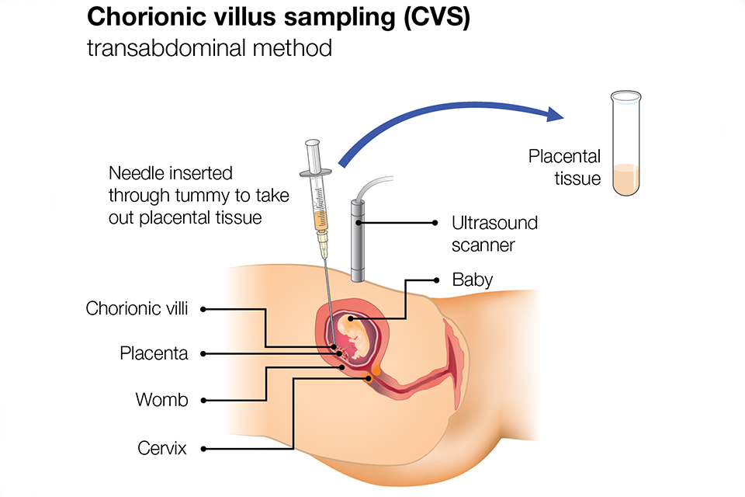

Image of an amniocentesis sample being taken:
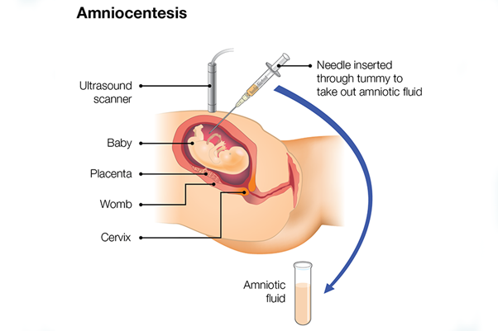
CVS (chorionic villus sampling)
This is usually performed from 11 to 14 weeks of pregnancy but can be done later. A fine needle, usually put through your abdomen, is used to take a tiny sample of tissue from the placenta.
Very occasionally, it may not be possible to perform a CVS safely due to the position of the placenta. If this happens, a specialist will discuss alternative options with you such as offering another diagnostic test (amniocentesis) after 15 weeks of pregnancy.
You will get the first CVS result in about 3 days. If this confirms the NIPT result, and there were relevant scan findings, then your doctor will discuss your options with you. However, if your scan did not show anything relevant, then a further test on your original CVS sample may be needed. If this further test is needed, it can take about 2 weeks to get the results and you will be advised to wait for these if you are considering ending the pregnancy.
This is because of a rare condition called confined placental mosaicism (CPM) in which the DNA in the placenta is not the same as the baby’s DNA. In a very small number of cases, another diagnostic test (amniocentesis) may be needed to test the DNA of the baby.
Amniocentesis
This is usually performed after 15 weeks of pregnancy. A fine needle is passed through your abdomen into the uterus to collect a small sample of the fluid surrounding the baby.
Amniocentesis results are usually available in around 3 days. They are a true reflection of the baby’s DNA. In some circumstances it may be more appropriate to wait for an amniocentesis rather than having a CVS.
Continuing support and care
Which, if any, testing to have in your pregnancy is a personal decision. Your health care team will support you whatever you decide. Only you know what is the best decision for you and your family.
Remember, whatever decision you make, we will support you.

National Support organisations
ARC is a national charity that provides support for people making decisions about screening and diagnosis and whether to continue a pregnancy. You can call them on 020 713 7486.
DSA (the Down’s Syndrome Association) provides information and support for parents. You can call them on 0333 12 12 300.
SOFT provides information and support to families about Edwards’ syndrome and Patau’s syndrome.
Named Team | Antenatal Screening Team
Antenatal Screening Specialist Midwives | Charlie Aldous, Danielle Peat, Rachel Trabelsi and Naomi Yeoh
Contact Details: | 01603 287949 (Monday- Friday 9-4)
Contact Email: | Antenatal.newbornscreening@nnuh.nhs.uk

References:
Screening tests for you and your baby (STFYAYB) - GOV.UK (www.gov.uk)
Your choices after a higher-chance screening result - GOV.UK (www.gov.uk)
Screening in pregnancy: CVS and amniocentesis information for parents - GOV.UK (www.gov.uk)

