

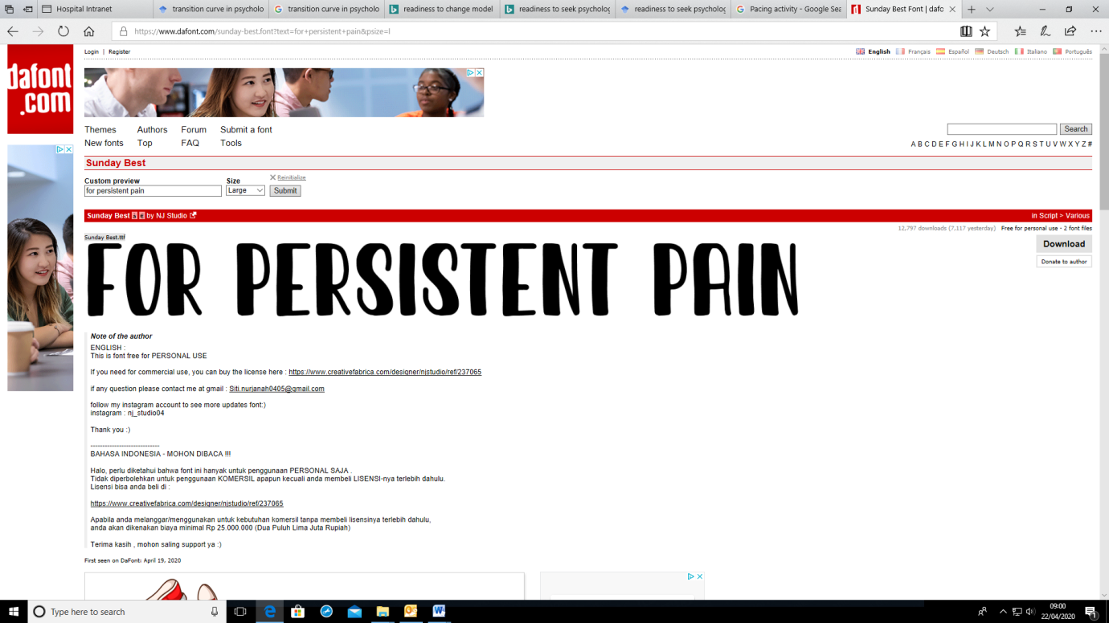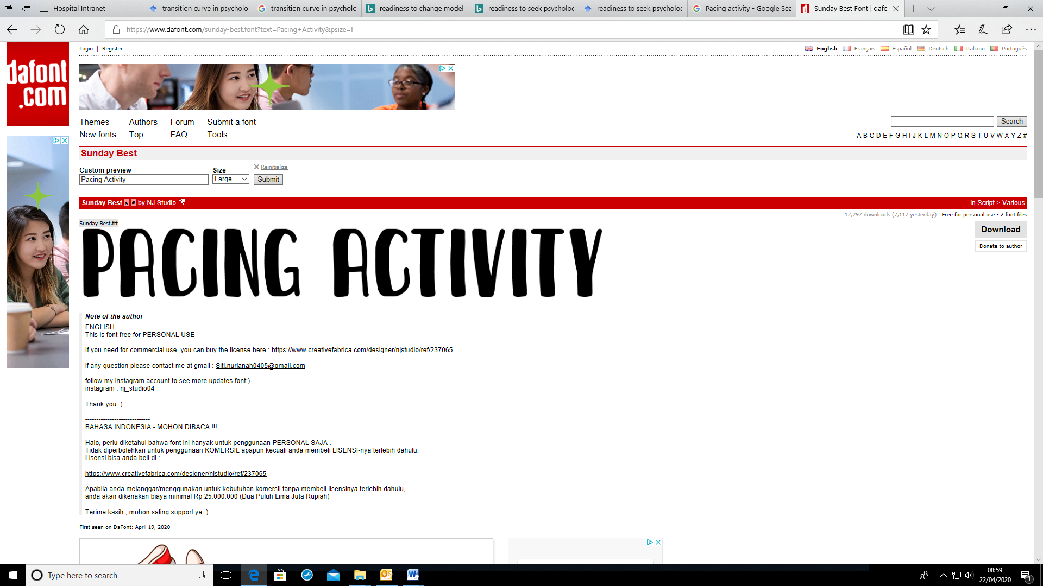



Patient Information Leaflet for: Pacing Author/s title: Lucy Reeve Approved by : PIF

Date approved: 06/04/2021 Review date: 03/06/2022 Trust Docs ID: 17489 Page 1 of 18

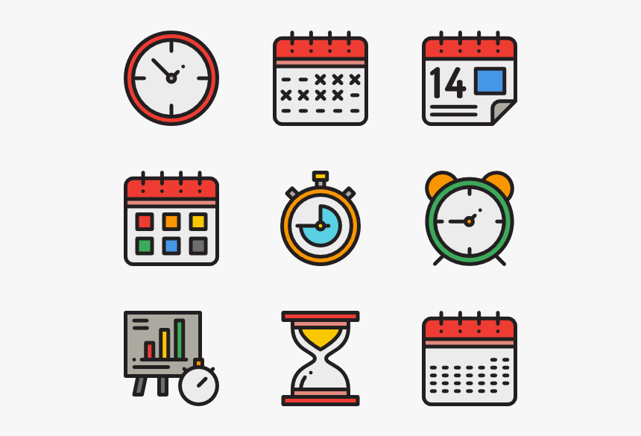

**A**

**B**

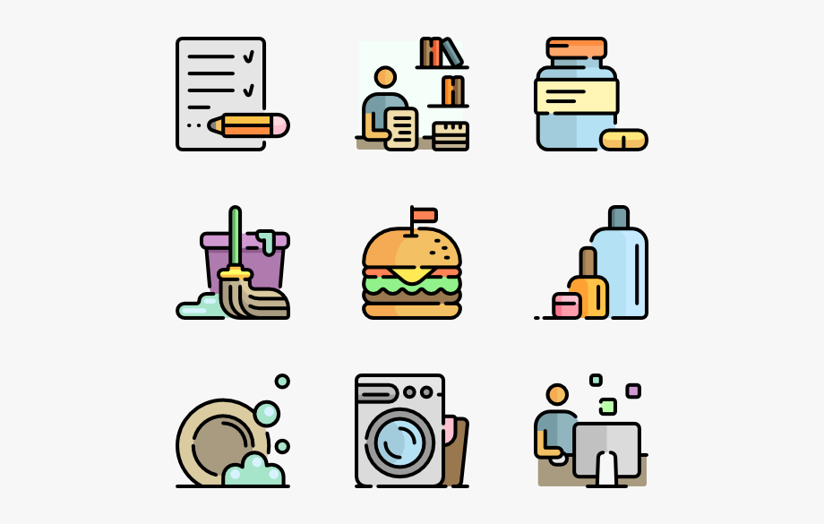



Patient Information Leaflet for: Pacing Author/s title: Lucy Reeve Approved by : PIF

Date approved: 06/04/2021 Review date: 03/06/2022 Trust Docs ID: 17489 Page 2 of 18

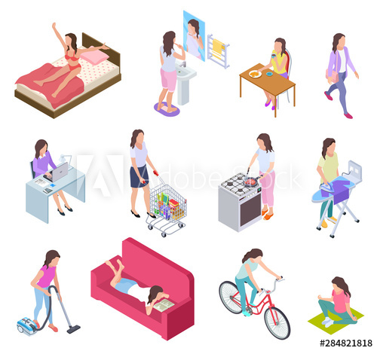  

**The Avoidance of Activity cycle**

Many people are concerned that they will make their pain worse or hurt themselves in some way and become fearful of doing things. They avoid lots of activities and do very little to try and keep their pain low. They may give up their normal roles at home and work and stop hobbies, leisure activities and socialising. Instead they rest and sleep more.

Many people spend a lot of time worrying about what is causing their pain and what might happen to them in the future. Common thoughts that people have that lead them to stop activity include:

* I am in pain so there must be something wrong, I must be damaging myself
* The doctor said there is a problem with my back so I need to wait for it to be fixed before I do things again
* I am in too much pain to do anything. I need to wait until it is better before I do anything.

Avoiding activity is a common sense response to pain. Pain is not nice. That is why it is so effective. It is there to stop us. This is very helpful in an acute pain situation, where the pain is a sign of damage because, for example, we have broken a bone or had an operation so our bodies need time to heal. But, when pain persists long beyond the time of healing then prolonged rest will do more harm than good. Persistent pain is a sign that your body and brain have become hypersensitive and overprotective, but it is NOT a sign of damage. Maintaining a consistent level of activity and trying to do as much as possible is essential to managing persistent pain.

**Managing your daily activities**

Living with persistent pain is difficult, to say the least. Pain can wear you down. At times it feels like life is sliding into a hopeless mess. You’re frustrated because you can’t do what you used to be able to do. You may feel like you have become a different person. You might be sleeping all the time or hardly sleeping at all. Your mood is low, your motivation disappears. You are grieving for the ‘old me’. You try to carry on as normal, hoping that your pain will go away, or perhaps you spend your time searching for a cure. Maybe you have given up work or you are doing less household tasks or fewer social activities. Maybe you spend most of your day resting.

When we are faced with such a difficult situation we naturally try our best to deal with it. Of course, some of the things we do are helpful and others can be unhelpful, especially in the long-term. As human beings we tend to respond to pain in a few common ways. There are two cycles of unhelpful behaviours that most people struggle with.

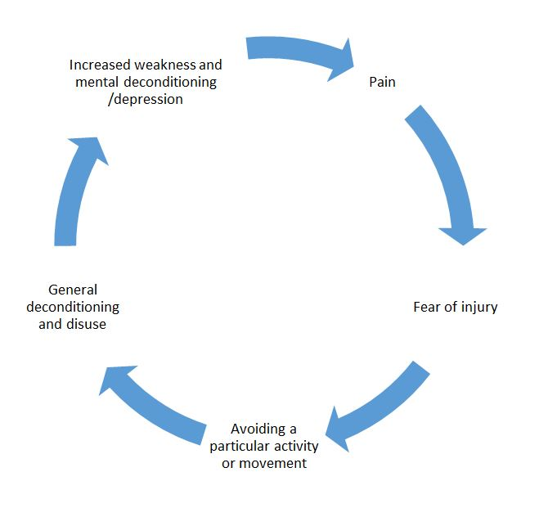

**The problems of avoiding activity**

While rest is a helpful way to reduce pain in the short-term, it is important to continue to do some activity. Our bodies are designed to move, so it is important to keep moving them so they stay healthy. If you are doing very little activity you will lose strength, stamina and flexibility. Lack of fitness makes muscles and other tissues tight and weak, and they then tire more easily when you do want to use them. This will lead to more pain. Furthermore, joints that don’t get moved regularly become stiff and tighten up which will cause movement to be painful. In time, your balance and coordination are affected and your weight may increase. When people are doing very little they will start to feel increased levels of fatigue and start to sleep more. Your heart and lungs become less efficient. You will lose confidence in your abilities and start to feel low in mood and motivation. The less you do, the less you want to do. This is a very vicious cycle that we want to avoid as it only serves to increase your existing pain levels.

Patient Information Leaflet for: Pacing Author/s title: Lucy Reeve Approved by : PIF

Date approved: 06/04/2021 Review date: 03/06/2022 Trust Docs ID: 17489 Page 3 of 18



**Over activity and Under activity cycle (Boom and Bust!)**

It is natural to use pain as a guide. To many people it seems sensible to make plans and do things based on the amount of pain they are in at the time. We all tend to ‘tune in’ to our bodies to see how much pain we are in before we decide what we are going to do. But, when we are guided by pain levels this can lead to a pattern of over activity followed by under activity. We call this pattern ‘Boom or Bust’. When pain levels are low people get out their ‘to do list’ and keep going with activity until they feel pain, then they stop, are forced to rest, maybe take some pain medication and wait for the pain to ease. Then once the pain eases a little they try again, until the pain stops them again. This pattern of over- activity followed by rest happens again and again.

Whenever people have a good day, or a time when pain levels are low they try to make up for lost time, catching up on all of the things they couldn’t do when their pain was high, and end up overdoing it again. Some people try to cram in as much activity as possible first thing in the morning before the pain kicks in and forces them to rest, or rush through activities as fast as possible. Unfortunately, over time the peaks of activity tend to reduce and the time it takes to recover increases. With time pain chips away at all the activities we do until we are doing less and less and needing more and more time to recover. If this happens again and again many people feel frustrated because they are not able to do things as easily as they used to do and they start to fear and avoid more and more activities.

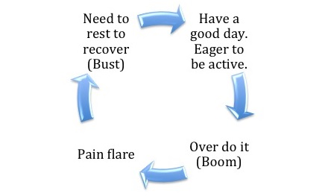

Patient Information Leaflet for: Pacing Author/s title: Lucy Reeve Approved by : PIF

Date approved: 06/04/2021 Review date: 03/06/2022 Trust Docs ID: 17489 Page 4 of 18



This is what it looks like on a graph:

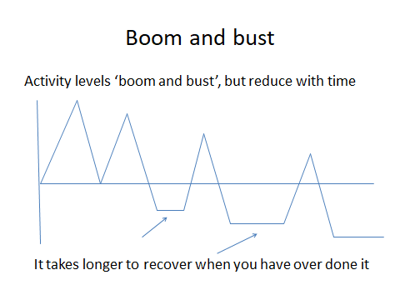



We often refer to activities that lead to a long recovery time as ‘expensive’, because they cost you. If you spend an hour doing your hoovering and then you are in so much pain that you are forced to rest for the next two days this is an expensive use of your time. You have actually spent two days hoovering. If you push yourself to do a couple of hours in the garden and then can’t really do much for the rest of the week, then again you have effectively spent a week gardening.

People get stuck in this ‘Boom and Bust’ cycle for a number of reasons.

1. Firstly, as we said above, it is human nature to make decisions about our activities depending on how we are feeling at the time. When we feel fine, physically and emotionally, we naturally just keep doing what we are doing. This is what we call the ‘lure of a good day’. Unfortunately, there is a fine line between doing the right amount and pushing things too far and it is easy to suddenly find you have done too much. Your pain does not always kick in until much later in the day or perhaps the next day. Pain is a very unreliable indicator of how much you can do.
2. Secondly, it feels good to complete an activity. There is that sense of achievement when you can tick something off your ‘to do list.’
3. Some people have a strong sense of ‘not letting the pain beat them’. They fight their pain and tend to keep going with activities despite it increasing.

Patient Information Leaflet for: Pacing Author/s title: Lucy Reeve Approved by : PIF

Date approved: 06/04/2021 Review date: 03/06/2022 Trust Docs ID: 17489 Page 7 of 18



**Pacing**: Knowing your limitations and being realistic about how much you can do, never pushing yourself to your limit and having regular breaks to recover

**Planning**: Rather than allowing pain levels or how you feel to dictate what you do on the day, make a plan of action for the week

**Prioritise**: Pain places limitations on you. You can’t do everything so you need to make sure you are doing the most important things

**Problem Solving**: Working out the most easy and efficient way of doing things

1. Some people put on a brave face and keep battling on, because they don’t like to ask for help or delegate to other people.
2. Some people try to block out their pain or try ignore it by getting busy. Activity is often enjoyable and distracts us from the pain and we may get very involved in an activity and lose track of time.
3. Many people have had very active lifestyles before they had their pain. They like to be busy and find it difficult to switch off and relax.
4. Others have a tendency to prioritise the needs of others; and use their energy helping other people, such as family, friends and work colleagues.
5. Some people are perfectionists who like to get a job done to a high standard. This means they find it difficult to do only part of a task, or to attempt activities when they are not able to give their best. We often have rules about how things ‘should’, ‘must’ or ‘ought’ to be done.
6. Many people tell us that they feel guilty when they think that they are ‘doing nothing’, especially if the people around them are busy.

Unfortunately, the ‘boom and bust’ pattern of activity is one of the biggest risk factors for maintaining and increasing your pain. Every time you do too much and flare your pain up it reinforces it and makes it worse. Constantly flaring up your pain increases the sensitivity of your brain and nervous system and it will take longer and longer to settle down again. Your brain will learn to associate certain activities with increased pain so there will be more and more activities that you start to avoid which will lead you into the Avoidance Cycle we talked about above.

**How to manage your activity – Activity Pacing**

Activity Pacing is an essential skill for managing the ‘Boom and bust’ and Avoidance Cycles. The goal of pacing is to find a consistent level of activity that you can safely manage every day. A level that does not make your pain worse. Pacing gives you more control over your pain and enables you to achieve more.

There are a number of key strategies involved with Activity Pacing.

They are the **4 Ps**:



Patient Information Leaflet for: Pacing Author/s title: Lucy Reeve Approved by : PIF

Date approved: 06/04/2021 Review date: 03/06/2022 Trust Docs ID: 17489 Page 6 of 18



Patient Information Leaflet for: Pacing Author/s title: Lucy Reeve Approved by : PIF

Date approved: 06/04/2021 Review date: 03/06/2022 Trust Docs ID: 17489 Page 7 of 18

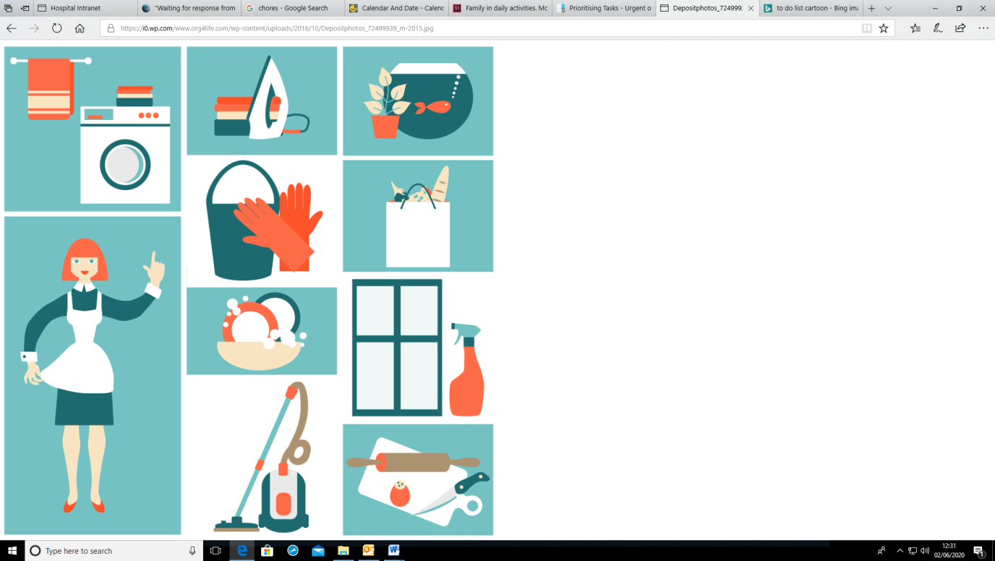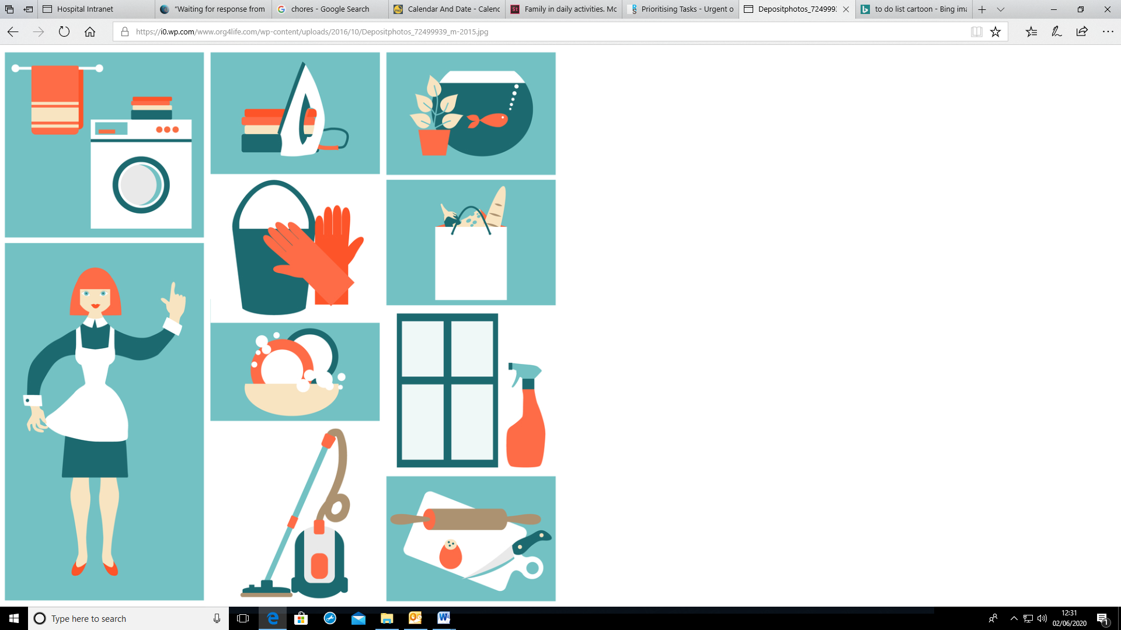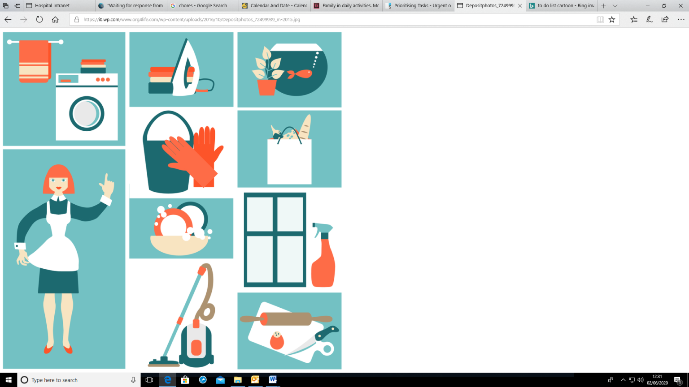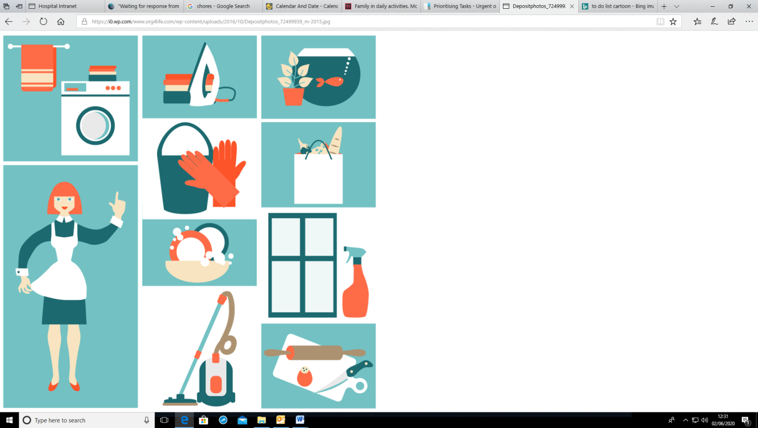

**PACING**

Firstly, let’s look at the idea of pacing. Pacing involves:

* Knowing your limitations. Knowing how much of an activity you are physically capable of doing without flaring your pain.
* Stopping before your pain tells you to.
* Doing less, more often. Doing small manageable amounts of activity regularly.
* Using time or distance not pain as a guide
* Having a balanced pattern of varied activity each day/week
* Changing your posture regularly from sitting, to standing and moving
* Having regular ‘recovery breaks’
* Doing the same or similar levels of activity every day – rather than over doing it on good days…or underdoing it on bad days!
* Carrying out activity at a steady pace
* Doing some activity even at times when you don’t feel like it – for instance when you are tired, in pain or feeling down
* Steadily increasing the amount you do and the types of activity you do over time

**How do you pace yourself?**

Before you do anything else you need to learn about what is happening now. What is a typical week like? What do you do during a typical day?

Many people find it helpful to complete the ‘Activity Diary’ in the handout (See Appendix One), which is a timetable of what you do during the week. This increases awareness of what is happening at the moment. We are often completely unaware of how we spend our time. By filling in the diary you can start to see exactly what you are doing, how much you are doing and what impact this has on your pain levels.

Look at your daily routine. Start to notice if you spend all morning doing the same type of repetitive tasks. Start to notice if you always need a rest in the afternoon or whether some days seem busier than others.

Try to identify the activities, situations (and people!) that increase your pain or tire you out…the ‘energy vampires’; as well as those that boost your energy!

Also pay attention to the times when you don’t get any pain. What is happening then? What precedes these times? Are there activities that help your pain?

Perhaps you will notice that there are times when your energy levels naturally seem to be higher. Make a note of all these things because they are going to help you start to make helpful changes in your life.

Patient Information Leaflet for: Pacing Author/s title: Lucy Reeve Approved by : PIF

Date approved: 06/04/2021 Review date: 03/06/2022 Trust Docs ID: 17489 Page 8 of 18

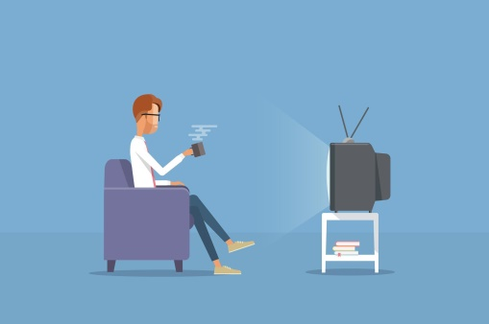

When you know what is happening at the moment you can start to change how you do things.

1. Pick a situation or activity where you always ‘overdo it’ or an activity that you have stopped doing
2. Figure out how much you can do without causing a flare-up of your pain. This is called your ‘baseline’. Always start with an amount of activity that is smaller than you think you can manage. It is easy to overestimate your own capabilities. It can be helpful to start with an amount that you could manage even on ‘bad’ days. That way you know you will be able to easily do it.
3. Please note: Your baseline will vary for different activities.
4. Break your activities up into manageable chunks using your baseline as a guide, for example, you might break your ironing up into chunks of 20 minutes, and your hoovering up into 10 minute chunks, and sitting at your computer into 30 minute chunks. If we break tasks into smaller chunks we can still get that sense of achievement from completing a task.
5. Use a ‘timer’ for pacing your activities so you don’t go over the time you have set for yourself. Don’t use your levels of pain or fatigue to tell you when to stop. You need to break BEFORE you need a break! You need to stop when you still feel ok. This is really difficult because we tend to use how we feel to guide our activity, so if you still feel ok it is likely that you will think something like ‘I could do a bit more...I still feel ok...I really want to finish this’. But, often it is just that bit more that tips you over the edge into pain or exhaustion. It is also easy to get engrossed in the task and go over the limit that you have set yourself.

1. Remember: Always stick to your baseline even when you are having a good day and feel you could do more.
2. Stick to your baseline for a few days until you feel confident you have got it right. Once you are confident that the amount you are doing is ok, and your pain has been stable for a few days you can start to slowly increase it a little at a time. Do not be tempted to increase too quickly! Just increase by a minute or two at a time.
3. Balance chunks of activity with rest. Take frequent short rests in between activity to recover, rather than having one long rest after you have finished doing something. Resting can be surprisingly hard to do. Many people see it as a sign of weakness or failure to cope. Try renaming it: ‘Recovery time’.
4. Recovery breaks don’t have to be actual rest. Having a stretch or a drink or snack; listening to some music; putting a hot water bottle on your back; doing a relaxation technique or some exercise or chatting to a friend can be effective for some people. Do whatever you know helps you.
5. Change task and position regularly - Our body gets very tired and uncomfortable if it is one position all the time or doing a repetitive task; so, make sure you change your task regularly, and vary between sitting, standing and moving throughout the day. Remember the old sayings: ‘Change is as good as a rest’ and ‘Variety is the spice of life’.
6. Some people set their watch or phone alarm to go off every 15 mins to remind them to change the job they are doing or their position.



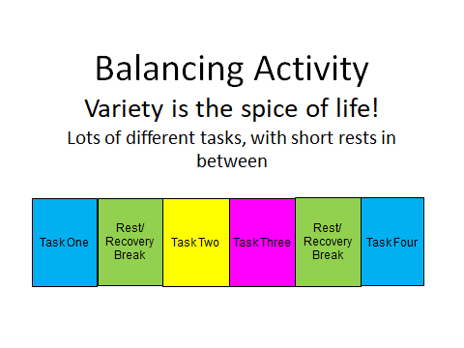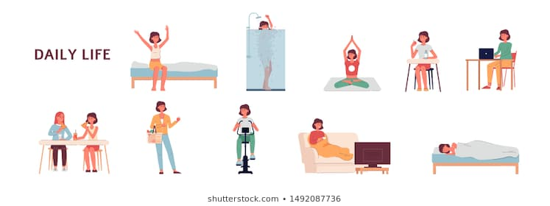

Balancing Activity  
Variety is the spice of life!  
Lots of different tasks, with short rests in between

Patient Information Leaflet for: Pacing Author/s title: Lucy Reeve Approved by : PIF

Date approved: 06/04/2021 Review date: 03/06/2022 Trust Docs ID: 17489 Page 9 of 18

**PLANNING**

To make sure that you pace yourself and are not guided by your pain or how you feel on the day you need to make an effective plan of how you are going to carry out the tasks you want to achieve over the course of the week. Planning your life may sound like a hassle you don’t want but you would be surprised how much easier it makes your life. Some people like to use the ‘Activity diary’ as an ‘Weekly Planner’. Some people use their electronic devices, but even the back of an envelope will do. The main thing is that you can see your week planned out in front of you.

Here are some ideas about how to use planning to make your life easier and ensure that you pace yourself:

1. Stick to a routine. Having a daily routine gives your day structure. It provides a framework to build tasks around. Start with a regular time that you get up every morning and go to bed. Set regular times for meals and rest breaks. Then fit all your other daily tasks around this framework.
2. Plan your rest - Where and when will you integrate rests into your day so that they work best for you? If you don’t timetable them in it is likely you will not stop for a break!
3. Plan your ‘recovery breaks’! Plan in all the things that you do that help to reduce your pain and boost your energy. Perhaps going for a massage or doing a relaxation technique helps? Don’t wait until you are in a lot of pain and desperately need them, plan them in as part of your routine.
4. Make sure heavy and demanding tasks are spaced out throughout each day or week. Alternate heavy tasks with lighter, easier tasks. Plan out changes of task and position. Keep your activity levels fairly consistent so that one day is not more tiring than another.



Patient Information Leaflet for: Pacing Author/s title: Lucy Reeve Approved by : PIF

Date approved: 06/04/2021 Review date: 03/06/2022 Trust Docs ID: 17489 Page 10 of 18

1. Plan for overload – sometimes you will look at your week and see a day that is just going to be a nightmare of over-activity and there is nothing you can do about it. Firstly, don’t panic. Sometimes you simply have to get through the overload. Be realistic about what breaks, however small you might fit into the day, and what help that you might be able to get. Can you plan to have quieter days before hand to help you rest prior to the event or afterwards to help you recover?
2. Pick the ‘best time’ to do something. Are there times of the day when you are at your best? If so, then that might be the time to do the most demanding activities, and leave the times when you have less energy for easier tasks.

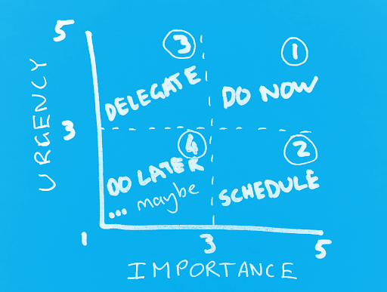

**PRIORITISING**

The idea of having to make decisions about what you can and can’t do may be very hard. But it is vital! We all fondly remember ‘old me’, who used to be able to do everything they wanted. But when we can’t do everything, we need to make sure that what we are doing is a good use of our limited time and energy.

Take a closer look at your usual ‘to do list’. Consider all the jobs you do during a typical day/week. You might want to think about things that you are no longer doing but would like to do, or might be beneficial for you.

Ask yourself the following questions:

1. Does this need to be done at all? Could some jobs be cut out of your daily routine or done less often?
2. Does it need to be done today? How important is it? Try and put activities in order of priority so that those that must be done are completed first, before your energy is running low.
3. Does it need to be me who does it? Are there some jobs, or parts of jobs that could be done by other people? This might be family, friends or paid help. Is this task your responsibility? Remember that learning to say ‘no’ is an important part of taking control over your time and energy. Consider outside help for certain tasks that you find difficult. For example, could you pay someone to do the ironing, cleaning or gardening?
4. What about fun? When people have limited comfort and energy they often stop doing the things that used to give them pleasure, such as seeing friends or doing hobbies. Many people feel they should give all their time to work, household tasks, or their family. However, tasks that provide you with fun and enjoyment can lift your mood and boost your energy, so it helps to include them.

If you eliminated some tasks from your ‘to do’ list it might lead to a big improvement in your overall pain levels, and there might be tasks that should be added into your week because they would help you. So, think, for each task ask yourself:

Will you **‘Do it, Dump it, or Delegate it?**

Patient Information Leaflet for: Pacing Author/s title: Lucy Reeve Approved by : PIF

Date approved: 06/04/2021 Review date: 03/06/2022 Trust Docs ID: 17489 Page 11 of 18

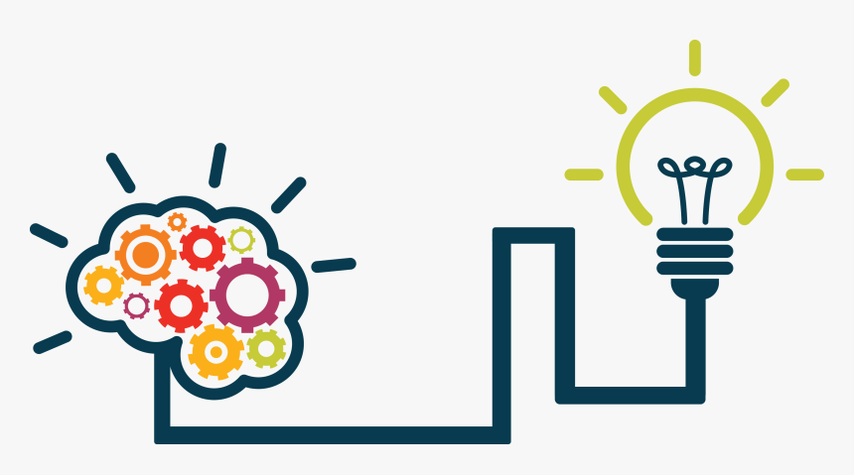

Patient Information Leaflet for: Pacing Author/s title: Lucy Reeve Approved by : PIF

Date approved: 06/04/2021 Review date: 03/06/2022 Trust Docs ID: 17489 Page 12 of 18

**PROBLEM SOLVING**

If you have noticed that you always tend to overdo certain tasks or that some jobs always cause you problems then ask yourself:

* How can I do this differently?
* How can I make this easier?

For every task there are alternative ways to do it and this could reduce the amount of pain and fatigue that you experience. Start to look carefully at how you do certain activities. You can always change the situation to make it better. You may find the following categories help you with your problem solving.

1. **Environment**

The environment you live in can help or hinder what you are doing. Start looking around you and thinking about your home, work and garden. Ask yourself:

Have you got things you need in the most convenient place to carry out the task?

Are things at the right height for you?

Are your chairs, bed or toilet suitable for you?

Is your environment cluttered? Is it easy to clean and maintain?

1. **Equipment**

The tools we use to carry out tasks can make a huge difference as to how easy or difficult they are for us to do. Ask yourself:

Can you use gadgets or labour-saving equipment or technology to make tasks easier? The Disability Living Foundation www.dlf.org has a wealth of information about equipment that is available to help with all the tasks we do.

Do you have the most effective equipment for this task? The type of hoover you use, the types of kitchen utensils or gardening equipment you have are all going to make a difference to how easily you can carry out a task.

Are there any ‘materials’ e.g. alternative cleaning products that would make it easier? For example, spray foam cleaning products, e-cloths. Are your clothes made from non-iron, easy care fabrics?



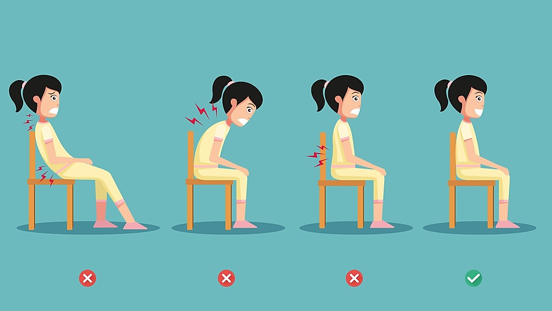

Patient Information Leaflet for: Pacing Author/s title: Lucy Reeve Approved by : PIF

Date approved: 06/04/2021 Review date: 03/06/2022 Trust Docs ID: 17489 Page 13 of 18

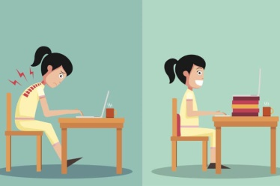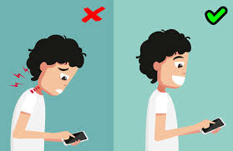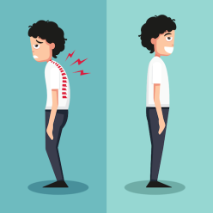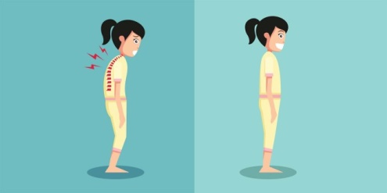

1. **Technique/Posture**

We often carry out routine daily tasks automatically with very little thought. When we are not paying attention to how we are doing tasks then it is easy to get into bad habits. When people have pain they often adopt different postures in order to try and keep themselves comfortable. Some people will ‘brace themselves’, literally, and do things in a tense and careful way for fear of triggering their pain.

Unfortunately, in the long run this can lead to more pain, more tension and pains in other areas. So, start to pay attention to how you are doing things. Are you:

* Bracing/tensing?
* Stooping, twisting, or bending?
* Adopting a lop-sided posture when you stand, sit or move?
* Rushing to finish?
* Staying in one position for long periods of time?

It is important to have a good posture when you are sitting, standing or moving about. If you want advice regarding this you can speak to one of our Physiotherapists. As mentioned above in the pacing and planning sections we need to make sure that we change our posture and position regularly, and make sure we stretch and move often. If you notice that you are very tense then it would be helpful to learn relaxation techniques. There are some handouts on this subject and you can speak to one of our therapists for more advice about this.



Patient Information Leaflet for: Pacing Author/s title: Lucy Reeve Approved by : PIF

Date approved: 06/04/2021 Review date: 03/06/2022 Trust Docs ID: 17489 Page 14 of 18

1. **Other people**

It is also important for relatives, friends and employers to understand your problems and the principles you are following to manage your pain more effectively. This will enable them to help you make adjustments to your lifestyle. However, it is difficult for the people around you to really understand what you are experiencing. They are not inside your body, and unless they have a similar problem then they will not understand about your pain. They are not being uncaring or awkward. We all know how hard it is for any of us to put ourselves into the shoes of another person. This can mean that they will not always provide the support you might want them to. What can you do about this to improve the situation?

1. Talk to people about your situation and the specific problems you are having. Give them written information about persistent pain and encourage them to read it so they understand.
2. If you are planning on making changes to the way you do everyday activities discuss it with them so they know what you are doing and can support you. Other people cannot mind-read our thoughts. If we need their help with an activity, we need to ask for it.
3. Buddy up! You might be able to do most of a task but need help with specific elements, or need to share the task with someone. Perhaps you can get dressed but need help with your socks. Maybe you can change most of the bed but need help to change the duvet.
4. Look to see how other people do tasks that you find difficult. Would their way be easier for you? Brainstorm ideas about how to make tasks easier with your family and friends. Two heads are often better than one when it comes to problem solving.
5. As mentioned above, you might need to delegate some tasks to other people. Sometimes you will find that you are doing tasks that are actually someone else’s responsibility. Perhaps people can iron their own clothes or tidy up after themselves? Have a family rota for household tasks so everyone is helping and the responsibility does not all fall to one person.
6. If it is possible, then pay someone to do tasks that you find really difficult or don’t like doing. Tasks such as cleaning, ironing or gardening for example. Save your energy for tasks that are more important for you, or that you really enjoy doing.



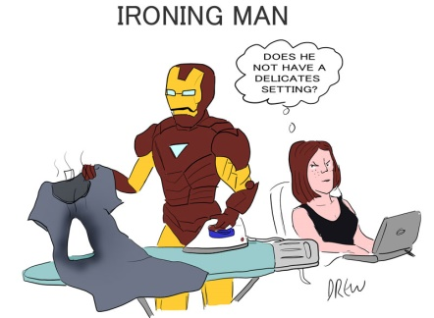

Patient Information Leaflet for: Pacing Author/s title: Lucy Reeve Approved by : PIF

Date approved: 06/04/2021 Review date: 03/06/2022 Trust Docs ID: 17489 Page 15 of18

**Putting it all together**

Here is an example of using the ‘4 Ps’ to carry out the task of ironing more effectively. At the moment, it might be your normal routine to do all the ironing on a Monday afternoon, and you can no longer do this. Rather than avoiding the ironing you need to change the way you do it. There will be many ways that you can change how you do the task to improve the situation. For example, you could:

* Do a little every day, e.g. 20 minutes, or just iron what you need for the next day
* Alternate ironing with all the other tasks that you do on Monday so you change your task and position regularly
* Have a break halfway through, put a heat pack on your back and have a coffee.
* Do it in the morning at 11am after a coffee break when you are at your best
* Use a perching stool/chair to sit and do it
* Buy a lighter iron and use the steam option
* Check the height of your ironing board so it is correct for you
* Rock or sway so you are moving while ironing, rather than standing in a fixed position. You might even move in time to some music!
* Delegate some of it to other family members i.e. everyone is responsible for ironing their own clothes
* Start taking this approach to all activities. By becoming a problem solver and developing new ways of doing things you can really make a difference.

Have a look at Appendix Two, which summarises all of the information on the 4Ps together.



Patient Information Leaflet for: Pacing Author/s title: Lucy Reeve Approved by : PIF

Date approved: 06/04/2021 Review date: 03/06/2022 Trust Docs ID: 17489 Page 16.of 18

**Changing your activity - It’s simple, but it’s difficult**

The advice provided in this handout, is not complicated, it probably sounds like common sense. On paper, Activity Pacing sounds simple. It is simple, but that doesn’t mean it isn’t difficult to do. It involves changing the way you live your life, and making change to our existing habits can be challenging. The unhelpful cycles that we talked about at the beginning of this handout are difficult to get out of.

Many people with persistent pain have low mood and little energy, which makes it hard to find the motivation to change. Everything feels like it is all too much effort. Some people resent having to change. They think “I like my life how it was before I had this pain. I want the ‘old me’ back, I want my pain to go away! I don’t want to change.” Some people are concerned that doing things differently might make their pain worse. But, the benefits of changing how you do your daily tasks are enormous. They are the key to getting your life back. They are the way to do more and improve your physical and mental health.

The key is to start small! Start by just making tiny changes. Remember we want you to do less...more often. Treat every day like an experiment where you try out different ways of doing things and see what makes a difference.

If you want advice about how to manage your everyday activities there is lots of help available. Ask if you can talk to one of our Occupational Therapists at the Pain Management Centre.

**Appendix 1**

Activity Diary/Weekly Planner

|  |  |  |  |
| --- | --- | --- | --- |
| Day | Morning | Afternoon | Evening |
| Sunday |  |  |  |
| Monday |  |  |  |
| Tuesday |  |  |  |
| Wednesday |  |  |  |
| Thursday |  |  |  |
| Friday |  |  |  |
| Saturday |  |  |  |

Patient Information Leaflet for: Pacing Author/s title: Lucy Reeve Approved by : PIF

Date approved: 06/04/2021 Review date: 03/06/2022 Trust Docs ID: 17489 Page 17 of18



Patient Information Leaflet for: Pacing Author/s title: Olivia Sutton Approved by :PIF

Date approved: 03/06/2020 Review date: 03/06/2021 Trust Docs ID: Page 1 of 2

Patient Information Leaflet for: Pacing Author/s title: Olivia Sutton Approved by :PIF

Date approved: 03/06/2020 Review date: 03/06/2021 Trust Docs ID: Page 1 of 2

Patient Information Leaflet for: Pacing Author/s title: Olivia Sutton Approved by :PIF

Date approved: 03/06/2020 Review date: 03/06/2021 Trust Docs ID: Page 1 of 2

**Appendix Two**

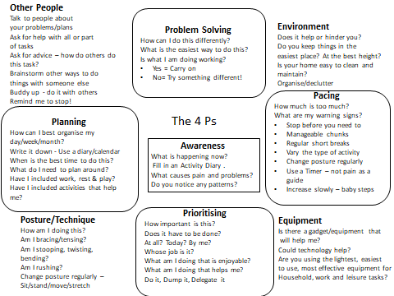Summary of the 4Ps

Patient Information Leaflet for: Pacing Author/s title: Lucy Reeve Approved by : PIF

Date approved: 06/04/2021 Review date: 03/06/2022 Trust Docs ID: 17489 Page 18 of 18