

**Practical Advice**

**for Managing Daily**

**Activities**



Patient Information Leaflet for: Managing every day activity Author/s title: Lucy Reeve, Olivia Sutton Approved by : PIF

Date approved: 23/07/2020 Review date: 23/07/2022 Trust Docs ID: 17680 Page 1 of 35



**This advice leaflet** looks at some of the everyday activities that we do and offers some suggestions about how they may be carried out more easily and comfortably, using less energy. This leaflet does not provide an exhaustive list of ways to carry out your daily tasks, it just provides some suggestions that you might find helpful. The key is to keep experimenting with the ways in which you do tasks, in the hope that you will find easier ways that work best for you, in your own environment.

First, here are some general principles that can be applied to all situations:

**Adapting your environment –**

* Make sure all surfaces are the correct/best height for you to work at. You can raise or lower work surfaces to make them more suitable. Also think about the height of cupboards, especially those that you use often.
* Good lighting will help to reduce eye strain and improve concentration and make it easier and safer for you to carry out tasks. It will also increase safety if your stairs, hallway and landing are well lit.
* Make sure you have enough space to move around your home. Can you easily move from room to room and in between the furniture? Consider decluttering and getting rid of any items that are no longer needed.
* Consider removing loose mats or carpets that might be difficult to walk over and could be a trip hazard.
* Good ventilation is important to reduce heat, which can often sap your energy, especially in a kitchen when the oven is on or in the bathroom when you are having a bath or shower.



Patient Information Leaflet for: Managing every day activity Author/s title: Lucy Reeve, Olivia Sutton Approved by : PIF

Date approved: 23/07/2020 Review date: 23/07/2022 Trust Docs ID: 17680 Page 2 of 35



* Lever taps, or other easy to use models can be fitted in the kitchen, utility and bathroom. You can also fit tap turners onto existing taps. See the Living Made Easy website (web address on page 34 of this booklet).
* Organise tools, materials and the work area before you start an activity. If you collect together everything that you will need to do your task before you start then it makes the task much easier.
* Think carefully about where you store things – are they within easy reach?
* Have a specific area for each job. For example, somewhere where you work, or do your washing, or ironing. Store the equipment you use for these tasks there for immediate use. For example, have a tea-making area with teabags, kettle, and mugs in place; washing powder next to washing machine; bleach next to the toilet and so on.
* Think about the height of electrical sockets. Many people find that raising sockets makes them easier to use if you have difficulty bending down. Sockets can be raised with an extension cable or you can get an electrician to rewire them. You might not need all of them done, just the ones that you use often.
* Plugs with large hand grips or stick on plug grips are available to make plugs easier to pull out.

****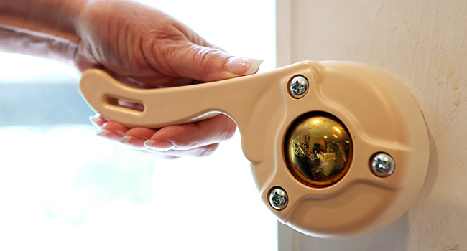

Patient Information Leaflet for: Managing every day activity Author/s title: Lucy Reeve, Olivia Sutton Approved by : PIF

Date approved: 23/07/2020 Review date: 23/07/2022 Trust Docs ID: 17680 Page 3 of 35

Patient Information Leaflet for: Managing every day activity Author/s title: Lucy Reeve, Olivia Sutton Approved by : PIF

Date approved: 23/07/2020 Review date: 23/07/2022 Trust Docs ID: 17680 Page 4 of 35

* Think about the type of handles you have on your doors. Are they easy for you to turn or open? The same thing applies to the handles on your cupboards and drawers throughout the house. Sliding doors on cupboards might be easier.
* Light switches are easier to use if they are the large rocker switch, pull-cord or touch operated type
* Built up key handles and key grips are available to help you use your front and back door keys more easily.
* If you are buying new equipment, for whatever task, research the market to know what options are available so you can consider which might work best for you. Get the equipment that suits your needs rather than first considering cost or the best looking. Always try before you buy! There are many different pieces of equipment and gadgets on the market that manufacturers will tell you are the best thing...but, you need to test it out for yourself to decide if that is true. Try several options and don’t be rushed into a decision.



****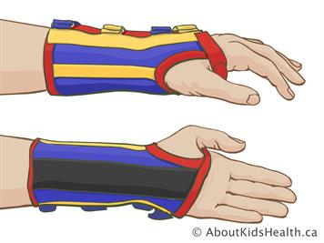****

Patient Information Leaflet for: Managing every day activity Author/s title: Lucy Reeve, Olivia Sutton Approved by : PIF

Date approved: 23/07/2020 Review date: 23/07/2022 Trust Docs ID: 17680 Page 5 of 35

* Many items of equipment can be activated by remote control nowadays. You can connect equipment up to your iPad or Smart Phone or have a remote controller that operates a variety of tasks. Some people have an Alexa, which can operate a number of systems in their homes. Heating, lighting, opening and closing curtains are just a few of the tasks that can be operated remotely.
* Remote controls with large buttons and modified grips are available
* Always consider your safety. Fix a second bannister on the stairs. Grab rails near front and back door, by the bath, shower or toilet can be helpful
* You might find it helpful to use hand splints to support your hands and wrists when you are doing heavy or repetitive tasks. Talk to your Occupational Therapist or Physiotherapist about whether this might help you

Patient Information Leaflet for: Managing every day activity Author/s title: Lucy Reeve, Olivia Sutton Approved by : PIF

Date approved: 23/07/2020 Review date: 23/07/2022 Trust Docs ID: 17680 Page 6 of 35

**Stair Lifts and Homelifts**

Stairs are often difficult to manage but if you are struggling to use them it doesn’t automatically mean you need to go to the hassle and expense of moving to a bungalow or ground floor flat!

1. Option One - change the way you live in your present home. You might want to consider if you can live on the ground floor. This is a good option if you already have a ground floor toilet/bathroom and can easily convert one of your downstairs rooms into a bedroom.
2. Option Two – install a stair lift. You will need an assessment to see if this is suitable for your home, and whether you could use it safely given the health issues you have. It can be best to have an Occupational Therapist to do a home visit and assess whether this is a good option for you rather than going straight to a private company but, if you do want to do it yourself, or you are not eligible for funding then there are a number of options on the market. Always choose a reputable company who are used to installing these. Often the local council can recommend companies who they use themselves.
3. Option Three – install a Through-floor lift. If you use a wheelchair to get around your home and would have difficulty getting onto and off a normal stairlift safely then you might want to consider a through-floor lift. These operate much the same as a lift you would find in a department store. Once again get professional advice.





**Adopt a good posture**

* Try to maintain an upright and symmetrical posture during all tasks, check that the work surfaces are the right height for you.
* Rest on a perching stool if necessary while carrying out tasks that normally require you to stand. For example, when you are working in the kitchen, or doing your ironing, or for sitting to have a strip wash at the sink
* Use a high-back chair that supports you while carrying out tasks in sitting, for example, when eating or using a computer.
* **Choosing a chair** - Consider the chairs that you regularly sit on. Are they comfortable? Do they support your back and neck in a good position? Do you get more aches and pains after you have been sitting for a while? Are they the right height? If you don’t want to change your existing chair then it might be possible to raise it using chair raisers that fit over the legs. Ask your Occupational Therapist for advice. There are literally thousands of easy chairs on the market and many claim to be specially designed for people with health problems. You can buy riser recliner chairs that are operated by remote control and help you get up and down from your chair. The golden rule when buying a new chair is: **Try before you buy**! Don’t be harassed by sales assistants, take your time. The Disabled Living Foundation is a useful website to help guide you. There is a factsheet that provides advice for choosing a new chair. (Web address on page 34 of this booklet).
* A reaching stick or ‘grabber (pick up stick) helps you to pick things up from the floor without reaching down. You can also use it to get things out of the back of awkward cupboards, or if you have lost something behind a radiator, under the bed or similar.

Patient Information Leaflet for: Managing every day activity Author/s title: Lucy Reeve, Olivia Sutton Approved by : PIF

Date approved: 23/07/2020 Review date: 23/07/2022 Trust Docs ID: 17680 Page 7 of 35

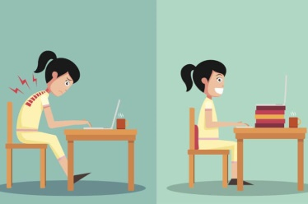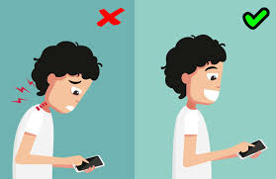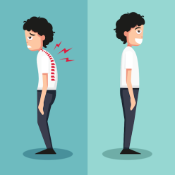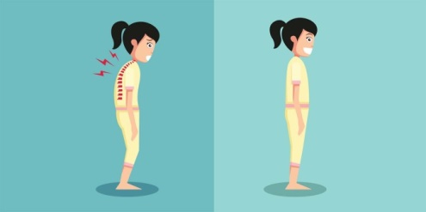



Patient Information Leaflet for: Managing every day activity Author/s title: Lucy Reeve, Olivia Sutton Approved by : PIF

Date approved: 23/07/2020 Review date: 23/07/2022 Trust Docs ID: 17680 Page 8 of 35

**Personal care**

*Getting dressed*

Getting dressed can be a time-consuming and tiring activity!

* It is usually easiest to sit down to get dressed whenever possible, either on the bed or a suitable chair.
* Collect all your clothes together before you start
* Choose clothes that are loose and ideally do up at the front so that they are easier to put on and take off. Casual clothes and lightweight fabrics are often easier to wear.
* Put your pants and trousers over your feet at the same time and pull them up together. Put skirts on over your head. When you are putting on shoes and socks it can help to sit and cross one leg over the other to bring your foot closer to you.
* Pay attention to the type of fastenings that are on your clothes as some are easier to use than others. Larger buttons, chunky zips and velcro are easier to use than fiddly buttons or hooks. Loop a piece of ribbon or similar through small zips to help you pull them up. There are also button hooks that might be useful (although they tend to be used for bigger buttons). There are extendable loops that can be used on the fastenings of your trousers and bra that make it easier to take tighter items on and off.



* Equipment may be helpful, there are many gadgets available, for example:
  + Long-handled shoehorns
  + Dressing sticks, which have a hook at one end and a rubber thimble at the other. You can use the hook end to help you pull clothing over your feet and you can use the rubber end to push shirts, tops and jumpers off your shoulders and socks off your feet
  + Sock aids are available so you can sit to put your socks on. they will hold the sock open while you push your foot into it. They have long tapes attached to then help you to pull it up your leg.
  + You can even use a grabber (pick up stick) to help will dressing your lower half. You can clasp it around the legs of your pants, or use it to hold onto your trousers while you lower then down to your feet
* Most people like to be independent in personal care tasks but sometimes getting someone else to help can prevent you struggling and using up all your energy.
* See the Disabled Living Foundation for more information, there are specific sections for clothing and footwear. (Web address on page 34 of this booklet).

**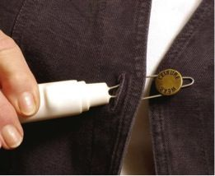

Patient Information Leaflet for: Managing every day activity Author/s title: Lucy Reeve, Olivia Sutton Approved by : PIF

Date approved: 23/07/2020 Review date: 23/07/2022 Trust Docs ID: 17680 Page 9 of 35



*Bathing*

* Consider when to take baths, as they may increase your fatigue. It is best to have a bath prior to going to bed as this often helps you feel tired and relaxed and helps you sleep.
* A non-slip mat in the bath or shower will give you more grip and increase your safety. Grab rails, a bath board and seat or a powered bath seat lift might enable you to continue to have a bath if you prefer it to a shower. Another possible option is a special walk-in bath, although this is an expensive option.
* Many people decide to change their bath to a shower. The following options can help even further. Grab rails can help you get into and out of the shower easier and increase your safety while standing. You can have a shower stool or use a wall mounted shower seat if your shower is suitable. Even a plastic garden chair can be used in some showers. If your shower is over the bath then you may find it safer to sit on a slatted bath board placed across the bath. Walk-in showers are easier than over bath showers, and many people find that having their bathroom (or another room) converted to a wet room or having a level access shower installed is helpful so there is no step into the shower to contend with.
* The Disabled Living Foundation has further information on bathing, and on showering. (Web address on page 34 of this booklet).
* Have a chair available or sit on the toilet to dry and dress yourself. Many people find that using a perching stool is helpful for having a strip wash near the sink
* You may find a good-quality towelling bathrobe allows you to dry yourself with less effort. You can put this on straight from the shower or bath. It is much easier than struggling with a bath towel.

**

Patient Information Leaflet for: Managing every day activity Author/s title: Lucy Reeve, Olivia Sutton Approved by : PIF

Date approved: 23/07/2020 Review date: 23/07/2022 Trust Docs ID: 17680 Page 10 of 35



**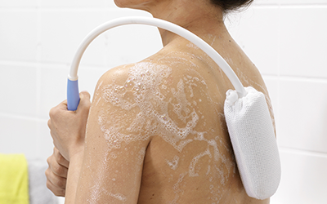

Patient Information Leaflet for: Managing every day activity Author/s title: Lucy Reeve, Olivia Sutton Approved by : PIF

Date approved: 23/07/2020 Review date: 23/07/2022 Trust Docs ID: 17680 Page 11 of 35

* You might find that a micro fibre towel helps as they are much lighter and you don’t have to rub yourself. They can be found in outdoor pursuit shops, or just look online.
* Lever taps or similar designs on the sink and bath are easier to use.
* Liquid soap with a pump dispenser is easier to use than a bar of soap
* Always consider how easy the products you buy are for you to open and use. Alternatively you can decant shampoo, shower gel and similar products into containers that are easy for you to open. You might put them into pump dispensers.
* Try dry shampoo
* Equipment may also be useful, for example:
  + A long-handled sponge, for reaching your back or your feet
  + A long-handled brush for reaching the back of your head.
  + A long flannel strap with hand rings/loops for drying your back and legs
  + A toothpaste squeezer to help you dispense your toothpaste
  + An electric toothbrush, or choose toothbrushes with chunky handles, or use foam pipe lagging (as for pens, cutlery etc)
  + A lightweight electric razor
  + Try fattening the grip on make-up pencils and brushes by wrapping an elastic band around them, or thin foam pipe lagging. You might be able to use the pen grips that you would use on a normal pen/pencil
  + Use a small make up sponge to apply face cream/moisturiser/foundation if you find it difficult to do it with your fingertips
  + Use a lightweight hairdryer or straighteners. You can get hairdryer holders/stands so that you don’t have to hold the dryer



****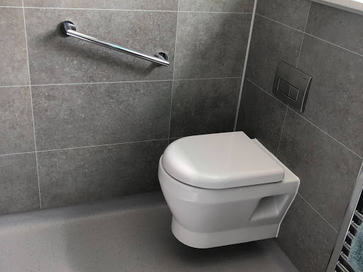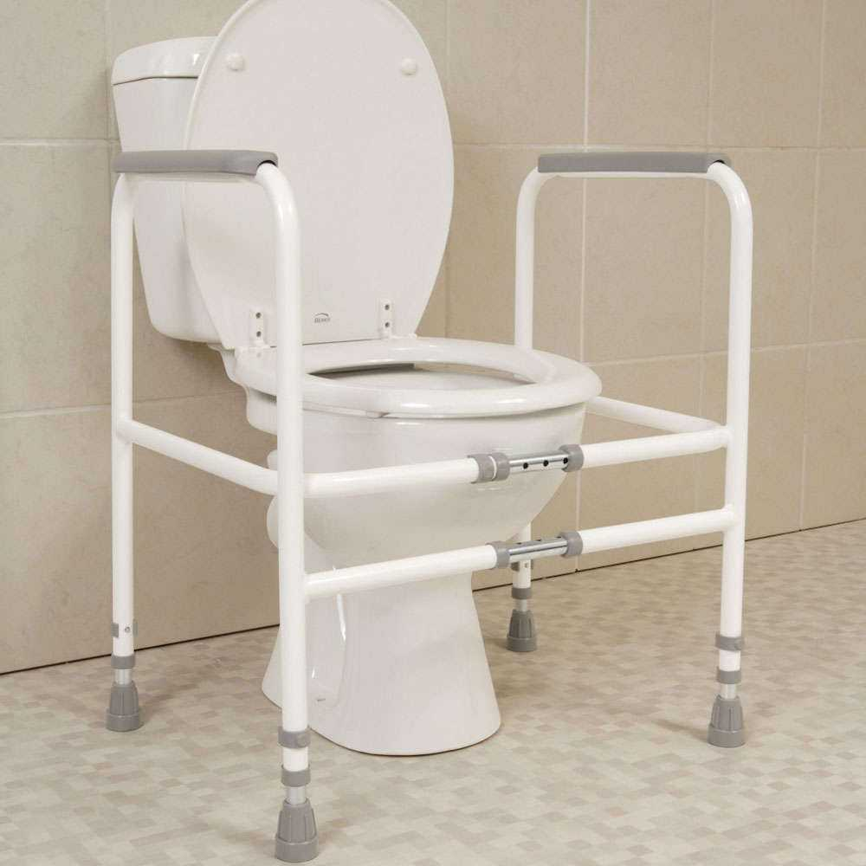

Patient Information Leaflet for: Managing every day activity Author/s title: Lucy Reeve, Olivia Sutton Approved by : PIF

Date approved: 23/07/2020 Review date: 23/07/2022 Trust Docs ID: 17680 Page 12 of 35

*Using the toilet*

* If your toilet is too low then you can have it raised by a number of means. The easiest is to fit a raised toilet seat. Sometimes just changing the toilet seat to a more substantial one will give enough of a raise to makes getting on and off it easier. Toilets can also be raised on plinths by a local builder.
* A grab rail beside the toilet can help you get on and off it.
* A toilet frame surrounding the toilet to push up from can help.
* A portable bidet can be used which fits into a standard toilet pain
* If you find it difficult to clean yourself after using the toilet then you might want to consider an automatic flushing toilet with built-in bidet, which washes and dries you automatically.
* The Disabled Living Foundation has a section on their website about toileting equipment and toileting. (Web address on page 34 of this booklet).





Patient Information Leaflet for: Managing every day activity Author/s title: Lucy Reeve, Olivia Sutton Approved by : PIF

Date approved: 23/07/2020 Review date: 23/07/2022 Trust Docs ID: 17680 Page 13 of 35

**The Bedroom**

We spend about a third of our lives in bed so the type of bed and mattress you have matters. Lying on a mattress that provides no support for eight hours a night is going to create pain. Your bed needs to hold your spine correctly. Most people need a medium firm surface which conforms to and supports your body.

You should think about the condition of your current mattress. Is it more than ten years old? Is it sagging or lumpy? Can you feel the springs easily? These are all signs that it might be past it’s best.

Consider the following points:

* Research the market so you know what your options are
* Go to a good retailer, who can discuss the features and benefits of the products
* Put comfort and long life before looks
* Try out several mattresses to find the best one. There is no substitute for trying out beds yourself. You should lie in the position that you normally sleep in and stay there for a while...not just 5 minutes. Don’t be shy. Take your partner with you if you both share the bed because you need to lie on it together.
* Where beds are concerned you get what you pay for. You need a good quality bed/mattress that will last you a long time.
* Some people find that having a mattress topper increases their comfort at night. There are many brands available.



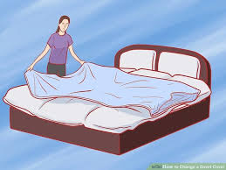****

Patient Information Leaflet for: Managing every day activity Author/s title: Lucy Reeve, Olivia Sutton Approved by : PIF

Date approved: 23/07/2020 Review date: 23/07/2022 Trust Docs ID: 17680 Page 14 of 35

Perhaps you find it difficult to get into and out of bed, or to position yourself comfortably in bed? There are a range of products on the market to help with this. The Disabled Living Foundation website is a really useful source information to help you. (Web address on page 34 of this booklet).

* If you find that your bed is too low then it might be possible to raise it on blocks, or special bed raisers.
* If you find it difficult to get your legs into bed then a leg lifter might help
* You might find that a lifting pole enables you to get into and out of bed more easily
* Transfer boards or glide sheets are also available to help you get from a wheelchair to a bed, or to move up and down the bed
* It is best to discuss this with a therapist to find out what is best for you.

Making a bed can be difficult, especially shifting the weight of the mattress and grappling with changing the duvet!!

* Fitted sheets make life easier if you get them in a bigger size than you need. Some people use a valance over the top of their mattress rather than having to tuck in sheets.

(continued on the next page)





Patient Information Leaflet for: Managing every day activity Author/s title: Lucy Reeve, Olivia Sutton Approved by : PIF

Date approved: 23/07/2020 Review date: 23/07/2022 Trust Docs ID: 17680 Page 15 of 35

* Buy easy care fabrics so they are easier to launder
* Some people use a separate sheet under the duvet so they don’t have to change the duvet so often.
* Ideally have your bed positioned so you can easily walk around it
* Look for duvet covers that have wide openings at the bottom to get the duvet into. Large buttons or velcro fastenings might be easier than poppers.
* When changing the duvet cover, lay the duvet out flat on top of the bed. Roll the duvet cover up so you can put the top two corners of the duvet cover onto the top two corners of the duvet. You can use a peg to hold the duvet cover in place while you then ease it down each side of the duvet, bit by bit.
* Changing the duvet is often a task to delegate to someone else, or at least get someone else to help you with. With two people the job really does get done in half the time.
* Make the bed in stages. Strip the bed...then go and do something else (or have a break), then come back and do the pillows and under sheets...then come back later to do the duvet (or get someone else to do that bit).



Patient Information Leaflet for: Managing every day activity Author/s title: Lucy Reeve, Olivia Sutton Approved by : PIF

Date approved: 23/07/2020 Review date: 23/07/2022 Trust Docs ID: 17680 Page 16 of 35

**Domestic activities**

*The Kitchen*

When buying new equipment or refitting your kitchen shop around to make sure what you are buying is easy to use and maintain. The Disabled Living Foundation have a factsheet on adapting your kitchen. (Web address on page 34 of this booklet).

* Are the worktops and cupboards at the right height for you and easy to work at or reach into?
* Can you open the doors and drawers of cupboards easily? Think about the type of handles that are fitted. Ideally have large handles fitted to drawers and cupboards and consider sliding doors for your cupboards.
* Are control knobs easy to reach, grip and turn, push or pull?
* Will you be able to clean and maintain equipment and surfaces easily?
* Can you lift or move equipment if you need to?
* If work surfaces are all on the same level with no gaps in between then it makes it easier to slide pans and groceries along them without lifting. Place a tea towel underneath pans/equipment to make them easier to slide.



**

Patient Information Leaflet for: Managing every day activity Author/s title: Lucy Reeve, Olivia Sutton Approved by : PIF

Date approved: 23/07/2020 Review date:23/78/2022 Trust Docs ID: 17680 Page 17 of 35

* Reaching into very low or high cupboards can be hard, particularly if they are cluttered or stacked several layers deep.
* Store items that you use often within easy reach on the work surface or at the front of cupboards at a convenient height.
* Have shelves that slide or rotate out when you open the door.
* Have drawers mounted on rollers which run more easily.
* Use plate shelves rather than piling crockery up.
* Use step shelves inside cupboards so you can easily see and reach the contents.
* Eye level ovens can reduce bending.
* Have good lighting and ventilation in the cooking area.
* A **kettle** is something you use often so make sure  
   it is easy to use. Designs vary. Some are much   
  heavier than others. Some pour more easily than  
   others. Ideally you want a lightweight kettle that is easy  
   to fill and pour. Some kettles can just boil one cup of water. You might consider buying a small travel kettle if you regularly just make yourself a drink. You might consider a kettle tipper if you find it tricky to lift and pour the kettle. Be aware that these will only work with some types of kettle.
* A useful tip is to have a lightweight plastic jug that you use to fill your kettle rather than having to move the kettle to the tap.
* You could think about installing a fast boil hot water tap that provides instant boiling water, such as Quooker ([www.quooker.co.uk](http://www.quooker.co.uk)).



Patient Information Leaflet for: Managing every day activity Author/s title: Lucy Reeve, Olivia Sutton Approved by : PIF

Date approved: 23/07/2020 Review date: 23/07/2022 Trust Docs ID: 17680 Page 18 of 35

*Meal preparation*

* Preparing food can be difficult if you find using your hands painful or difficult. There are a number of gadgets that are available on the market for you to try. For example, easy grip knives, ergonomic knives, ring pull can openers, jar openers, bottle openers, easy grip vegetable peelers and spring-loaded scissors. The Living Made Easy website has lots of products available to help with this. (Web address on page 34 of this booklet).
* Serrated knives are easier to use than those with a straight blade. There are also rocker knives. Some people find the herb knives that have a double handle and a rocker blade are helpful.
* Use light weight, two handled saucepans
* Slide heavy objects along the counter top rather than lifting them. Place a tea towel or similar underneath objects so they are easier to move.
* Use a damp dishcloth or a sticky surface such as Dycem® to keep items in place while working.
* Line baking pans with foil to minimise cleaning.
* Soak pots and pans to eliminate scrubbing.
* Use a dishwasher which you load and unload gradually, or delegate this task.
* To avoid standing for long periods try sitting at the kitchen table or perching on a high stool. Special perching stools are available. See the Living Made Easy website. (Web address on page 34 of this booklet).

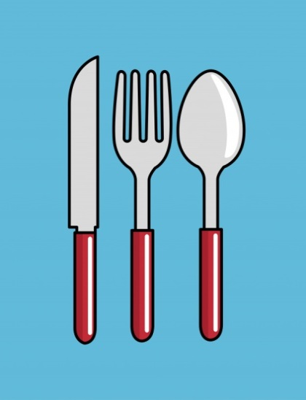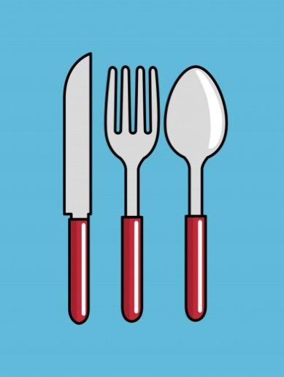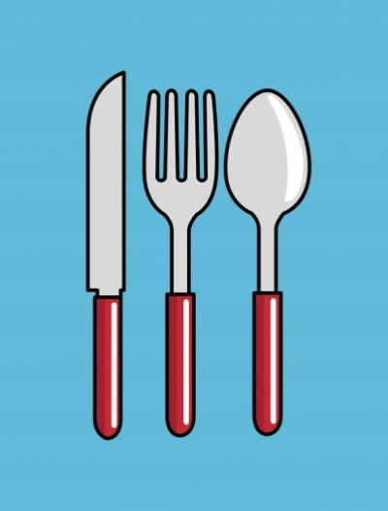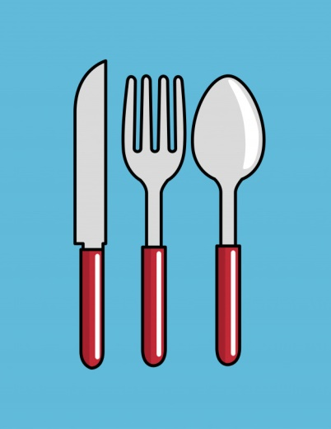

Patient Information Leaflet for: Managing every day activity Author/s title: Lucy Reeve, Olivia Sutton Approved by : PIF

Date approved: 23/07/2020 Review date: 23/07/2022 Trust Docs ID: 17680 Page 19 of 35

* Pace yourself. Spread food preparation throughout the day. Prepare food in the morning. Cook in the afternoon. Reheat in the evening.
* Search for recipes that are quick and easy to prepare
* Select food requiring minimum preparation, for example ready-prepared meals (fresh or frozen) and sauces. You can buy fresh vegetables that are pre-prepared (e.g. chopped vegetables, grated cheese). You can also use/frozen fruit and vegetables. Couscous, rice and similar products can be bought pre-prepared so you just add water. Ready-made soups and salads are a nutritious easy option.
* Prepare double recipes and freeze half to use later.
* Use a wire chip basket, placed inside saucepans to lift out vegetables or pasta when cooked to avoid lifting heavy pans containing hot water or use a slatted spoon which drains the vegetables/pasta as you serve.
* Use a flat-bottomed ladle to remove soups and stews from the saucepan.
* Use electrical equipment rather than manual items whenever possible, for example, use a food processor rather than spoons or hand whisks to make cakes. Electric can openers and hand held blenders are other things that are very helpful.
* A microwave oven can be much easier to use for heating meals, cooking vegetables and defrosting food. It usually cuts down on cooking and cleaning-up time.
* A vegetable steamer can make vegetable cooking easier, as they are lighter than a saucepan and use less water.
* A table top slow cooker can be easier to use than a casserole dish that you place in the oven
* Organise your kitchen so everything is easily accessible for you. Place items you use frequently within easy reach.
* Non slip materials such as Dycem ® are available, which can help with a number of tasks such as opening jars and bottles, and turning taps and door handles, and for stabilising bowls and other items of cooking equipment that you might be using.



**

Patient Information Leaflet for: Managing every day activity Author/s title: Lucy Reeve, Olivia Sutton Approved by : PIF

Date approved: 23/07/2020 Review date: 2307/2022 Trust Docs ID: 17680 Page 20 of 35

* There is a wide range of specialist cutlery available. Once again you can use foam tubing (pipe lagging) which comes in a wide range of sizes to bulk out cutlery and make it easier and more comfortable to hold.
* Use lightweight crockery and cups with wide handles to that they can be held easily and safely with several fingers. Insulated or pedestal mugs (which have an extra ‘step’ on the bottom) can be held with both hands because you can support them underneath without burning yourself. The Disabled Living Foundation have a whole section on eating and drinking. (Web address on page 34 of this booklet).
* To avoid stooping while washing up raise your washing up bowl by putting it on blocks or on top of another upturned bowl in the sink.
* Think about where you will be eating. Do you need a food trolley to transport food from the kitchen to the dining living room?
* There are a number of companies who provide ready prepared meals delivered to your door. These then just need reheating at home.



*Housework*

* Use a long-handled dustpan and brush so you don’t have to bend down.
* Use a towelling mitt for dusting or cleaning mirrors or windows as it is easier than gripping a cloth.
* Use a light-weight long handled mop to clean the bottom of the bath or shower tray.
* E-cloths can be helpful as they are light and absorbent and mean you can clean with water only.
* Use a light weight squeegee to clean shower screens and tiles
* There are gadgets available to help you open cleaning products that have child protective lids, such as bleach bottles.
* If you live in a house then you could consider having duplicates of heavy items, like a vacuum cleaner so you can keep one upstairs and one downstairs, to save you from having to carry them up and down.
* Spread out tasks over a period of time (over the day/week/month).
* Do a variety of jobs each day so that you vary your task and position often.
* Alternate heavy cleaning tasks with light ones.
* Get help for major heavy-duty cleaning tasks.
* Use a basket or trolley to transport cleaning equipment around the house to save on journeys.
* Think about how technology can help you. There are remote controlled hoovers (and lawnmowers) that can be programmed to do these jobs without you having to do anything!

**

Patient Information Leaflet for: Managing every day activity Author/s title: Lucy Reeve, Olivia Sutton Approved by : PIF

Date approved: 23/07/2020 Review date: 23/07/2022 Trust Docs ID: 17680 Page 21 of 35

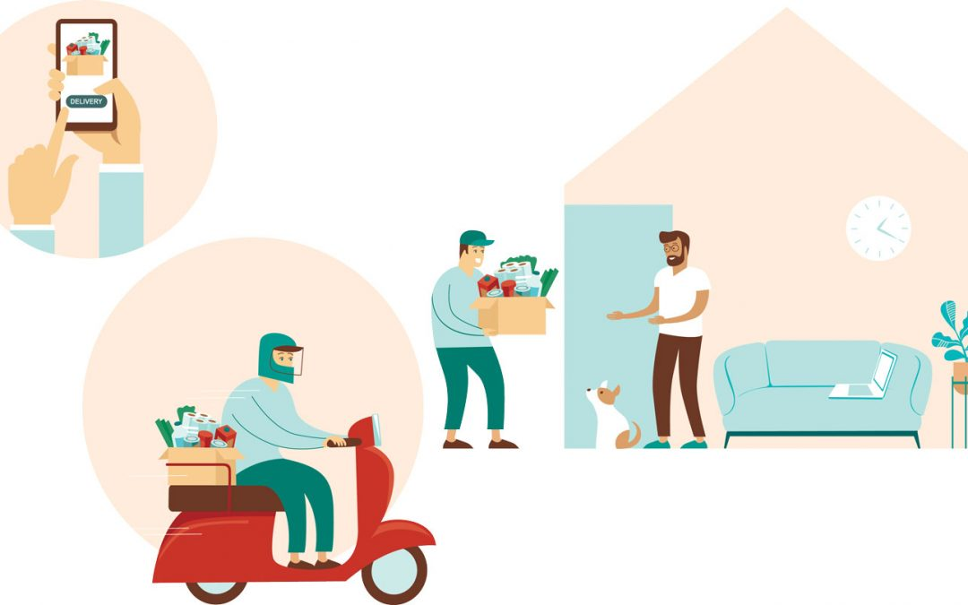

Patient Information Leaflet for: Managing every day activity Author/s title: Lucy Reeve, Olivia Sutton Approved by : PIF

Date approved: 23/07/2020 Review date: 23/07/2022 Trust Docs ID: 17680 Page 22 of 35

*Shopping*

* Internet shopping is an excellent option for most people and most things can now be purchased online and delivered to your door. All supermarkets enable you to shop online with a minimal charge for home delivery (although it will depend on where you live as to which supermarkets you can access). If you don’t like the internet then you can often order by telephone, especially from local food stores and farm shops.
* If you like to go out food shopping yourself then it helps if you use the same shops on a regular basis and learn where regular items are located for easier shopping. Shop during quieter times.
* Use the smaller trolleys so you don’t need to reach so far to get items into and out of the trolley (and so they are easier to manoeuvre
* Try to avoid carrying large and heavy bags. On request, many supermarkets provide assistance such as packers, a carry-out-to-the-car service, home delivery and wheelchairs/scooter loans. You can use shopping trolleys if you have to carry items a larger distance yourself. Consider having wheeled ‘bags’ or shoppers for any items that you are going to be carrying. There are a number of products available. Always have wheels on luggage bags, and shop around to find the ‘bags’ that are easiest for you. If you need to use bags choose ones with wide comfortable handles and use several so that you can spread your shop between lots of bags so each one is lighter to handle.



Patient Information Leaflet for: Managing every day activity Author/s title: Lucy Reeve, Olivia Sutton Approved by : PIF

Date approved: 23/07/2020 Review date: 23/07/2022 Trust Docs ID: 17680 Page 22 of 35

* Shop mobility schemes are available at most large shopping centres where you can hire standard manual and powered wheelchairs and scooters for a minimal deposit. (Please note: this needs to be booked in advance).
* Some areas have a Dial-a-Ride scheme which can be helpful if you find that shopping is exhausting and makes driving home afterwards difficult.
* If possible, take someone with you, or consider asking friends and neighbours to shop for you. Social services may arrange for someone to help if it is impossible for you to shop.

*Laundry*

* Wash one or two loads frequently (daily or every other day), rather than doing multiple loads on one day of the week. Many washing machines allow you to do small loads
* Collect clothes in one place and transfer to the laundry area on a trolley, if possible.
* If you live in a house have a collection point at the top and bottom of the stairs for clean and dirty clothes. You can throw laundry downstairs to save you carrying it down, then collect it in a basket. Equally you can leave clean laundry at the foot of the stairs and then take bits up when you go to save an extra trip. Alternatively, you can ask someone else to bring laundry down with them when they come down or take things up when they go. (This applies to anything you might want someone to carry upstairs for you, especially heavier items).
* A clothesline should be hung at shoulder height so you don’t have to stretch to reach it. A rotary line can be easier than a straight line as you can stay in one place and turn it, so you don’t have to keep moving and lifting the washing basket. Consider getting a line that is height adjustable.





Patient Information Leaflet for: Managing every day activity Author/s title: Lucy Reeve, Olivia Sutton Approved by : PIF

Date approved: 23/07/2020 Review date: 23/07/2022 Trust Docs ID: 17680 Page 23 of 35

* Place the wash basket on a chair while hanging laundry (or have a wheeled laundry trolley that is set at the correct height for you).
* If you use pegs choose larger easy grip pegs. Old fashioned dolly peg style pegs that just push onto the line can be easier to use.
* Sit or perch while ironing or consider an ironing service. For small amounts of ironing you can use a metallised ironing cloth or a thick towel on a worktop or table rather than getting the ironing board out. If you have room always leave the ironing board up and ready to use (or delegate this part of the task to someone else). Use a reflective ironing board cover so you only need to iron clothes on one side.
* Try to buy clothes that require minimal maintenance whenever possible, such as ‘drip dry’/’non-iron’.
* Consider labour-saving devices, for example use a tumble dryer so you don’t have to hang out your washing.
* Consider having the washing machine/tumble dryer on a raised surface to reduce bending.
* Keep washing products next to the machine so you have everything you need within easy reach.
* Consider the type of iron that you use. Make sure it is light weight, that it has a steam function. That it is easy to grip and hold.

If domestic tasks are proving difficult or are not a priority for you, discuss the situation with family and friends so that you all share in domestic tasks, or consider employing help. For some people there may be help available through your local social services/home care organiser.



*Infant and childcare*

* Good planning and organisation is the key to making child care easier. Try to organise your routine to enable you to plan certain tasks for when you have most energy.
* Organise areas at home so that you have the equipment you need for each task to hand.
* Wash, change and dress an infant at worktop height.
* Plan certain tasks when there are others available to help.
* Arrange help/support when possible to allow for your own rest or to help with certain tasks. This can be from family or friends or you may consider outside agencies.
* Always use leg and arm muscles rather than back muscles when lifting an infant or child.
* Kneel while washing a child in the bath or sit on a stool or the toilet.
* Always consider the types of clothes that you are buying for your child to make getting them dressed/undressed easier for you (and them!). You might want to adapt the fasteners on a child’s clothing for easier dressing (or ask someone who is able to). Look for loose clothes, that have velcro fastenings or large buttons.
* As soon as they are able to teach your children to do certain tasks for themselves, this not only helps you, but it helps them to be independent too.
* If you are going out ensure there are places that you can rest e.g. if you are going to the park is there a bench that you can sit on? Most places have areas for parents to rest and relax while their children are involved in an activity, so start to think about which places you can all enjoy.



Patient Information Leaflet for: Managing every day activity Author/s title: Lucy Reeve, Olivia Sutton Approved by : PIF

Date approved: 23/07/2020 Review date: 23/07/2022 Trust Docs ID: 17680 Page 24 of 35



Patient Information Leaflet for: Managing every day activity Author/s title: Lucy Reeve, Olivia Sutton Approved by : PIF

Date approved: 23/07/2020 Review date: 23/07/2022 Trust Docs ID: 17680 Page 26 of 35

**Driving**

* Think carefully about the car you drive. Is it the best design for you? If you are considering changing your car try out a range of models to see which is best. Think about what it is like to drive and how easy it is to get in and out of. For some people it is easier to drive an automatic car.
* Whenever you are driving (or a passenger) take time to ensure that your car is as comfortable as possible as this will make driving easier. Check the position of the seat, head rests, mirrors and so on.
* Car adaptations are available to make driving safer and more comfortable. This ranges from padded steering wheel covers to make gripping more comfortable, head or back supports for your car seat, to panoramic mirrors which give you a better view. Heated steering wheel and seats can make your drive more comfortable too. The Disabled Living Foundation website has a range of items and other advice for you to look at. (Web address on page 34 of this booklet).
* Try changing your driving habits to make driving more pleasurable. For example, take drinks or snacks to maintain your energy levels on long journeys. Plan your route so you know where you can take regular breaks to stretch and move around. Consider having an overnight stay if you are going on a long journey.





Patient Information Leaflet for: Managing every day activity Author/s title: Lucy Reeve, Olivia Sutton Approved by : PIF

Date approved: 23/07/2020 Review date: 23/07/2022 Trust Docs ID: 17680 Page 27 of 35

* Share the driving with someone else and change over frequently.
* If possible, plan journeys at the times when your energy levels are highest, for example, some people are better mid-morning.
* If you commute to work consider whether it would be easier to use public transport, or whether there is a car sharing scheme available.
* Apply for a blue badge scheme if you are only able to walk very short distances before getting fatigued.
* If you have certain disability benefits then you may qualify for the ‘Motability scheme’ which provides financial support for purchasing a car. Look online at Motability. (Web address on page 34 of this booklet).
* If you want advice on any aspect of driving then we are lucky enough to have a specific service available for advice in Norfolk, East Anglian Driveability, who are based in Thetford. (Web address on page 34 of this booklet).
* It is important to first and foremost consider your safety and that of other road users. You should ensure that you are medically fit to drive. You should ensure that any medications that you are taking do not adversely affect your ability to drive. Discuss this with your GP. Never drive when you are tired or if you are feeling unwell. Ensure you have breakdown cover for emergencies.

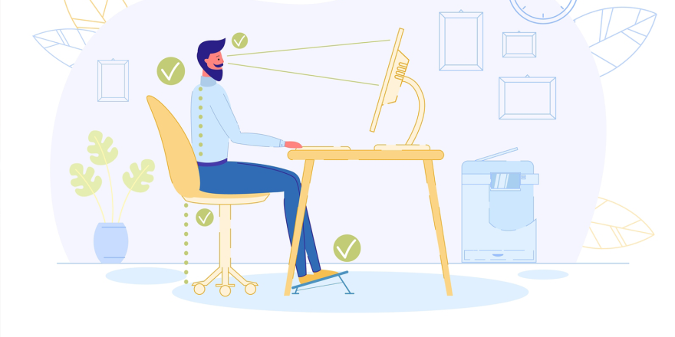

Patient Information Leaflet for: Managing every day activity Author/s title: Lucy Reeve, Olivia Sutton Approved by : PIF

Date approved: 23/07/2020 Review date: 23/07/2022 Trust Docs ID: 17680 Page 28 of 35

**Work**

The general principles of work simplification and job analysis discussed above all apply to the work situation – take rest periods, plan ahead and eliminate unnecessary jobs. Everybody will have unique circumstances regarding their work situation and it is important to look at this using a problem-solving approach to identify the changes you can make that will help you most.

* Always discuss your health difficulties with your employer so they are aware of your situation and the things that would be most helpful to accommodate your needs. You may have an Occupational Health Department who can help you with this and can provide more specific advice and support.
* You might want to negotiate changes to your working hours/environment if this would help you. This might be a permanent change or a temporary one. For example, a temporary reduction in your working hours may help you if you are experiencing a ‘flare up’ of your symptoms.
* Would it help to change your times of work or work flexitime? This can help you work when you have most energy. It can often be exhausting to contend with the morning and evening rush hours, so changing hours to accommodate this can help some people.
* Consider your transport to and from work. Are there any ways that this can be made easier?
* Working from home for some of the week may be an option for some people.



Patient Information Leaflet for: Managing every day activity Author/s title: Lucy Reeve, Olivia Sutton Approved by : PIF

Date approved: 27/07/2020 Review date: 27/07/2022 Trust Docs ID: 17680 Page 29 of 35

* See if you can find or request a quiet comfortable place to go for rest periods. Some people like to rest in their car if that is possible.
* Use a trolley to move things from A to B. Have a wheeled bag for your laptop/files or any specific work equipment you need to carry around.
* Sit rather than stand where possible. Discuss with your employer about the type of chair or desk that you have and ensure it is appropriate for your needs.
* The following information can be helpful for those in an office setting.
  + *Computer -* Sitting at a computer for a long time with poor posture will make you uncomfortable. You should take regular breaks and change your position often. Sit squarely at the computer with your back and arms supported. Use a table and a chair that allows you to sit comfortably and make sure you have a good upright posture. Ideally your computer screen should be at eye level, and your wrists should be in a neutral position. There are numerous adaptations that are available for computer key pads and also there are many varieties of mouse which can be more comfortable to use.
  + You could try using voice activated software if you use your computer a lot and have a lot of difficulties using your hands.
  + Arrange your office so that your filing cabinets, computer terminal, etc. are easily accessible from your swivel chair.
  + Consider labour-saving devices, such as telephone support for extended conversations or assistive computer software or a Dictaphone for long documents.



****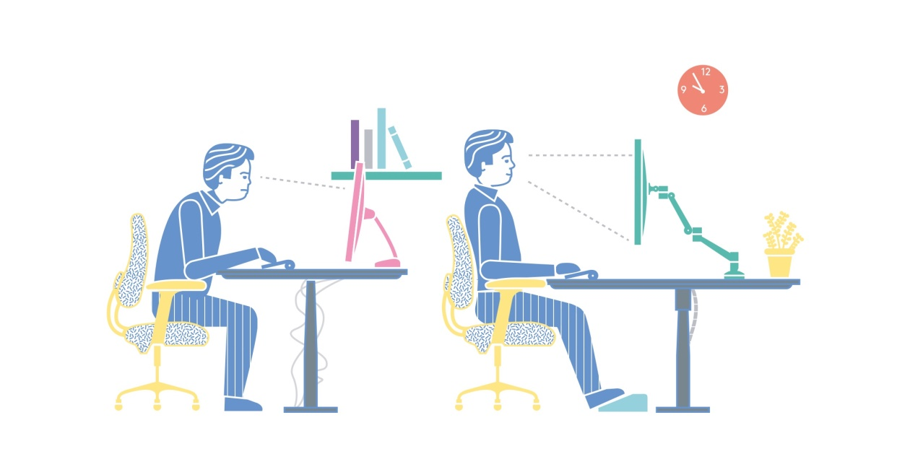

Patient Information Leaflet for: Managing every day activity Author/s title: Lucy Reeve, Olivia Sutton Approved by : PIF

Date approved: 23/07/2020 Review date: 23/07/2022 Trust Docs ID: 17680 Page 30 of 35

* Assistive equipment or major adaptation to the work environment is sometimes useful to enable you to carry out certain tasks more easily or access the areas in the work place that you need to. For example, a stairlift, powered chair for work or funding for taxis to reduce the effort of commuting. Funding is even available to employ someone to help you. Support and advice is available through the ‘**Access to Work’** scheme. You can contact this service direct or via your local Disability Employment Advisor (DEA). (Web address on page 34 of this booklet).
* If you want further advice on work and the support available from the government have a look at their website (on page 34 of this booklet).

**

Patient Information Leaflet for: Managing every day activity Author/s title: Lucy Reeve, Olivia Sutton Approved by : PIF

Date approved: 23/07/2020 Review date: 23/07/2022 Trust Docs ID: 17680 Page 31 of 35

**Leisure**

It is essential for your physical and mental health that you have a range of leisure tasks in your weekly routine. When people have persistent pain and fatigue they often stop doing the things that they enjoy and spend all their time and energy on the essential household and work tasks. However, it is often these leisure and social tasks that boost your energy and positively affect your mood so please include them.

There are a range of leisure tasks that could be discussed under this heading but here are a few things that might be helpful:

*Writing*

* There are thousands of brands of pen on the market, and so it is a matter of trial and error to get what works best for you. You may find that chunky pens are easier to grip. Some will have non-slip rubber grips on them which can be helpful.
* There are also a range of pen grips that can be added to existing pens to make them easier to hold. See the Disabled Living Foundation Website.



*Reading*

* Try resting your book on your lap or the table to avoid straining your fingers. You can also use a beanbag, lap tray or book rest. Anything that takes the weight of the book may be more comfortable than holding it. The Living Made Easy website has lots of ideas.
* Think about using an e-reader or tablet to get digital copies of books and magazines. Some models are very light and may be easier to hold than a book. Many have covers that double as a stand so you don’t have to hold them.

*Gardening*

* Plan out your garden so that it is low maintenance. This will keep the gardening simple and easy to manage.
* Follow the advice above about your changing task and position regularly, and taking short breaks between tasks.
* Consider raised garden beds, use of tubs, indoor gardens and lightweight lawn mowers.
* Use specialised equipment that is designed to make tasks easier, such as garden tools with long handles which minimise bending.
* Avoid gardening in extreme temperatures for long periods.
* Get help for tasks that you find difficult. You may have family or friends who can help out, or consider using outside agencies.

There is a particularly good section on gardening on the Versus Arthritis website that goes into a lot of detail about designing your garden to suit your needs and the equipment there is available. (Web address on page 34 of this booklet).

There is also a large section on the Disabled Living Foundation website with lots of helpful information. (Web address on page 34 of this booklet).



Patient Information Leaflet for: Managing every day activity Author/s title: Lucy Reeve, Olivia Sutton Approved by : PIF

Date approved: 23/07/2020 Review date: 23/07/2022 Trust Docs ID 17680: Page 32 of 35



**Additional Advice and resources**

This selection of ‘top tips’ are just some of the ideas that might help you. For more help and advice speak to our Occupational Therapist (OT) at the Pain Clinic who can give you more specific advice. We will also be able to discuss if you might need further advice from OTs who are based in the community and will either be linked to your GP practice or based in the Adult Social Services Department. The community OTs can come and visit you in your own home to assess your needs and provide advice on specialist equipment and adaptations, and where possible arrange their provision. They can advise on grants that might be available for bigger adaptations. Social services many also be able to arrange for you to have help with personal care and advise you on local schemes that offer help with housework and shopping.

Many of the products mentioned in this leaflet are available in supermarkets, hardware, household and DIY stores. You may also find them in kitchen shops and chemists. Prices vary so shop around. If you do a google search or search on Amazon you are sure to find what you want. If you have Amazon Prime it is likely you may get your item to try the next day!

Don’t forget that eBay is also a brilliant place to find second hand items. The larger charity shops that keep a stock of second hand furniture are often good places to find second hand items too. You may find walking aids, wheelchairs, bath boards, perching stools and trolleys looking for a new home.



Patient Information Leaflet for: Managing every day activity Author/s title: Lucy Reeve, Olivia Sutton Approved by : PIF

Date approved: 23/07/2020 Review date: 23/07/2022 Trust Docs ID: 17680 Page 33 of 35





**Useful Websites**

* The Disabled Living Foundation: <https://www.dlf.org.uk/>
* Quooker: [www.quooker.co.uk](http://www.quooker.co.uk)
* Living Made Easy: <https://www.livingmadeeasy.org.uk/>
* Motability: [www.motability.co.uk](http://www.motability.co.uk)
* East Anglian Driveability: <https://www.eastangliandriveability.org.uk/>
* Information on Disability Employment Agency: <https://www.gov.uk/government/publications/access-to-work-factsheet/access-to-work-factsheet-for-customers>
* Government Advice on Work and Support: <https://www.gov.uk/browse/disabilities/work>
* Versus Arthritis [https://www.versusarthritis.org](https://www.versusarthritis.org/about-arthritis/living-with-arthritis/gardening/)

**Voluntary organisations**

The **British Red Cross** runs an equipment and loan service for wheelchairs and other specialist items of equipment.

<https://www.redcross.org.uk/>

**Age UK** provides lots of advice about help and support available in your local area. They may provide assistance with finance and benefits. They help with shopping and housework in some areas. They also offer a handyman service for help with gardening and small household jobs.

<https://www.ageuk.org.uk/norfolk/>

Call 0300 500 1217

Age UK have a guide on how to adapt your home to suit your condition too. Here is the link.

<https://www.ageuk.org.uk/information-advice/care/housing-options/adapting-home/>

Patient Information Leaflet for: Managing every day activity Author/s title: Lucy Reeve, Olivia Sutton Approved by : PIF

Date approved: 23/07/2020 Review date: 23/07/2022 Trust Docs ID: 17680 Page 34 of 35



**Disabled Living Foundation**

There is a lot of advice on managing daily tasks and the specific equipment that is available to make tasks easier on the Disabled Living Foundation website [www.dlf.org.uk](http://www.dlf.org.uk)

They have a number of factsheets that you might also find helpful. The full list of factsheets available is here:

<https://www.dlf.org.uk/content/full-list-factsheets>

**Disabled Living Centres**

There are over 40 Disabled Living Centres (sometimes called Independent Living Centres) in the UK. Most have a range of equipment for you to try. Many of the staff are therapists who can give impartial advice. Here is a link to find out if there is one in your local area.

<https://www.livingmadeeasy.org.uk/contacts_edc.php>

There is a site in Norfolk in Gorleston that is run by the Red Cross. We also have a facility at the University of East Anglia called the NEAT Home which is set out like a domestic bungalow and houses a whole range of equipment.

<https://www.uea.ac.uk/health-sciences/innovation/neat>

**Versus Arthritis** is another charity that has a lot of helpful advice about managing everyday activities at home and at work. It is dedicated to people who have arthritis and other Rheumatological conditions.

[www.versusarthritis.org](http://www.versusarthritis.org)

<https://www.versusarthritis.org/about-arthritis/living-with-arthritis/your-home/>

Patient Information Leaflet for: Managing every day activity Author/s title: Lucy Reeve, Olivia Sutton Approved by : PIF

Date approved: 23/07/2020 Review date: 23/07/2022 Trust Docs ID: 17680 Page 35 of 35