Cytology Instruction
NON GYNAE cytology user manual

DATE OF ISSUE | Dec 2024
EDITION No. | 19
REVIEW INTERVAL | Annual
AUTHORISED BY | Benjamin Pinchbeck
AUTHOR | Lynn Parsons
RELATED STANDARDS | ISO: 15189:2022 – 7.2.2
COPY | 1 of 2
LOCATION OF COPIES | - Master Copy on Q-Pulse  - NNUH Intranet (Trust Docs)

DETAILS OF AMENDMENTS
Date | AMENDED BY | DETAILS
10.10.2013 | SARA CASSON | NEW TEMPLATE  ADDITIONAL SECTIONS ADDED FOR ISO
31.12.2014 | SARA CASSON | Updated contact names & numbers  Updated specimen transport summary  Addition of new ICE forms  Updated NHSCSP standards  Removal of SLN details  Updated OOP & UNL letters
31.01.2016 | SARA CASSON | Updated contact names & numbers  Addition of new ICE forms
03.04.2017 | ALEXANDER BOLINGBROKE | New header + footer, author + authoriser changed, removed CPA standards, updated Failsafe table, updated transport container information, updated referral percentages, updated Glossary.
17.04.18 | KATE MATTHEWS | Altered lay out in line with ISO standards
01.11.18 | KATE MATTHEWS | Added information regarding rejection of samples received in out of date vials and updated for processing of work from Peterborough.  Also updated for changes made regarding returning OOPs vials to sender
13.12.18 | KATE MATTHEWS | Changed reject letter templates
23.08.19 | KATE MATTHEWS | Changed sara’s number, included info regarding waiting at least 84 days post inad/rejected sample, updated for east of england contract
14.01.2021/09.03.2021 | KATE MATTHEWS | Changed title to reflect removal of cervical cytology information, updated contacts, updated info regarding results. Included Covid as a high risk sample. Change of author and authoriser. Added accreditation section
May 2022 | LYNN PARSONS | Amended to reflect current practice; anal brushings, ?CJD (not accepted), ≤4 slides with needle washings. RCPath guidelines on turnaround times added. Links checked.
July 2023 | LYNN PARSONS | Update of Quality Policy. Addition of DCC. Information on consent added. Delivery after collection advice. Reports electronic.
Dec 2023 | KATE MATTHEWS | Updated for ISO15189:2022  Amended contents section, added link for patient consent section, added clarification to storage and transport section, added link to Trust confidentiality policy, updated job roles where required, specified what room temperature is, changed section 27.0 to be more aimed at service user rather than patient, added info regarding samples received in LBC fixative.
Dec 2024 | LYNN PARSONS | Amended contents section. New format. DCC, new transport, serous fluid changes.
INDEX
1.0 QUALITY POLICY 5
1.1 ACCREDITATION 6
2.0 LOCATION 6
3.0 CONTACT NAME & NUMBERS 7
4.0 CLINICAL SERVICES 10
5.0 NORMAL WORKING HOURS 10
6.0 OUTSIDE NORMAL WORKING HOURS 10
7.0 DIAGNOSTIC CYTOLOGY 11
7.1 REQUEST FORMS AND THEIR COMPLETION 11
7.1.1 Non Gynae ICE Request Form (PREFFERED) 11
7.1.2 Non Gynae/Histopathology Request Form 12
7.1.3 Spire Clinical Pathology Services Request Form 14
8.0 CONTAINERS FOR NON-GYNAECOLOGICAL SAMPLES and REQUIRED VOLUME OF SAMPLE 15
9.0 RELEVANT CLINICAL INFORMATION 17
10.0 DETERMINATION OF IDENTITY OF PATIENT 17
11.0 SPECIMEN COLLECTION 17
11.1 BREAST CLINIC 17
11.2 CEREBROSPINAL FLUIDS 17
11.3 BRONCHIAL WASHINGS 17
11.4 SAMPLES IN LBC FIXATIVE INCLUDING BRUSHINGS AND BRUSH TIPS 18
11.5 FINE NEEDLE ASPIRATES 18
11.6 TO PREPARE AIR-DRIED SMEARS 19
11.7 FLUIDS – PLEURAL, ASCITIC, PERICARDIAL, SYNOVIAL / JOINT FLUIDS, ENDOMETRIAL AND OTHER ASPIRATES 20
11.8 SPUTUM 21
11.9 URINE 21
11.10 DISPATCH / DELIVERY 21
12.0 URGENT SAMPLES 21
12.1 HOW TO SEND URGENT SAMPLES 21
13.0 ACCEPTANCE/REJECTION CRITERIA 22
14.0 FACTORS AFFECTING SAMPLE & REPORT QUALITY 23
15.0 HIGH RISK SAMPLES 23
16.0 DIAGNOSTIC CYTOLOGY TURNAROUND TIMES 23
17.0 SPECIMEN STORAGE 24
18.0 DISPOSAL OF COLLECTION MATERIAL 24
19.0 SPECIMEN TRANSPORT 24
20.0 RESULT ENQUIRIES 25
21.0 TELEPHONE RESULTS 26
22.0 PACKAGING 26
23.0 FLAGGING OF HIGH RISK SPECIMENS 26
24.0 CLINICAL ADVICE & INTERPRETATION 26
25.0 SUPPLIES 27
26.0 RETURNING OUT OF DATE / UNWANTED SUPPLIES redistribution. 27
27.0 PROTECTION OF PERSONAL INFORMATION 27
28.0 CONSENT 27
29.0 COMPLAINTS PROCEDURE 27
30.0 REFERENCES & sources of information 28
31.0 GLOSSARY 28
Appendices 30
32.0 NOTES FOR CORRECT COMPLETION OF NNU36 REQUEST / REPORT 30

QUALITY POLICY
The Quality Policy of the Norfolk and Waveney Cellular Pathology Service,
Norfolk & Norwich University Hospital

In order to ensure that the needs and requirements of all users are met, the Norfolk and Waveney Cellular Pathology Service which comprises of Cytopathology, Histopathology Mortuary and Bereavement departments is committed to providing a scientific, analytical, clinical service and patient support service of the highest quality and shall be aware and take into consideration the needs and requirements of all its users.

In order to ensure that the needs and requirements of all users are met, the Cellular Pathology Service will:

o Operate a quality management system to integrate the organisation, procedures, processes and resources.
o Set quality objectives and plans in order to implement this quality policy to achieve continual quality improvement.
o Ensure that all personnel are familiar with this Quality Policy, the Quality Manual and all procedures relevant to their work to ensure that the needs are requirements of the user are met.
o Commit to the health, safety and welfare of its entire staff.
o Treat visitors to the department with respect giving due consideration will be given to their safety whilst on site.
o Commit to comply with all relevant environmental legislation.

The Norfolk and Waveney Cellular Pathology Service is committed to complying with the international standards for ISO15189:2022 and will:
o Uphold professional values and promote good professional practice and conduct.
o Recruit, train, develop and retain staff at all levels to provide a full and effective service to its users.
o Procure and maintain equipment and other resources as are needed for the provision of the service.
o Collect and handle and all specimens in such a way as to ensure the correct performance of laboratory examinations.
o Use standard operating procedures, instructions and forms to ensure the highest achievable quality of all aspects of the service provided and that examinations are fit for intended use.
o Report results of examinations in ways which are timely, confidential, accurate and reliable.
o Assess user satisfaction, and undertake internal audit and external quality assessment, in order to produce continual quality improvement, setting and reviewing quality objectives published in document CP.SH.P.1005

Signed on behalf of the
Norfolk and Waveney Cellular Pathology Service
Stephanie Walker
Cellular Pathology Service Operations Manager 16th Edition Date
(Reviewed 6th June 2024)

1.1 ACCREDITATION
The department of Cellular Pathology is a UKAS accredited medical laboratory No 8405, to ISO15189:2022. Our current accredited repertoire is available on the UKAS website (www.ukas.com)’

2.0 LOCATION
The Cytopathology Department (part of Cellular Pathology) is part of the Medical & Clinical Support Division. The Directorate is managed by the Clinical Director, Service Manager, and the Laboratory Managers and is part of Norfolk & Norwich University Hospital NHS Foundation Trust.
The postal address is:
Histopathology & Cytopathology
Norfolk & Waveney Cellular Pathology Service
The Cotman Centre
Colney Lane
Norwich
NR4 7UB
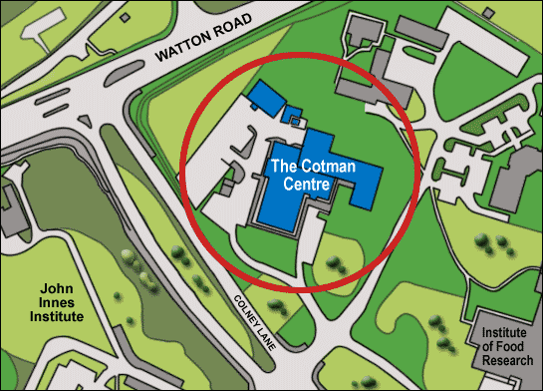
Tel: 01603 287412
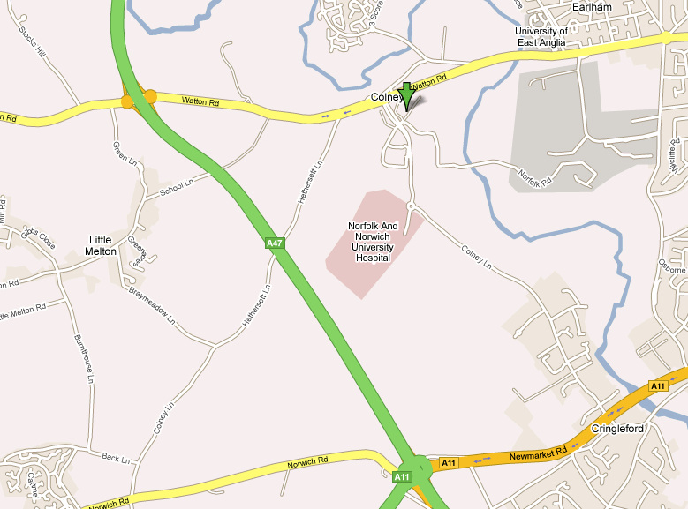
The Cotman Centre is approximately a 10 – 15 minute walk from the main NNUH site.

3.0 CONTACT NAME & NUMBERS

Dr Lazlo Igali  01603 286016
Chief of Service
Laszlo.Igali@nnuh.nhs.uk

Philip Hinson  01603 286026
Deputy Cytology Manager – HPV Reception Lead
PHILIP.HINSON@nnuh.nhs.uk

Dr Xenia Tyler  01603 287943
Lead Consultant Cytopathologist & Consultant Histopathologist
Xenia.Tyler@nnuh.nhs.uk

Viki Frew  01603 286 033
Consultant Biomedical Scientist & Cervical Screening Provider Lead
Viki.Frew@nnuh.nhs.uk

Sara Casson  01603 286031
Cytology Laboratory Manager
Sara.Casson@nnuh.nhs.uk

Mark Hunt  01603 647933
Consultant Biomedical Scientist, Pathway Manager for Suffolk, North East Essex and Mid & South Essex
Mark.Hunt@nnuh.nhs.uk

Carol Taylor  01603 286024
Senior Biomedical Scientist- Screening & HPV Lead
Carol.Taylor@nnuh.nhs.uk

Kate Matthews  01603 286024
Consultant Biomedical Scientist- Pathway Manager for Cambridge, Peterborough and Milton Keynes
Katherine.Matthews@nnuh.nhs.uk

Lynn Parsons  01603 286024
Senior Biomedical Scientist –Diagnostic Cytology, Health & Safety and Training Lead
Lindsay.Parsons@nnuh.nhs.uk

Roseanna Bignell  01603 286024
Senior Biomedical Scientist –Office and Training Lead
Roseanna.Bignell@nnuh.nhs.uk

Lola Olatunde  01603 286024
Senior Biomedical Scientist-Gynae Lab Lead
Lola.Olatunde@nnuh.nhs.uk

Kelly Austin  01603 286024
Senior Biomedical Scientist – Quality Lead, HPV Primary and Training Lead

Emma Williams  01603 287412
Cytology Office Manager
Emma.Williams@nnuh.nhs.uk

Michal Allison  01603 286035
Cytology Deputy Office Manager
Michal.Allison@nnuh.nhs.uk

4.0 CLINICAL SERVICES
The cytology department provides a diagnostic cytology service to the Norfolk & Waveney area with a workload of 3000 samples per year.

5.0 NORMAL WORKING HOURS

Monday 08.30 – 17.00
Tuesday 08.30 – 17.00
Wednesday 08.30 – 17.00
Thursday 08.30 – 17.00
Friday 08.30 – 17.00
Saturday CLOSED
Sunday CLOSED

6.0 OUTSIDE NORMAL WORKING HOURS
If samples cannot be collected during working hours or have been taken after the last collection, departments are advised to refrigerate fresh specimens and send the next day. If there is no fridge available, please take the samples to pathology reception at NNUH or JPUH and request for it to be refrigerated and to be sent on to the Cotman Centre next day on the first delivery. If the sample is collected in LBC fixative DO NOT refrigerate before sending the next day.
JPUH deliveries may be after 5pm (breast clinic samples) – therefore cover for accepting this delivery must be pre-arranged – Contact the laboratory.

7.0 DIAGNOSTIC CYTOLOGY

7.1 REQUEST FORMS AND THEIR COMPLETION

7.1.1 Non Gynae ICE Request Form (PREFFERED)
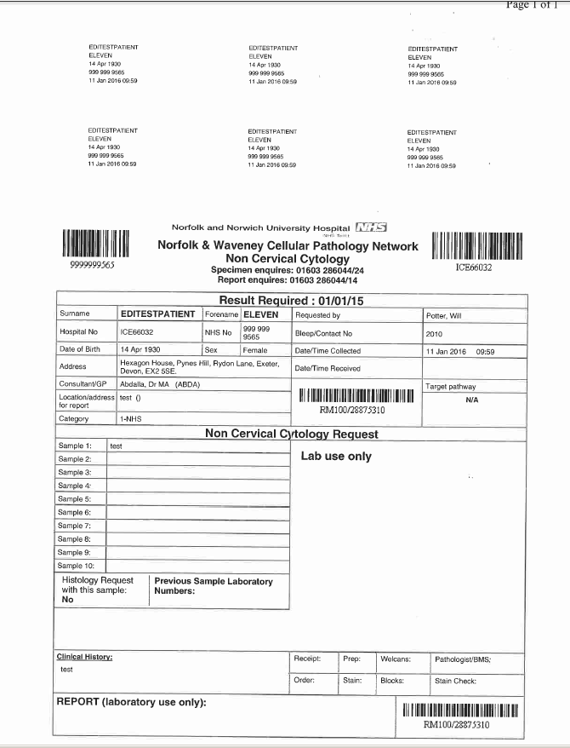
ICE forms for Cytology can be located in ICE under the Cellular Pathology tab
For information on the completion of the non-gynae ICE request form follow the link ICE form completion guide.

7.1.2 Non Gynae/Histopathology Request Form
Front
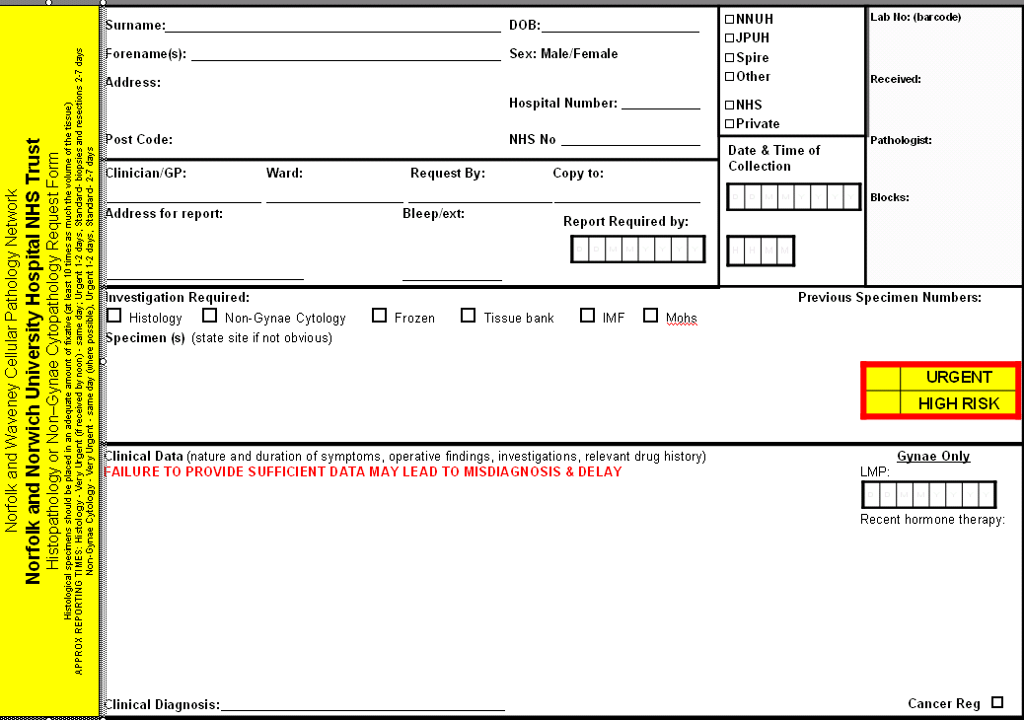

Back
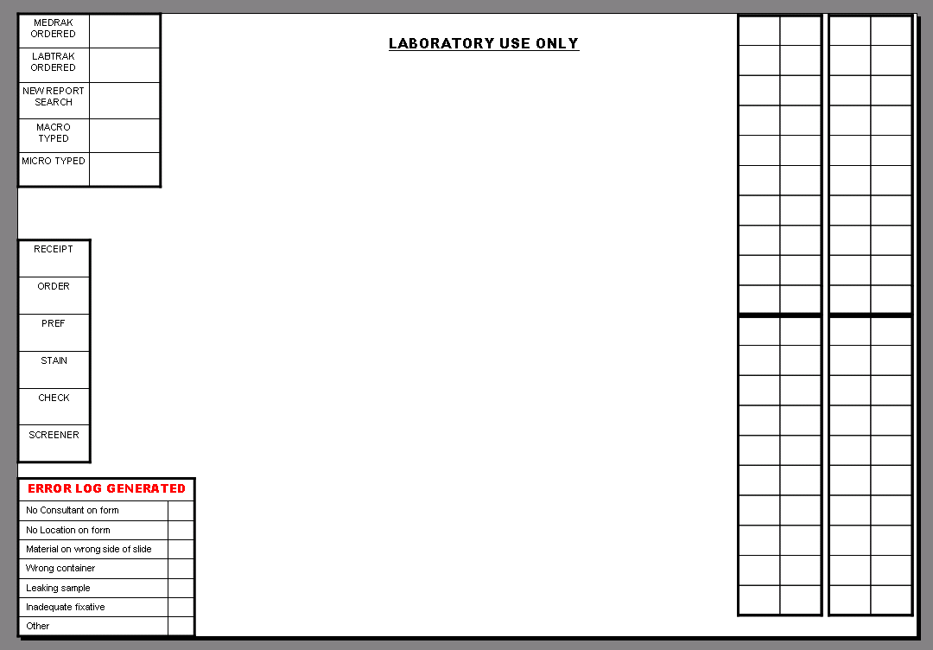
The NNU36 paper form is used for requesting examination of Diagnostic (Non-Gynae) Cytopathology. The form must be completed correctly, a bar coded name label can be attached or the boxes filled in as in appendix 21.0. The form is then sent with the sample to the laboratory. Requesters should ensure that all information provided on the NNU36 form is complete and legible to support the laboratory in identifying the patient, producing an accurate report, and ensuring that the report is sent to the correct destination. The laboratory sends a copy of the completed result reported by the Cytopathologist and the result is available on ICE.

Note that these instructions refer to the standard form and not to locally designed variations which may be arranged differently or include alternative data fields and/or options, and must be filled in appropriately.
If the sample is private this must be clearly stated on the form.

7.1.3 Spire Clinical Pathology Services Request Form
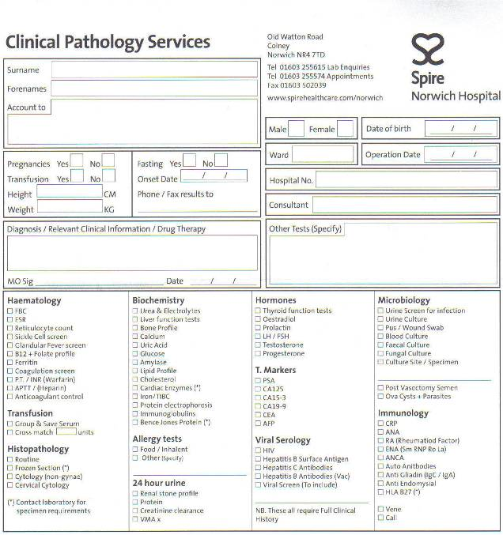

The above form is used for requesting examination of non-gynae pathology samples from Spire hospital. The form must be completed correctly, indicating in the tick boxes which test is requested. A bar coded name label can be attached or the boxes filled in appropriately. The form is then sent with a completed form NNU36 as above, with the sample to the laboratory. Requesters must ensure that all information provided on the MSL 22 and NNU36 form is complete and legible to support the laboratory in identifying the patient, producing an accurate report, and ensuring that the report is sent to the correct destination. The laboratory sends a copy of the completed result reported by the Cytopathologist.

Note that these instructions refer to the standard form and not to locally designed variations which may be arranged differently or include alternative data fields and/or options, and must be filled in appropriately.

Private samples must be clearly indicated on the request form & for Spire Pathology Services must have an H number sticker attached.
Testing will only be performed where it is indicated to whom the bill should be sent.
Please ensure that your patients are aware that they will be charged for these tests before the sample is taken.
Prices for testing of non-gynae samples are available on request from Viki Frew: 01603 286 033 Viki.Frew@nnuh.nhs.uk

8.0 CONTAINERS FOR NON-GYNAECOLOGICAL SAMPLES and REQUIRED VOLUME OF SAMPLE
NAME | PICTURE | USED FOR | MAXIMUM VOLUME / CONTENT
EMPTY  STERILE  UNIVERSAL CONTAINER | 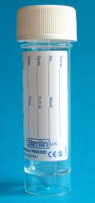 | Cerebro-spinal fluids  Endometrial aspirates  Breast cyst fluids  Fluids – pleural, ascitic, pericardial etc.  Cyst fluids  Sputum  Synovial / joint fluids  Urine  Ureteric washings  Bronchial washings  Differential Cell Counts (DCC) on Bronchoalveolar Lavage samples – these need to be prearranged with the laboratory | 20ml
UNIVERSAL CONTAINER WITH LBC FIXATIVE | 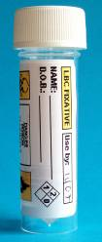 | Bronchial brushings  Duodenal brushings  Oesophageal brushings  Biliary tract brushings  FNA needle washings  Trans-Bronchial Needle Aspirate | 7ml
VIAL CONTAINS FIXATIVE CALLED PRESERVCYT/ LBC FIXATIVE. | 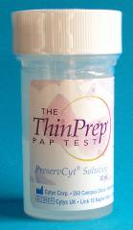 | Anal Brushings | 20ml
SLIDE MAILER | 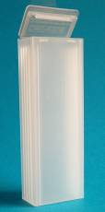 | FNA slides | Maximum 4 slides  1 slide per groove  (if sending more than 4 slides – please use multiple containers)

9.0 RELEVANT CLINICAL INFORMATION
Any relevant clinical data such as DANGER OF INFECTION, symptoms, duration, results of imaging studies, clinical differential diagnoses should be included in the appropriate section of the request form.

10.0 DETERMINATION OF IDENTITY OF PATIENT
It is the responsibility of the sample taker to determine the identity of the patient and to clearly and accurately fill out request form and label sample container.

11.0 SPECIMEN COLLECTION

11.1 BREAST CLINIC
JPUH
Breast clinic at JPUH is all day every Tuesday (pm) & Wednesday (am).
Samples are sent via the routine JPUH transport (first approximately 9am, last routine transport leaves JPUH at approximately 2pm); if the transport has been missed (e.g. late sample) a courier is available through JPUH pathology reception (4pm Tuesday or 8am Wednesday) – samples may be delivered up to 5pm Tuesday or before 9 am Wednesday if required for the same day MDT.
JPUH reception should contact Cytopathology departments to inform of any late arriving samples.
NNUH
The one-stop breast clinic at NNUH: samples are sent via the urgent porter (extn 6021 / bleep 1113)

11.2 CEREBROSPINAL FLUIDS
Place CSF into a plain universal container with a white top.
It is VERY IMPORTANT to send the sample to the laboratory immediately as an URGENT sample as above, as the cells degenerate rapidly.
Contact:  Urgent Porter 6021, or bleep 1113
These samples MUST be refrigerated if there is any delay, or if the laboratory is closed.
URGENT SAMPLES
Do not attempt to arrange delivery after 4.30pm – please refrigerate the sample any fresh samples and store any samples in LBC fixative at room temperature (between 4 and 30ºC) & arrange for an urgent porter the following morning.

11.3 BRONCHIAL WASHINGS
Place washings into a plain universal container with a white top. Label and complete the non-gynae ICE form and send to the laboratory as above.
Bronchoalveolar Lavage samples for DCC – these must be pre-arranged with the laboratory. Universal containers containing 10ml RPMI- Hepes collection buffer will be dispatched to the clinic the day before the sample is to be collected. Refrigerate collection vials on arrival. Add 10ml of sample to the collection vial and send immediately to the laboratory via the Urgent Porter as these samples deteriorate rapidly. Contact:  Urgent Porter 6021, or bleep 1113.
DCC samples are not currently covered by our UKAS standards.

11.4 SAMPLES IN LBC FIXATIVE INCLUDING BRUSHINGS AND BRUSH TIPS
These samples include bronchial brushings, gastric and biliary tract brushings and anal samples (see 8.0, 14.0, 17.0 and 25.0). The plastic cover MUST be removed from the brush tip before placing in fixative.
**Please make sure that the brush tip end is in the fixative**.
The brush tip can either be sent in the LBC fixative or the cellular material removed from the brush by vigorous mixing in the LBC fixative. Label and send with an appropriately completed non-gynae ICE form to the laboratory as above. The LBC fixative (7ml, in white topped universal, for all except anal samples) is only available from Cytology (01603 286 024, extn 2024, or 01603 286 044, extn 2044). For anal samples ThinPrep Preservyt vials (20ml) should be used – these can also be obtained from Cytology (01603 286 024, extn 2024, or 01603 286 044, extn 2044) – please specify they are for anal samples when calling.

Any out of date fixative must be returned to the laboratory & clearly labelled on the packaging as ‘OUT OF DATE – FOR DISPOSAL’.

11.5 FINE NEEDLE ASPIRATES
FNA samples can be prepared as demonstrated on section 11. Excess FNA sample can be transferred to a labelled white topped sterile universal containing LBC fixative – ‘needle washings’ (we recommend preparing a maximum of 4 direct spread slides to preserve sufficient material for the needle washings for immunohistochemistry if needed enabling more detailed reporting). Send the sample with a completed non-gynae ICE form.

11.6 TO PREPARE AIR-DRIED SMEARS
Obtain material by FNA. Spread material over the correct side (i.e. – side with the frosted surface) of the slide using one of the following methods:

A. SEMI-SOLID SAMPLE
Figure 1
Apply slight pressure, and use the flat surface of another slide gently to smear the material.
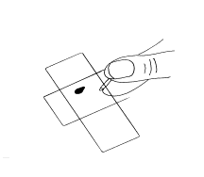
Figure 2
Draw out the sample.

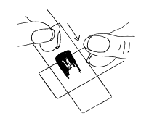

B. SAMPLES MIXED WITH BLOOD
Make the smear as in the preparation of a peripheral blood smear with a droplet collected obliquely behind the edge of the slide.
When the material is drawn along the slide, the particles present collect at the end of the smear (the “tail”) (Figures 3 – 4).
Figure 3
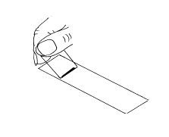
Figure 4
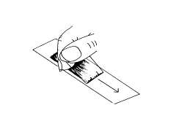
Figure 5
If large particles are present, gently squeeze the particles by applying flat pressure.
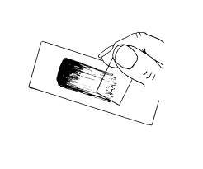
Label each slide IN PENCIL on the ground glass area (do not write in ink which is washed off in the fixative) with patient’s name, DOB and hospital number – the details must be written on the same side of the slide as the spread sample. Please ensure that the sample is spread onto the correct side of the slide. Air-dry rapidly, and place slides into a plastic slide container (no more than 4 slides per container). Complete a non-gynae ICE request form and log sheet, and send form and sample to the Cytopathology Laboratory-see instructions for transport of non-gynae samples.

11.7 FLUIDS – PLEURAL, ASCITIC, PERICARDIAL, SYNOVIAL / JOINT FLUIDS, ENDOMETRIAL AND OTHER ASPIRATES
Place up to 20 ml* of fluid in a plain universal container with a white top. Complete the non-gynae ICE request form and send to the laboratory as above.
*In order to maximise the possibility of detecting malignancy, the International System for Serous Fluid Cytopathology recommend that a volume of at least 75mls is examined. Kala C, et al. The International System for Reporting Serous Fluid Cytopathology: An Institutional Experience on its Implication and Assessment of Risk of Malignancy in Effusion Cytology. J Cytol. 2023 Oct-Dec;40(4):159-164. doi: 10.4103/joc.joc_111_22. Epub 2023 Oct 16. PMID: 38058672; PMCID: PMC10697320.

**DO NOT send more than 100ml of sample (equivalent to 4 universals) as the laboratory is not equipped to deal with this volume of sample**

11.8 SPUTUM
Use a plain universal container with a white top, label and send with completed non-gynae ICE request form.
Wherever possible, obtain specimen from the first deep cough of the day, before breakfast, tooth-brushing etc.
Complete the request form and send to the laboratory as above.

A Patient Information Leaflet Patient Information: ‘How to Take a Sputum Sample for Testing in Cytology’ is available on https://www.knowledgeanglia.nhs.uk/ or in Trust Docs on the Intranet.

11.9 URINE
Use a plain universal container with a white top.
Do not collect early-morning urine, but do collect the first part of the stream as this contains the most cells.
Complete the non-gynae ICE request form and send to the laboratory as above.
A Patient Information Leaflet Patient Information: ‘How to Take a Urine Sample for Testing in Cytology’ is available on https://www.knowledgeanglia.nhs.uk/ or in Trust Docs on the Intranet.

11.10 DISPATCH / DELIVERY

Please ensure all sample types are dispatched to the laboratory as soon as possible following collection – all samples may deteriorate if delayed (the turn around time for reporting will also be effected). See section 12 for urgent specimens. If transport is not available please refrigerate overnight (except samples in LBC) and send with the first available transport.

12.0 URGENT SAMPLES
Please contact the laboratory ( 01603 286 024, extn 2024, or  01603 286 044, extn 2044) and give patient details, ward and clinic, and contact number. Please ensure that the sample is accompanied by a correctly completed request form detailing when the result is needed and who to contact with the result (please include bleep or telephone number). Both the specimen and the request form must be clearly labelled as "URGENT".

12.1 HOW TO SEND URGENT SAMPLES
Urgent samples are collected for delivery directly to the Cotman Centre.
The issue of urgent reports is dependent upon time of receipt of the sample – the laboratory must be contacted before sending a sample requiring an urgent telephone report
These samples are:
- Breast clinic samples
- Bronchoscopy clinic samples on Tuesday, Friday & Saturday or those required urgently for MDT meetings
- CSF & eye fluid samples – for urgent processing
- Any sample requiring an urgent report
Contact:  Urgent Porter 6021, or bleep 1113

Samples must be placed in a transport box if available with a log sheet for urgent specimens – if there is no available transport box the Urgent Porter will supply one.

13.0 ACCEPTANCE/REJECTION CRITERIA
All samples should be sent with a completed request form.
- Request form
Three patient identifiers are required as below:
- Patients forename and surname
- Hospital number (HRN) or NHS number if hospital number not available
- Date of birth (DOB)
Additional information is required as below:
- Ward/location
- Clinician
- Sample type
- Sample requester contact details

- Sample
Two patient identifiers are required including patient’s full name (forename and surname) and one of the following:
- Hospital number
- Date of birth
- NHS number
Samples which do not have 3 patient identifiers on the request form or 2 matching identifiers on the sample will be investigated further by laboratory staff. These may be accepted depending on the nature of omission or may be returned to sample taker for the omission to be corrected.

Please be aware that unlabelled samples of a repeatable nature such as urine or sputum samples will not be accepted by the laboratory but will be discarded and a repeat sample advised. Every effort will be made to return other unlabelled samples for labelling.

14.0 FACTORS AFFECTING SAMPLE & REPORT QUALITY
- Correct sample taking – refer to sections below for Non-Gynae
- Use of correct sample container
- Refrigeration of fresh samples if there is a delay in sending / collection (i.e. overnight / weekends) Samples in Preservcyt must be stored at room temperature (between 4 and 30ºC).
- Correct slides used for FNA samples – refer to section below
- Sample spread on correct side of the slide – i.e. sample & patient details written in pencil (on the frosted end) must be on the same side of the slide.
- Slides must be sent in a plastic slide mailer – one slide per section (maximum of 4 slides per box)
- Ensure that slides are correctly & sufficiently labelled on the ground glass end in pencil – full name, HRN & / or DOB
- Use the correct request form & complete in ink in legible writing
- Correct labelling of sample container & completion of request form

15.0 HIGH RISK SAMPLES
Doctors responsible for the care of patients have a duty of care towards other members of staff. Therefore ALL specimens from patients who are immuno-compromised, known HBsAg carriers, HIV positive, Haemophiliacs, Carriers of micro-organisms included in Hazard Group 3 (e.g. Mycobacteria, Brucella spp, Typhoid, Hepatitis B, C, meningitis, SARS CoV 19) or strongly suspected of carrying any of the above and patients with PUO recently returned from Africa, must be labelled (both sample container & request form) with a ’Danger of infection' label which should be available in all clinical areas. Appropriate clinical details should be given on the request form. Failure to do this may result in infection to fellow workers.
Please note we do not accept ?CJD/TSE samples .
Any queries please contact the laboratory.
Cytology ( 01603 286 024, extn 2024, or  01603 286 044, extn 2044)
High Risk notification does not mean that reports will be delayed unnecessarily, but it will affect our handling of such samples within the laboratory.

16.0 DIAGNOSTIC CYTOLOGY TURNAROUND TIMES
According to RCPath guidelines - expectations are that 80% of cellular pathology cases should be reported within seven calendar days and 90% of all cases are reported within ten calendar days, https://www.rcpath.org/uploads/assets/a428b2af-7ae9-42da-bf9343e184ee05cf/Key-Performance-Indicators-Proposals-for-implementation-Current-version.pdf. The department adheres to the 2 week wait NHS pathway for suspected cancer referrals.
- Urgent reports can be given verbally by the reporting Pathologist (e.g. – breast clinic FNAs)
- The issue of urgent reports is dependent upon time of receipt of the sample
- Urgent Fine Needle Aspirates (FNAs) (slides) – results may be available within 4 hours of receipt in the laboratory if requested/pre-booked by telephone the day before
- Urgent cerebro-spinal Fluids (CSFs) - results may be available within 4 hours if requested by telephone/ prebooked the day before
- Urgent body fluid, non-urgent FNAs (fluids) & respiratory specimens - preliminary report available within 4 hours – ONLY if requested by telephone/ pre-booked the day before; full report to follow the next day after the clot has been processed (immunohistochemistry if needed will take longer).
- Almost all routine non-gynaecological Cytopathology will be reported within 2-5 laboratory working days unless further tests such as immunohistochemistry are required.
- Turnaround times for non-gynae samples are monitored monthly – turnaround times of 10+ days are flagged for review.

17.0 SPECIMEN STORAGE
While awaiting transport all fresh specimens should be refrigerated, samples in preservcyt must be kept at room temperature (between 4 and 30ºC).

PreservCyt Solution preserves cells for up to three weeks at temperatures between 4°C (39°F) and 37°C (98°F)

18.0 DISPOSAL OF COLLECTION MATERIAL
All collection material must be disposed of in the same manner as all clinical waste.

19.0 SPECIMEN TRANSPORT
GENERAL
All samples must be placed in closed marsupial bags with the form in the separate pocket.
GP SURGERIES-Norfolk and Waveney
Samples (cervical screening & diagnostic cytology samples) are collected throughout the day by EMED drivers from surgeries across the Norfolk & Waveney catchment area. All deliveries are tracked via a bar code on top of the transport bag; these samples are then delivered directly to the Cotman Centre.

NNUH
Designated Pathology porters collect samples in transport boxes throughout NNUH and deliver them to transport vans. The list of designated collection times is in the Cellular Pathology/Laboratory Medicine Specimen Collection and Transportation to the Cotman Centre (CPLM 149).
JPUH
Specimens are collected from EPA pathology reception on a daily / twice daily basis Monday to Friday & delivered to the lab. Specimens are delivered to JPUH reception in metal transport boxes sealed with a plastic cable tie. Daily transport times from JPUH for specimens are 09.20 and 14.00; expected arrival is at 10.30 and 15.00.
SPIRE
Specimens from Spire are delivered to the specimen reception by the Spire courier in blue plastic transport boxes.

URGENT NON-GYNAE SAMPLES (via the urgent porter) ARE DELIVERED DIRECTLY TO THE BIOHAZARD ROOM.

Approved transport containers –
Transport bags labelled with tracking barcode, ‘UN3373 Biological Substance Category B sticker’, Cellular Pathology address and with a contact phone number – are supplied to departments on the delivery schedule list. They all contain an absorbent pad at the base of the bag.
Silver metal transport boxes labelled with biohazard stickers - ‘UN3373 Biological Substance Category B sticker’ and ‘diagnostic specimens NNUH’ and with a contact phone number – are supplied to departments on the delivery schedule list. They all contain an absorbent pad at the base of the box.
Blue plastic transport boxes labelled with biohazard stickers and ‘diagnostic specimens NNUH’ – are used exclusively by Spire Hospital who drop off samples and retain the box for future use. It contains an absorbent pad at the base of the box.
Before the porter arrives the container must be sealed using a plastic cable tie. The porter will collect the box at the time according to the delivery schedule and replace it with an empty container.
There is a shuttle service throughout the day between NNUH, the Cotman Centre.

20.0 RESULT ENQUIRIES
All non-gynaecological Cytopathology reports are available on ICE or NNUH, for JPUH and GPs.
N.B. the GP will only receive a copy of the report if they are the requestor, a copy will not be sent to the GP if it was requested by a clinician.
All result enquiries may be made through:
- Cytopathology office ( 01603 287 412, extn 3412 or  01603 286 035, extn 2035)
- Cytopathology Seniors ( 01603 286 024, extn 2024)
- Cytopathology Biohazard room ( 01603 286 044, extn 2044)

21.0 TELEPHONE RESULTS
Whenever possible, access reports from your ward or department ICE terminal or clinical system. This is by far the quickest way, and relieves office staff from unnecessary telephone calls.
If access to reports is unavailable result enquiries may be made through the laboratory staff ( 01603 286 024, extn 2024 or ( 01603 286 044, extn 2044)

22.0 PACKAGING
Specimens are a potential source of infection and should be treated accordingly. Non-gynaecological Cytopathology specimen containers must not be overfilled (see section 8 for maximum volume) and all containers must be securely closed. Leaking specimens with gross contamination of contents and containers are handled at the discretion of the laboratory. Marsupial / double pocket bags are suitable for specimen transport. The specimen is put in the sealable portion and the form in the open part (this will help to prevent contamination of the request form if there is any leakage from the specimen). One specimen per bag is the rule for safe transport.

23.0 FLAGGING OF HIGH RISK SPECIMENS
The Hospital Infection Control Committee recommends the following:
‘Medical officers responsible for the care of patients have a duty of care towards other members of staff - therefore all specimens from patients who are known to have or strongly suspected of having the conditions noted below - must be identified by adding a yellow biohazard/Danger of Infection label to the specimen container and the laboratory request form’
- Hepatitis B + C
- HIV infection
- Micro-organisms (biological agents) in Hazard Group 3 e.g. TB, Brucella, S.typhi / paratyphi
- Pyrexia of unknown origin recently returned from Africa
- Meningitis
- SARS CoV 19

24.0 CLINICAL ADVICE & INTERPRETATION
Much of the required advice should be able to be located in this User Manual. However if further advice is required please do not hesitate to contact the appropriate member of the Cytopathology department:
Advice Required: | May be given out by:
Sending Non-Gynaecological samples | BMS, Consultant BMS, Consultant
Non-Gynaecological clinical advice | Consultant Pathologist
Non-Gynaecological sample taking advice | BMS, Consultant BMS, Consultant

25.0 SUPPLIES

All supplies are available from the Pathology Stores Manager ( 01603 289430, extn 5430). For any queries, please contact Cytopathology ( 01603 286 035, ext. 2035 or 01603 287 412).
Histopathology / Non-Cervical Cytopathology request forms are available through the procurement department, order code NNU36.
Slide mailers, Leica Microsystem slides (‘sticky slides’) and LBC fixative filled universals are available from Cytology ( 01603 286 044, extn 2044).
Request forms can also be found on the Trust intranet Cellular Pathology pages & printed (double sided).

26.0 RETURNING OUT OF DATE / UNWANTED SUPPLIES
If you discover that any fixative containers are out of date please return these to the laboratory – clearly marked as ‘OUT OF DATE – FOR DISPOSAL’.
If you no longer need any particular stock, this may also be returned to the laboratory for disposal / redistribution.

27.0 PROTECTION OF PERSONAL INFORMATION
All patient information is strictly confidential and all staff who deal with medical records must keep them confidential at all times.
We have a legal duty to protect any information we collect from your patients and will only use information for the purpose of providing healthcare and for training and monitoring. We may need to share some information within the NHS and with partner organisations.
The laboratory adheres to the Trust Confidentiality Protocol which can be found on the NNUH website. Norfolk and Norwich University Hospitals NHS Foundation Trust » Data Protection and Confidentiality Policy 7.3 (nnuh.nhs.uk)

28.0 CONSENT
Information for patient consent can be found - Decision making and consent - ethical guidance - GMC Home - GMC (gmc-uk.org)

29.0 COMPLAINTS PROCEDURE
The Trust is committed to looking at ways to improve the service we provide you and you can help us by telling us what you think of our service, good or bad.
Modern healthcare is a complex process and things may not always go to plan despite our best intentions and if you are unhappy about your care, we would recommend you speak first to your consultant. Find more information on how to complain to the NHS at the Patient Advice and Liason Service (PALS) at https://www.nhs.uk/using-the-nhs/about-the-nhs/how-to-complain-to-the-nhs/
The Complaints Procedure, followed by the Trust, provides the method for dealing with formal complaints where there is dissatisfaction with our services.
For further details of the procedure, and the way that complaints are managed in the Trust, please search on the Trust internet site under the heading ‘Complaints’.

30.0 REFERENCES & sources of information
- http://www.nnuh.nhs.uk
- Home - GMC (gmc-uk.org)

31.0 GLOSSARY
- BMS: Biomedical Scientist.
- CJD / TSE Creutzfeldt Jakob Disease / Transmissible Spongiform Encephalopathy
- CSF Cerebro-Spinal Fluid
- Cytopathology: A branch of pathology that studies and diagnoses diseases at the cellular level. The most common use of Cytopathology is cervical sampling, used to detect cervical pre-cancerous lesions at an early treatable stage
- DCC Differential Cell Counts
- FNA Fine Needle Aspirate
- ICE: Electronic Pathology Services. ICE Requesting should be used for Cytology Gynae & Non-Gynae, Chemistry & Haematology, Blood Transfusion and PHLS Microbiology requests.
- ISO International Standardisation Organisation
- LabTrak: Laboratory Information Management Software (LIMS) used at NNUH - computer software that is used in the laboratory for the management of samples & reports
- LBC: Liquid Based Cytology
- Marsupial Bag: Double pocket bags suitable for specimen transport. The specimen is put in the sealable portion and the form in the open part
- NNU36: Histopathology / Non-gynaecological Cytopathology request form
- PALS Patient Advice and Liason Service
- Papanicolaou: Staining techniques used in Cytopathology
- Pathologist: A physician who interprets and diagnoses the changes caused by disease in the body.
- Preservcyt®: Transport medium used for the ThinPrep pap test
- PUO Pyrexia of Unknown Origin
- Sentinel Lymph Node: The lymph node closest to the primary tumour. Cancer cells may appear first in the sentinel node before spreading to other lymph nodes
- TBNA Trans-Bronchial Needle Aspiration
- Turnaround Times: Time between sample collection & patient receiving their result letter
- UKAS United Kingdom Accreditation Service
- Vision Biosystems Slides: positively charged slides, which contain margins for tissue placement

Appendices

32.0 NOTES FOR CORRECT COMPLETION OF NNU36 REQUEST / REPORT
All details listed in blue are required to be completed by the smear taker / sender.

Information Required | Usage Instructions
Hospital sending the request | Tick the requesting hospital or write details of other
NHS/private/urgent/high risk | Tick as appropriate
Clinician/GP | Please write the name of the Consultant requesting the sample or the correct consultant code. GP-indicate which GP is requesting the test
Address for report, also state if copy needed for another consultant/dept | The address the result should be sent to - state out - patient Dept, Ward, or GP address and code (Not EAU M/S, A&E)
Ward | State ward if current location of patient
Name and address of patient | Record the name and address of the patient – clearly written, or a bar coded sticky label.
DOB | Write if not on label
Sex, hospital no, NHS no. | Write if not on label
Report required by | State if needed by a date, or for an MDT meeting
Report requested by | Consultant / Registrar / SHO / GP who took or requested the sample
Bleep/extn | MANDATORY
Date | Date sample was taken
Specimen | State specimen , site if not obvious, and number samples if more than one
Previous specimen numbers | State if necessary
Clinical data & Clinical diagnosis | Relevant data e.g. DANGER OF INFECTION, symptoms, duration, results of imaging studies, clinical differential diagnoses.

