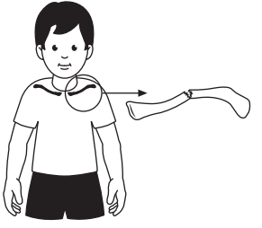
Patient information sheet
Fracture of the Clavicle (collarbone) in children

What is a clavicle fracture?
The clavicle (collarbone) connects your shoulder to your chest and supports your upper body movements. A break, also known as a fracture, of the collarbone is a very common injury which can be detected without an X-ray in most cases.
Clavicle fracture
The affected area may be sore, swollen, and painful to move, but it will heal with rest and time.
How is it treated?
The injury is treated like a sprain because the bones don’t need to be immobilised. Using a broad arm sling to take the weight off the shoulder for around 2 weeks helps with comfort. Encourage your child to move their elbow, hand and fingers straight away to prevent stiffness.
Using the numbers below, contact the hospital immediately if:
- Your child complains of increasing pain, not controlled by painkillers at the recommended dose
- Your child complains of persistent numbness or tingling of the arm or hand
- You have any other concerns

There is usually pain and swelling at first, so pain relief such as paracetamol should be given as directed by your child’s doctor/nurse. It may hurt at nighttime; sometimes being propped up by pillows can help.
What follow-up is needed?
Using the numbers below, contact the hospital if, after four weeks from the injury:
- Your child’s collarbone remains very painful or swollen
- Your child will not use their shoulder, arm or hand within 2-3 days of the sling being removed.
- You have any other concerns

The fracture requires no treatment to heal in the correct way. Therefore, your child will not need follow-up unless you have any concerns.
Your child can stop using the sling whenever they are comfortable enough, but it should not be needed for more than 3 weeks following the injury.
Shoulder movements may be a little stiff and sore at first. Gentle sports are fine as soon as your child is comfortable but avoid any contact sports for at least 6 weeks after the sling is removed. A small lump would normally form at the fracture site, and this may take up to a year to disappear. However, this is normal, so do not be alarmed.
For any concerns or queries, call 01603 286596 or 01603 287266
If no reply call 01603 286286 and ask the operator for bleep 0298.
Outside of work hours, call 01603 286286 and ask the operator for bleep 0996


