
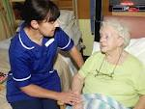
Pressure Ulcer - Patient Information

What is a pressure ulcer?

A pressure ulcer (sometimes called a bedsore or decubitus ulcer) is when your skin and underlying tissue gets damaged through pressure or shear or a combination of both.

How does the skin get damaged?

- Pressure - the weight of the body pressing down on the skin
- Shear - when layers of skin are forced to slide over one another, for example when you slide down or are pulled up a bed or chair

How can you spot one?

The first sign that a pressure ulcer might be forming is a change in the colour of the skin.

Are pressure ulcers serious?
Pressure ulcers can be serious, depending upon how much skin and tissue has been damaged. Severe pressure ulcers can destroy the muscle underneath the skin so they take a very long time to heal.

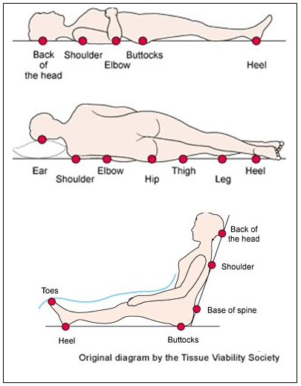
Where do they usually appear?

The most common place for a pressure ulcer is over a bony prominence. These are areas where bones are close to the skin like the bottom, heel, elbow, ankle, shoulder, spine and back of the ear.

Who gets a pressure ulcer?

Anyone can get a pressure ulcer whether they are young or old. But the people who are most at risk are:
- People who have trouble moving and cannot change position themselves
- People who cannot feel pain over part or all of their body
- People who are incontinent
- People who are seriously ill, or have had surgery
- People who have a poor diet and don’t drink enough water
- People who are very young or very old
- People who have damaged their spinal cord and can neither move nor feel their bottom and legs
- Older people who are ill or have suffered an injury like a broken hip

How can pressure ulcers be prevented?

Most pressure damage can be prevented with care and attention given to the following:

- Look after your skin by observing, washing and moisturising.
- Relieving pressure by moving, standing or turning, change position ideally every 2 hours
- Using equipment that has been recommended for you
- Eating a well-balanced diet and drinking plenty of fluids.

Why is nutrition important?

Good nutrition is vital in preventing and healing pressure ulcers. If you do not get enough calories, protein, vitamins, minerals and fluids you may develop a pressure ulcer or your pressure ulcer may fail to heal.

What can I do to help?

- Inspect and maintain your skin (you may need a mirror for awkward places)
- Report redness, blisters or damaged skin to a healthcare professional
- Do not sit for longer than 2 hours without relieving pressure
- Reduce or stop smoking
- Please ask your nursing team for assistance if you need help with any of the above

For further information

Healthcare professionals can provide further information and advice, if you require

https://www.nhs.uk/conditions/pressure-sores/

