Children’s Privacy Notice

This Privacy Notice provides information in an easy to understand format for children to understand how their personal information is handled by the Norfolk and Norwich University Hospitals NHS Foundation Trust (the Trust).

This supplements the Trust’s full Patient Privacy Notice which is available on the public facing website https://www.nnuh.nhs.uk/privacy-notice/

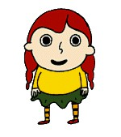
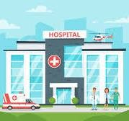
Here’s Daisy and Henry and they are children a lot like you. They go to school, they each live in a house, which has a phone number so their friends can call and arrange for a time to meet up. Their houses each have an address, so their friends know where to go when they come over to meet.
You may know this, but Daisy’s and Henry’s name, address and phone number are called personal information.
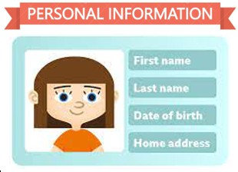
What is personal information?
It is anything which identifies you as a person, and we all have personal information. Here are some examples of personal information - your name, address, the date of birthday, pictures of you, your email address, your hospital records. This is personal information which tells us something about you.

Sometimes people you don’t know can use your personal information to trick you or put you in awkward situations. That’s why it is important to never give out your personal information to anyone you don’t know! You should only give this information to people you trust like your parents, teachers or staff working at the hospital.
To be like Daisy and Henry all you have to do is remember that your personal information is private, and what is private to you should only be shared with people you trust. It’s simple – your personal information is private to you.
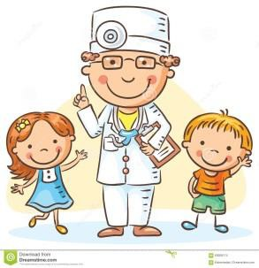
Here at Norfolk and Norwich University Hospitals (NNUH) we are trusted like your parents and teachers, and you can share your personal information with us. When you come into hospital, we need your personal information to help us make you better. It also helps us to contact you if we need to see you again.

When you come to the hospital, staff working in the hospital will have official NNUH badges to help you know they work for the hospital and it is safe to share your personal information with them.
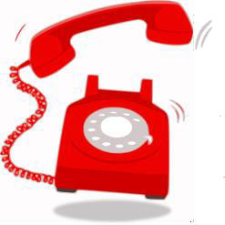
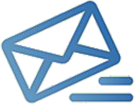
We may collect your information on paper, or by telephone, directly from you or your parents/guardians. If we are calling to talk to you or your parents, we will say who we are, where we are calling from and why we are calling. This information will be used to make sure you receive the right treatment.

There is a law called the UK General Data Protection Regulations to make sure we keep your information private and safe.
Sometimes we call it UK GDPR. Under this law the hospital must have a good reason to collect your information. Our reason is because we are a hospital and, we are also known as a Public Authority so we serve the public with something they might need, in this case a hospital service.

We have to keep your information safe and secure and not share with anyone unless they are trusted.
Would you ever walk into a giant hall of strangers and make it rain postcards with your name, address and telephone number? NO! That’s why we take steps to ensure your personal information is kept under lock and key with only those staff who are helping you in hospital allowed to look at it.

Ok, so we look after your personal information but in some cases, we may need to share your personal information with some other trusted people. We will only do this if it is absolutely necessary. We may share your personal information with doctors, nurses, ambulance services, your parents, the police, the school you attend or with other organisations we work with to help us to keep you safe.
Remember, your personal information is private and if you are not happy about sharing your personal information you should talk to a trusted person like your parents, your teacher or your doctor. You have rights, even though you are not yet an adult and you have a right to keep your personal information private.
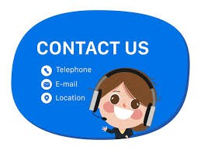
You can tell your parents/guardians if they need to speak to someone at the hospital about your personal information they can contact the Data Protection Officer– by telephone on 01603 286286 or by email to info.gov@nnuh.nhs.uk

